New Product(s) Submission to Jury_________________________
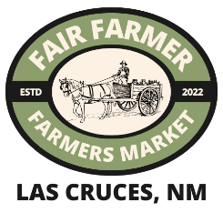
FFM is a farmer focused organization that takes pride in the unique and quality food items sold in its markets. Product just is an important part of our process to dermine which products best fit in our market. Please turn this paperwork in with and Ingredient Sourcing form for each of the products you would like to be considered.

Vendor Name:______________________________________________________ Date:___________________________
Vendor Checlist for Jury
__ Product in final sale packaging (if not finalized, a description of the intended packaging)
__ Legal requirements labeled such as net weight and ingredients
__ At least 15% of raw ingredients are purchased directly from local farms (State of New Mexico)
__ Ingredient sourcing form included for each item
Product(s) Name, Description and Price
- ___________________________________________________________________________________________

- ___________________________________________________________________________________________

- ___________________________________________________________________________________________

- ___________________________________________________________________________________________

- ___________________________________________________________________________________________

How/Where produced:_______________________________________________________________________________
Where your products are sold (states, stores, markets):

Allergen/Health Claims:_______________________________________________________________________________
Additional information or stories about your product(s):

