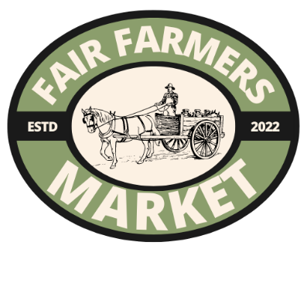
Fair Farmers Market of Las Cruces
Prepared Food Application
Name (first and last) |  |  |  |  |  | Date:
Business Name:
Business Address:
City: |  | State: |  |  |  | ZiP
Personal Address:
City: |  | State: |  |  |  | Zip:
Phone Number:
Emergency Contact: |  |  |  | Phone #:
Business Website:
Is your business a: | Corporation |  | Individual |  | LLC |  | Partnership

Las Cruces requires all businesses to be registered with Las Cruces. If your business is registered, please attach copy of registration. | Yes | No

Product description/list of all items you plan to sell:

Attach copies of the following:
- One well-chosen picture of EACH product type you propose to sell. You will be judged heavily on the pictures you send. Please take this into account when choosing pictures. NOT ALL ITEMS MAY BE APPROVED!
- Please upload one well-chosen picture of yourself creating the product in your studio/home/business
- If you have sold at markets before, please upload one well-chosen picture of your set-up at another market. If not, please take time to set up a table in a presentable manner showing how you would like to setup at the Fair Farmers Market.
- Proof of residency in New Mexico: ID, Passport, Bill in your name to your address (these are the only acceptable forms of ID Proof)
- Up-To-Date State Food Handlers Card
- NMED Permit (If required)
- P2 Letter (if required). There is no resale of any kind, including water, allowed without permission from FFM AND a P2 letter.

IMPORANT! Please review your application and all uploaded files to ensure that your application is complete and that you have uploaded the CORRECT documents. Uploading incorrect documents will result in an incomplete application. Incomplete applications will be rejected. If you have questions, please check the Frequently Asked Questions on the website.
Application will not be reviewed if not complete!!!

