The Issue:
Interest groups seek to influence policy and elected officials’ “Tone at the Top” through campaign contributions. The Supreme Court acknowledged this as the Corrupting Impact of “soft money” on the “independent judgement” of elected officials, in McConnell v. FEC. The Trump administration riotously highlighted this Corrupting Impact, specifically of pernicious interest group politics.
Additionally, accountability avoidance seems to have become easier in this environment, as “Tone at the Top” defines which behaviors are rewarded or punished. It also defines which citizen concerns are addressed, especially as elected officials also control fiscal capacity for municipal agencies.
The Proposal:
With rising income inequality, this phenomenon can have lopsided influence on policy, as this proposal contends happened with Affordable Housing in New York City (NYC). The Real Estate industry in NYC is an Interest Group seeking policy favoring higher-paying tenants. Using tools from research, accounting, and audit, this proposal seeks to study the impact of this influence on housing policy [1990-2020] by seeking:
- Direct evidence of impairment to Affordable Housing in NYC by Interest Groups using campaign contributions to directly influence portions of the 1997 & 2003 Rent Acts.
- Direct evidence this fostered an accountability avoidant environment in administrative agencies as a result of chronic under-resourcing and under-reporting.
The Methodology:
- Peer-reviewed meta-analysis literature review to expand definition of “Corruption” to include “Corrupting Impact” of campaign finance as defined by the Court in McConnell v. FEC.
  - An agreement on “number” of sources
  - An agreement on “acceptable” sources
- Peer-reviewed data analysis to quantify “Corrupting Impact”:
  - Studying “Displacement & Affordability Crisis” using data from stakeholder agencies with the following variables:
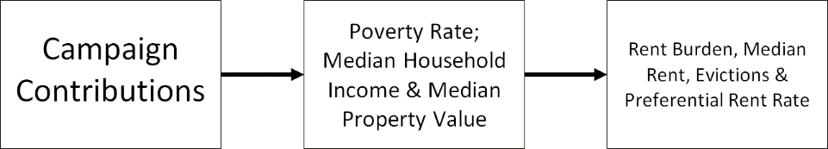

- Measuring “Accountability Avoidance” using agency performance audit and other reporting, for acknowledgement of, and responsiveness to, crisis:
  - Defining accountability avoidance: Paul Light - Monitoring Government
  - Measuring accountability avoidance
    - Compliance Review: Does agency provide citizens with transparent access to data for assessing non-compliance and accountability avoidance.
        - Individual “rent basis history”;
        - Information on “Preferential Rent” tenancies.
    - Capacity Review: Was agency capacity increased as evictions and % rent burdened increased. [City budget, Personnel Power, Self-Assessment Controllability survey]
        - “Due Diligence” verifying rent increases outside guidelines;
    - Performance Review: Did stakeholder agencies acknowledge and respond to developing crisis.
        - Awareness of developing crisis [Code Violations reporting; Agency Budget requests; Mercatus Center survey]
        - Corrective recommendations implemented [Mercatus Center survey; Sample-FA Individual, Agency Recommendation Assessment Form].
        - Citizen constituent “personal experience” [Appendix E]
        - Agency Reputation Analysis [customer satisfaction survey]
        - Elected Official Reputation Analysis [customer satisfaction survey]
The Outcomes:
- Quantify & report on disparate Corrupting Impact effect on protected groups.
- Work with all stakeholders for restorative justice through legislative and judicial measures.
- Ensure housing funds are “earmarked” and administrative agencies are fully funded to capacity requirements.

Interest group is a group of individuals that share a common interest in a specific subject and work jointly to influence public policy in its favor. Interest groups are also called pressure groups because they exert pressure on policy makers to influence public policies. – Retrieved from: Interest Group: Definition, Purpose, Theory & Examples - Video & Lesson Transcript | Study.com
Tone at the top, commonly referred to in auditing, is used to define a company’s management and board of director’s leadership and their commitment to being honest and ethical. The tone at the top sets forth a company’s cultural environment and corporate values. – Retrieved from: Tone at the Top - Definition, How To Improve, Example (corporatefinanceinstitute.com)
McConnell v. Federal Election Commission, 540 U.S. 93 (2003)
Strauss, D. (1994). Corruption, Equality, and Campaign Finance Reform. Columbia Law Review, 94(4), 1369-1389. doi:10.2307/1123287 (p.1370, pp.3-4).
IBID.
Citizen Constituents: The citizen constituent is a group larger than taxpayers and includes all individuals currently residing in any particular jurisdiction, at all levels of jurisdictional definitions.
Interest Groups: Real Estate Industry, Real Estate Investment Industry, Corporate Landlords
Stakeholder Agencies: Housing Preservation & Development; Housing & Community Renewal; NYC Council; NYS Assembly; City & State Comptroller’s Office; Housing Court; NYC Marshall’s Office; US Census; Mayor’s Office; Governor’s Office; Senator’s Office
Light, P. C. (1993). Monitoring Government: Inspectors General and the search for Accountability. Brookings Institution.

