Monday  27th April | Carpet bowls 11:00  In Garden View Lounge   | Bingo 14:30 Dining room  
Tuesday  28th April | Dominoes 11:00 dining room.   | Bean Bag Toss dining room 14:30  
Wednesday  29th April | Church Service, Sherwen Lounge, 11:30  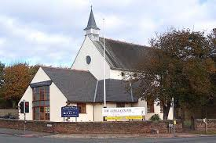 | Sing along in Sherwen Lounge. 14:30.  
Thursday  30th April | Residents meeting 11:00 Garden view lounge.  | Origami 14:30 dining room.  
Friday  1st May | Carpet bowls 11:00  Garden View Lounge. | Bingo 14:30  Dining room.
Saturday  2nd May | Snakes and Ladders, 11:00 dining room.  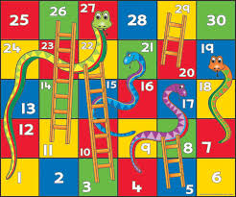 | Dominoes, 14:30 dining room.  
Sunday  3rd May | Chat with residents in their room.   | Film in the Sherwen Lounge 14:00  

