Monday | Quoits 11:00  Dining room  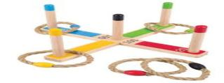 | Bingo 14:30 Dining room  
Tuesday | Carpet bowls  11:00 Sherwen lounge   | Dominoes and colouring 14:00 Dining room.  
Wednesday | Activity planning   | Ball balancing game 14:30 Dining room.  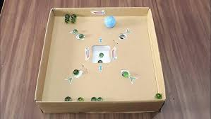
Thursday | Snakes and ladders. Ladders 11:00 Sherwen lounge  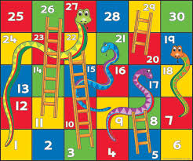 | Crafts 14:30 Dining room.  
Friday | Ten pin bowling Dining room 11:00   | Bingo 14:30 dining room
Saturday | Carpet bowls 11:00  Sherwen lounge | One to one room visits.  
Sunday | Hula hoop Game  11:00 Dining room   | Film 14:00 Sherwen lounge  

