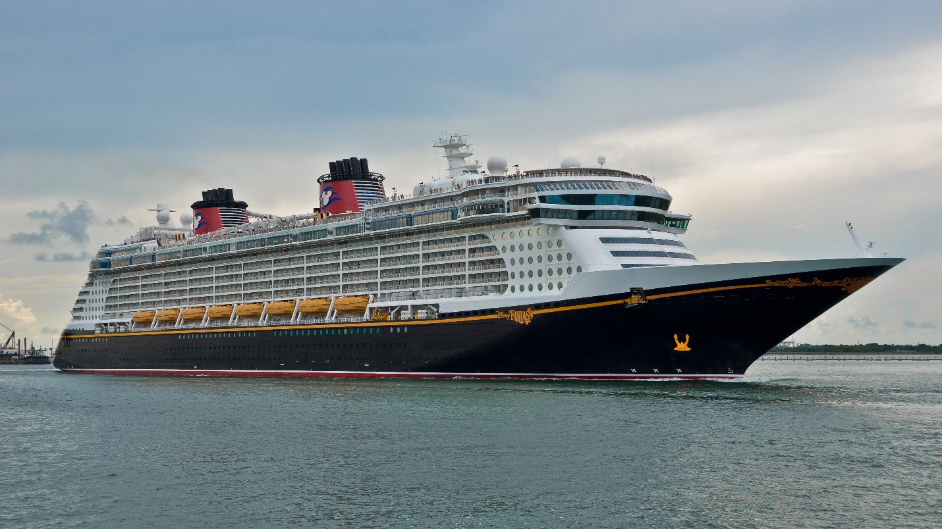

# Our tips for first time cruisers (all of us start there!)

* Research your ship by looking at deck plans, watching videos on YouTube and on the cruise line website.
  + Check on what amenities are available on your specific ship
  + Look at dining times, options, buffet, assigned dining as well as specialty dining options (extra costs associated). Check dress codes as it may vary by venue
  + Explore entertainment options
* Turn your phone on Airplane Mode to avoid roaming charges while sailing. These charges can climb quickly into the thousands of dollar ranges and carriers will not remove them from your bill.
* Some cruise lines allow you to bring onboard a 12 pack of soda per guest and a bottle of wine (21yr+). This can be a money saver so check with your cruise line.
* Look for discounted Gift Cards for your cruise line to aid in reducing your final costs. For example, AARP offers several cruise line gift cards at a reduced cost (8% savings). There is a limit to how many per month you can purchase so plan accordingly. These savings can add up and be helpful.
* Research your destinations for information regarding weather, currency, tipping policies.
* Ship and shore time can be different, always go by ship time to ensure you return at designated time (don’t be a pier runner). Wear a watch or have a device on ship time for reference
* Seasick? If you are prone to motion/sea sickness start medications prior to boarding or the night before. There are many types of motion sickness prevention/aids.
* Pack a small number of over-the-counter medications for colds, allergies, diarrhea and headaches. The ships stores carry these meds at a much higher cost and may not be available when you need them.
* Bring sunscreen and use it to prevent sunburn.
* Make sure you complete your muster drills according to your cruise requirement; it is a vital part of your onboarding process and can cause delays in departing port.
* Remember to pack accordingly and some ships do have self-service laundromats onboard.
* Most importantly, enjoy your cruise and remember the staff on board is there to provide you with assistance and guidance. Need information or have questions “ask”.