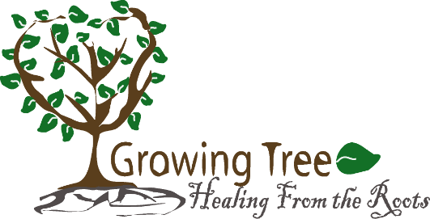 | Therapeutic Art classes help with emotional, social, and academic improvement

Application for the school office/ Registration at www.growingtreehealing.org
Classes starting Monday, June 12, 2023 (6-week sessions)
Please circle one:
Individual sessions or Group sessions

Applicant Information
Full Name: |  |  |  | Date:
 | Last | First | M.I.
Full Name (Parent(s)/ Guardian):
 | Last | First | M.I.

Address:
 | Street Address | Apartment/Unit #

 | City | State | ZIP Code

Phone: |  | Email

Tell me something about your child

Disclaimer and Signature

I am interested in having my child enroll in the program that Szilvia Fillmore provides. I allowed Szilvia Fillmore to take my child to the Art Bus to do the Therapeutic Art sessions.

Signature: |  | Date:

*Checks should be made payable to Growing Tree Healing From the Roots.

