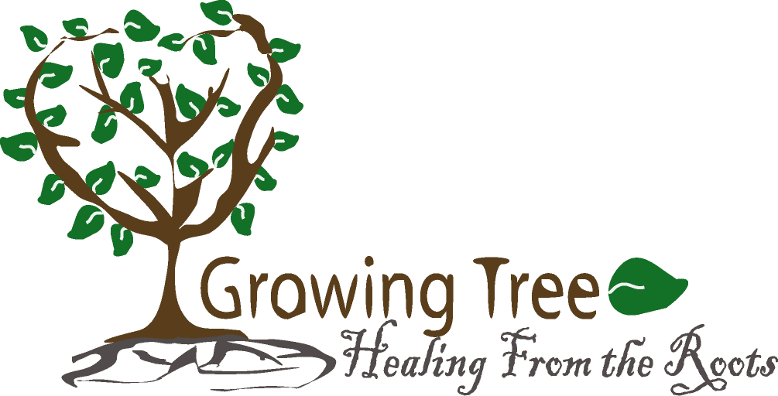
Assumption of the Risk and Waiver of Liability
The Growing Tree Healing from The Roots organization has put in place preventative measures to reduce the spread of COVID-19; however, the Growing Tree Healing from The Roots organization cannot guarantee that you will not become infected with COVID-19. Further, participation could increase your risk of contracting COVID-19.
READ CAREFULLY BEFORE SIGNING – INITIAL EACH PARAGRAPH
____ INITIALS By signing this agreement, I acknowledge the contagious nature of COVID-19 and
voluntarily assume the risk that I may be exposed to or infected by COVID-19 by participation.
____ INITIALS By signing this document, I agree that if I am exposed or infected by COVID-19 during
my participation in this activity, then I may be found by a court of law to have waived my right to
maintain a lawsuit against the parties being released on the basis of any claim for negligence.
____ INITIALS I have had sufficient time to read this entire document and, should I choose to do so,
consult with legal counsel prior to signing. Also, I understand that this activity might not be made
available to me or that the cost to engage in this activity would be significantly greater if I were to
choose not to sign this release, and agree that the opportunity to participate at the stated cost in return
for the execution of this release is a reasonable bargain. I have read and understood this document and
I agree to be bound by its terms.
____ INITIALS I agree that I will practice safe, wear a mask and clean hygiene during the sessions.
Signature _____________________________ Print Name _______________________ Date__________
PARENT OR GUARDIAN ADDITIONAL AGREEMENT
(Must be completed for participants under the age of 18)
In consideration of ____________________________________________________________________
(PRINT minor’s names) being permitted to participate in Growing Tree Healing from the Roots program, I further
agree to indemnify and hold harmless Releasees from any claims alleging negligence which are brought
by or on behalf of minor or are in any way connected with such participation by minor.
Parent or Guardian _____________________Print Name_______________________ Date___________

