**Orlando Youth Jazz Orchestra Audition Packet**

*Saxophone, Trumpet, and Trombone*

Scales

• Your E, G, Bb major scales

Prepared Piece

* *Anthropology* by Parker/Gillespie (Melody and Solo)
* *Willow Weep for Me* by Ann Ronell

• Solo over *Anthropology*

*optional doubling for saxophones on flute and/or clarinet (highly recommended but not mandatory) Please play the previous scales and the melody to “*Anthropology*”

*if interested in auditioning on Bass Trombone please add on to your audition the following three scales on bass trombone

C, F, A major scales.

This does not substitute your tenor trombone audition.

*Drums*

Be able to demonstrate steady time keeping and rhythmic creativity in the following styles. Imagine yourself backing up a horn soloist.

* Bossa Nova – quarter note = 110
* Songo – half note = 92
* 3/4 & 4/4 Swing – quarter note = 160
* Jazz Shuffle – quarter note = 120  
  Improvise
* Play the full melody of *Anthropology* on the drum kit. Do your best to emulate  
  and add creativity to the melody.  
  Grooves must be a minimum of 16 measures  
  *optional doubling on Vibraphone and/or auxiliary percussion is recommended but not mandatory. For vibraphone please play the melody to “*Willow Weep for Me*” and follow by comping over the chord changes.

*Guitar*

Scales

• Your Bb, Eb, G major scales

Prepared Pieces

* *Anthropology* (Comp & Solo)
* *Willow Weep for Me* (Comp only)
* Comp pieces in Swing, Bossa Nova, and “Freddie Green” Styles  
  *Optional:  
  o Chord Melody on tune of your choice  
  *Bass* (Electric and/or String Bass) Scales

• Your Bb, Eb, G major scales Prepared Pieces

* *Anthropology* (Bass line & Solo)
* *Willow Weep for Me* (Bass line only)
* Prepare bass lines for pieces in both Swing and Bossa Nova  
  *Piano*Scales

• Your Bb, Eb, G major scales (2 Octaves)

Prepared Pieces

* *Anthropology* (Comp & Solo)
* *Willow Weep for Me* (Comp only)
* Comp pieces in Swing and Bossa Nova Styles
* Optional:  
  o Chord Melody on tune of your choice

*Saxophonists only need to audition on one saxophone, due to the nature of the auditions and to better place all members, you might be assigned a particular saxophone.

**Audition Guidelines**

Orlando Youth Jazz Orchestra judging rubric

Name _______________________________________________________

Audition grade/NEXT year’s grade ______________

Audition Selection #1 ______________________________________________________________________________ Audition Selection #2 ______________________________________________________________________________

Instrument: _______________________ Sight Reading - E G F P COMMENTS:

Jazz Style- E G F P Improvisational Ability - E G F P

Rubric

|  |  |  |  |  |
| --- | --- | --- | --- | --- |
| Intonation | Intonation created a barrier to playing the solo in tune  123 | There were many instances of pitch problems  4. 5. 6 | Virtually all pitches were correct and in tune  7. 8. 9 | The entire performance was tuned beautifully  10 |
| Rhythm Accuracy | There were significant rhythm problems  1 2. 3 | There were several places in which rhythm was not clear  456 | Most rhythms were correct with only a few inaccurate spots  7. 8. 9 | Rhythms were precise. Attacks and releases were exact.  10 |
| Facility | Technical ability detracted from overall performance  1. 2. 3 | Technical ability accurate but limited in the jazz style  456 | Technical ability is proficient and jazz style is evident  7. 8. 9 | Excellent command of technical abilities in the jazz style  10 |
| Improvisation | Technical knowledge of scales and chords is at the basic level  1. 2. 3 | Shows proficiency in improvising with limited understanding of jazz “vocabulary”  4 5. 6 | Shows proficiency in improvising in the jazz style with few mis- takes  7. 8. 9 | Excellent understanding and execution of jazz improvisation. En- hances performance  10 |
| Phrasing, Dynamics and Expression | The performance did not express musical ideas effectively  1. 2.3 | Expression was inhibited, or too subtle to convey to the listener  4. 5. 6 | Musical expression was evident throughout  7. 8. 9 | Performance clearly expressed the composer’s musical intent  10 |
| Overall Effect | Limited understanding of musicality  1. 2. 3 | Basic understanding of musicality  4. 5. 6 | Proficient understanding of musicality  7. 8. 9 | Exceptional understanding of musicality  10 |

Total Score

**For Piano and Guitar**

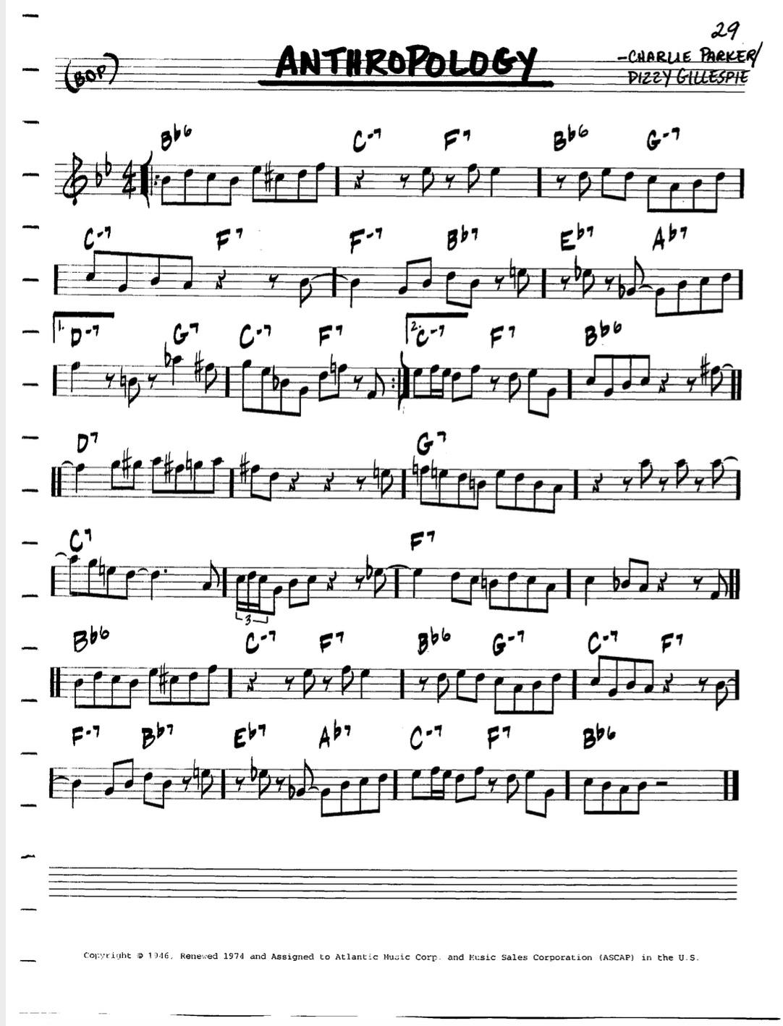

**For Piano and Guitar**

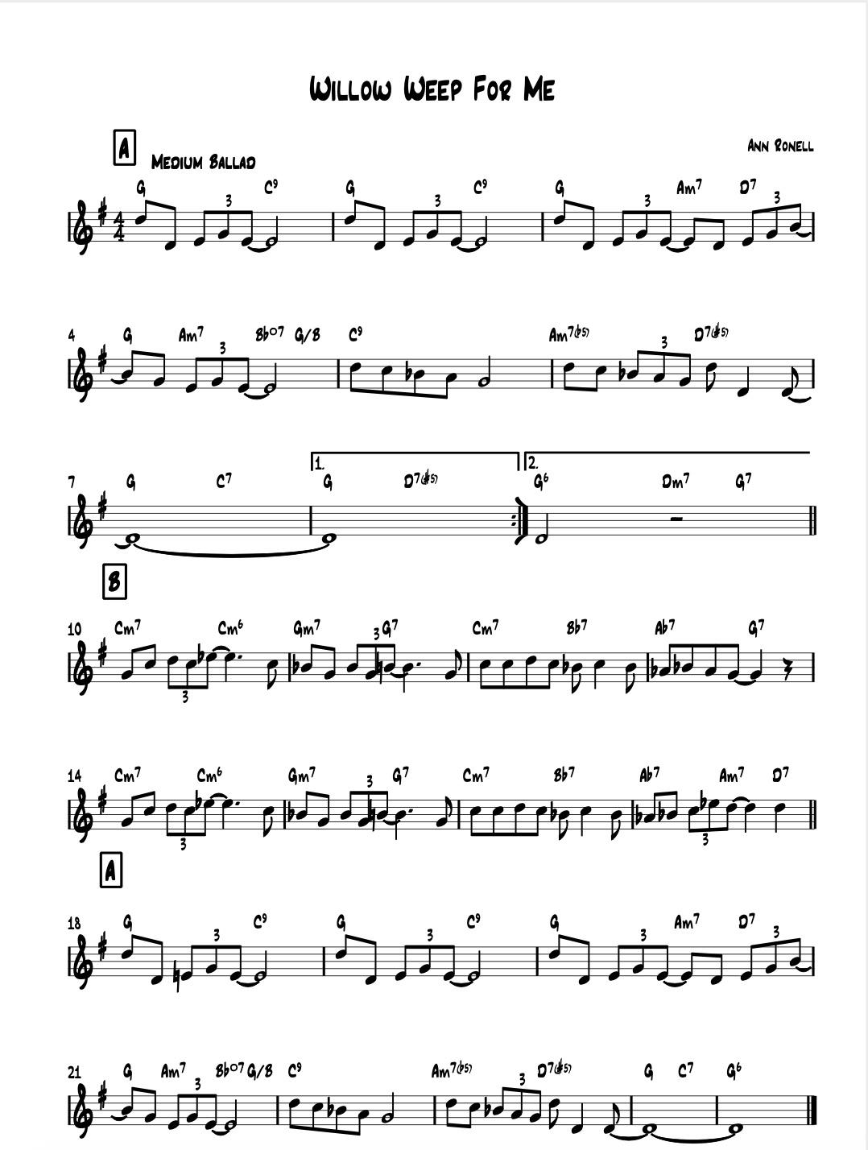

**For Trombone and Bass Guitar**

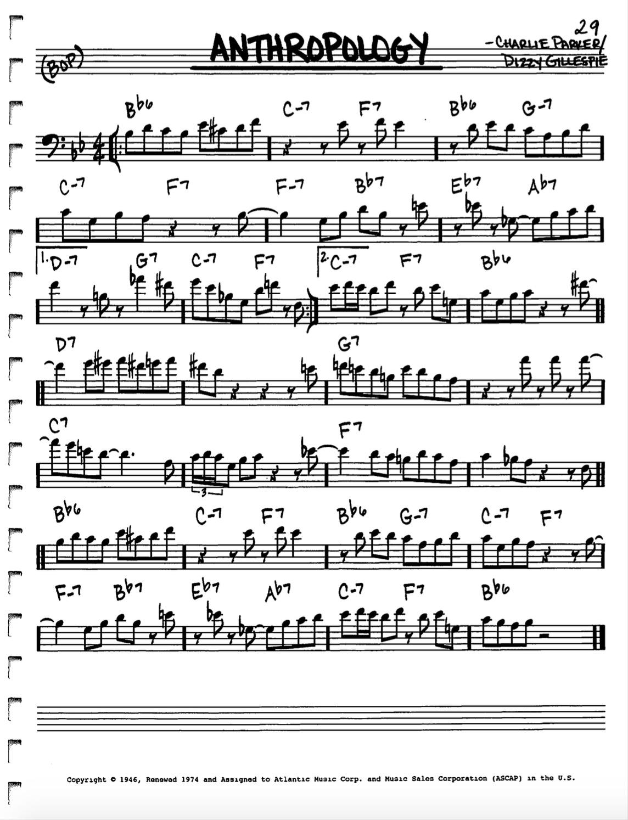

**For Trombone and Bass Guitar**

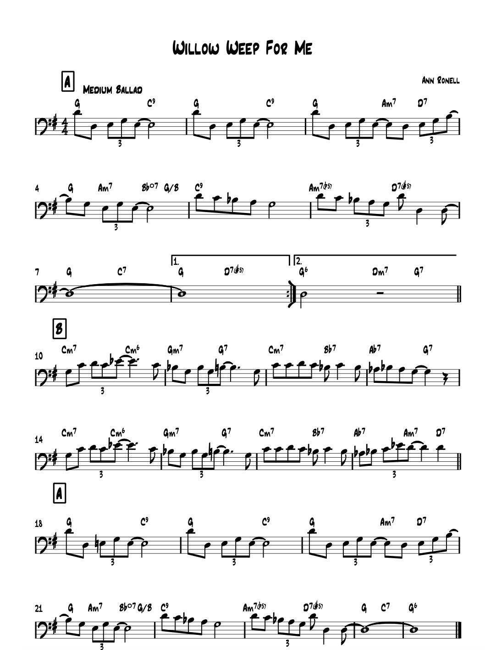

**For Trumpet and Tenor Sax**

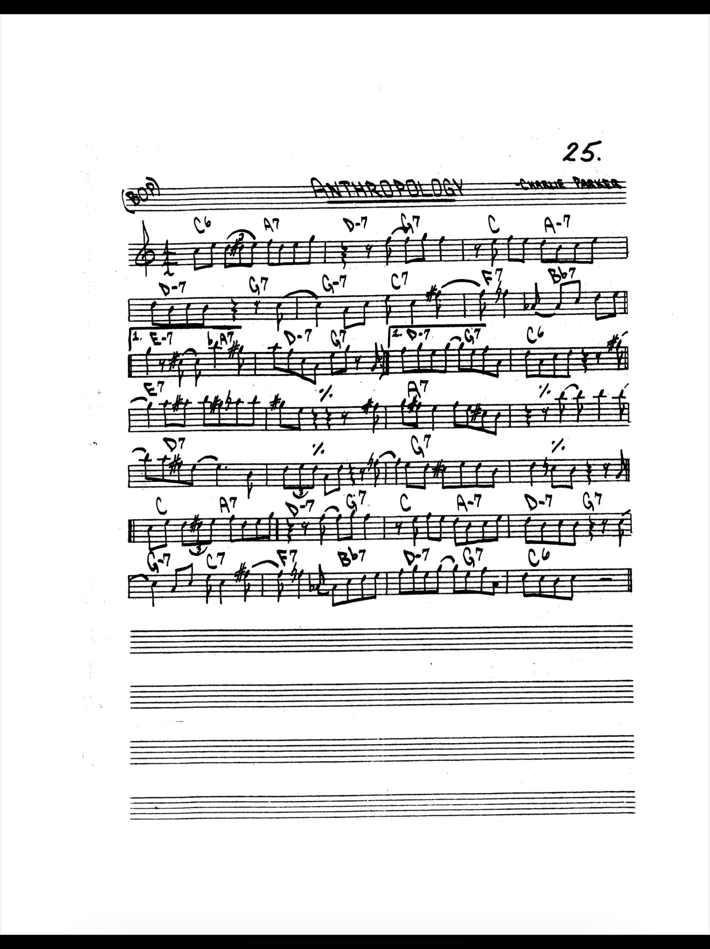

**For Trumpet and Tenor Sax**

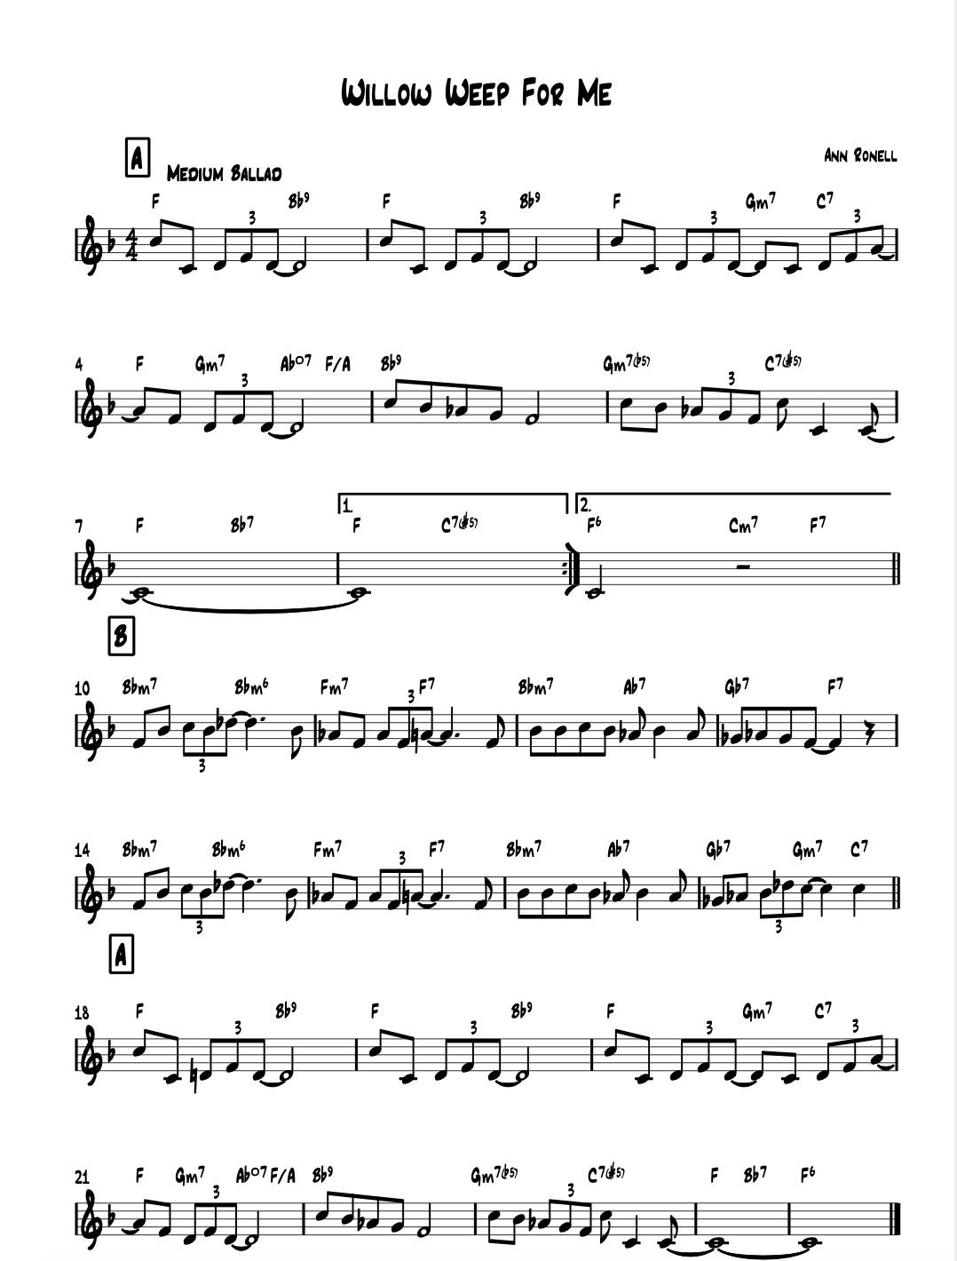

**For Alto and Bari Sax**

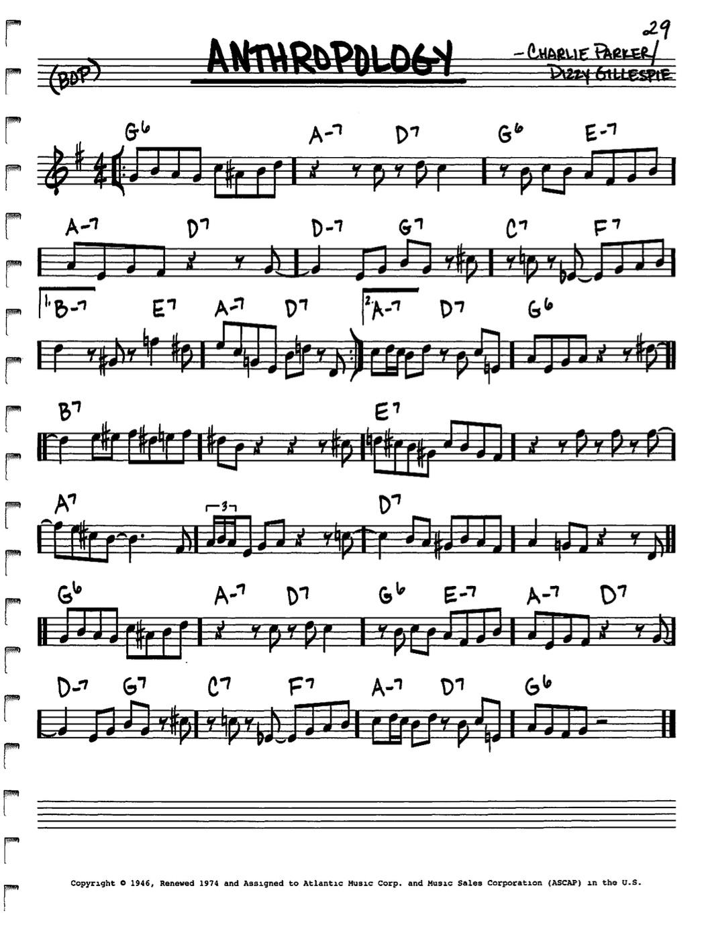

**For Alto and Bari Sax**

