OYCE

String Ensemble Audition Packet

2020/2021

**Violin**

Exposition from Concerto of choice

Orchestral excerpt: “Intermezzo” from Cavalleria Rusticana by Pietro Mascagni - From Figure 14 to 10th measure before the fermata (dotted quarter note)

Scales: G, A, B-flat (Major and melodic minor, 3 octaves). Only one scale will be randomly selected.

Sight-reading: Will be selected from works written by Black and/or LatinX composers

**Viola**

Exposition from Concerto of choice

Orchestral excerpt: “Intermezzo” from Cavalleria Rusticana by Pietro Mascagni - From Figure 14 (Forte Sostenuto) to 10th measure before the fermata (dotted quarter note)

Scales: C, D, and E (Major and melodic minor, 3 octaves). Only one scale will be randomly selected.

Sight-reading: Will be selected from works written by Black and/or LatinX composers

**Cello**

Exposition from Concerto of choice

Orchestral excerpt: 2nd Movement from Symphony No. 7 by Ludwig van Beethoven - From Figure A to the downbeat of measure before Figure B

Scales: C, D, and E (Major and melodic minor, 3 octaves). Only one scale will be randomly selected.

Sight-reading: Will be selected from works written by Black and/or LatinX composers

**Bass**

Exposition from Concerto of choice

Orchestral excerpt: “The Elephant” from Carnival of the Animals by Camille Saint-Saëns - From Measure 5 to the eighth measure of Figure 1

Scales: E, F, G (Major and melodic minor, 2 octaves). Only one scale will be randomly selected.

Sight-reading: Will be selected from works written by Black and/or LatinX composers

Violin Audition Excerpt

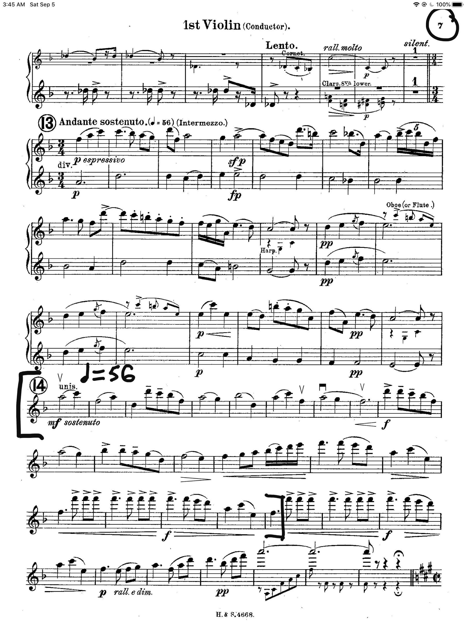

Viola Audition Excerpt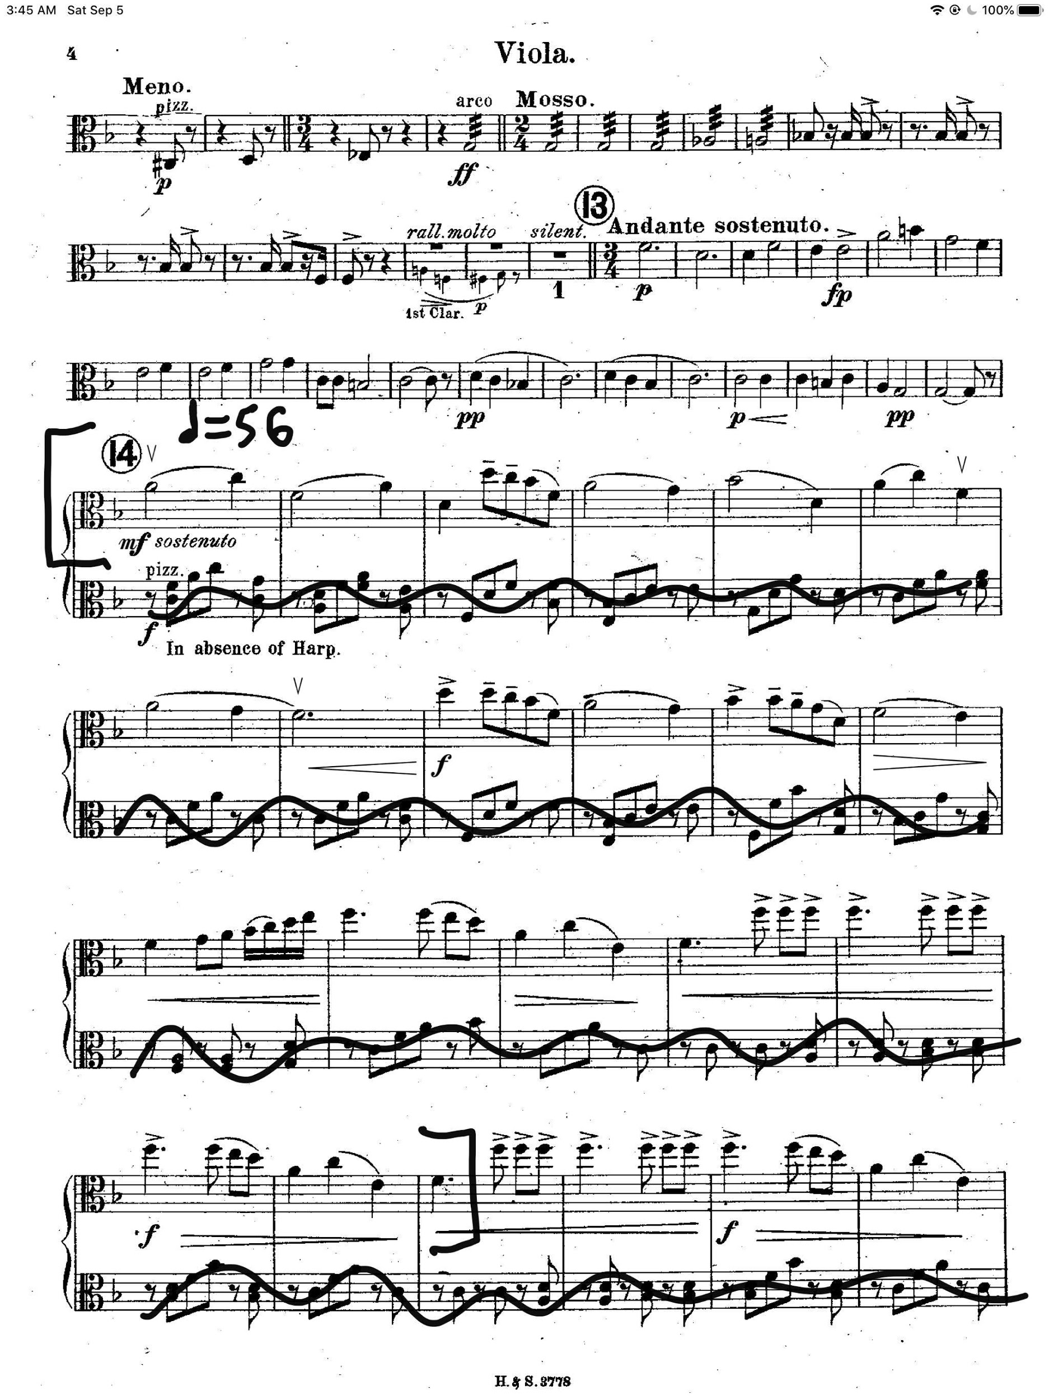

Cello Audition Excerpt

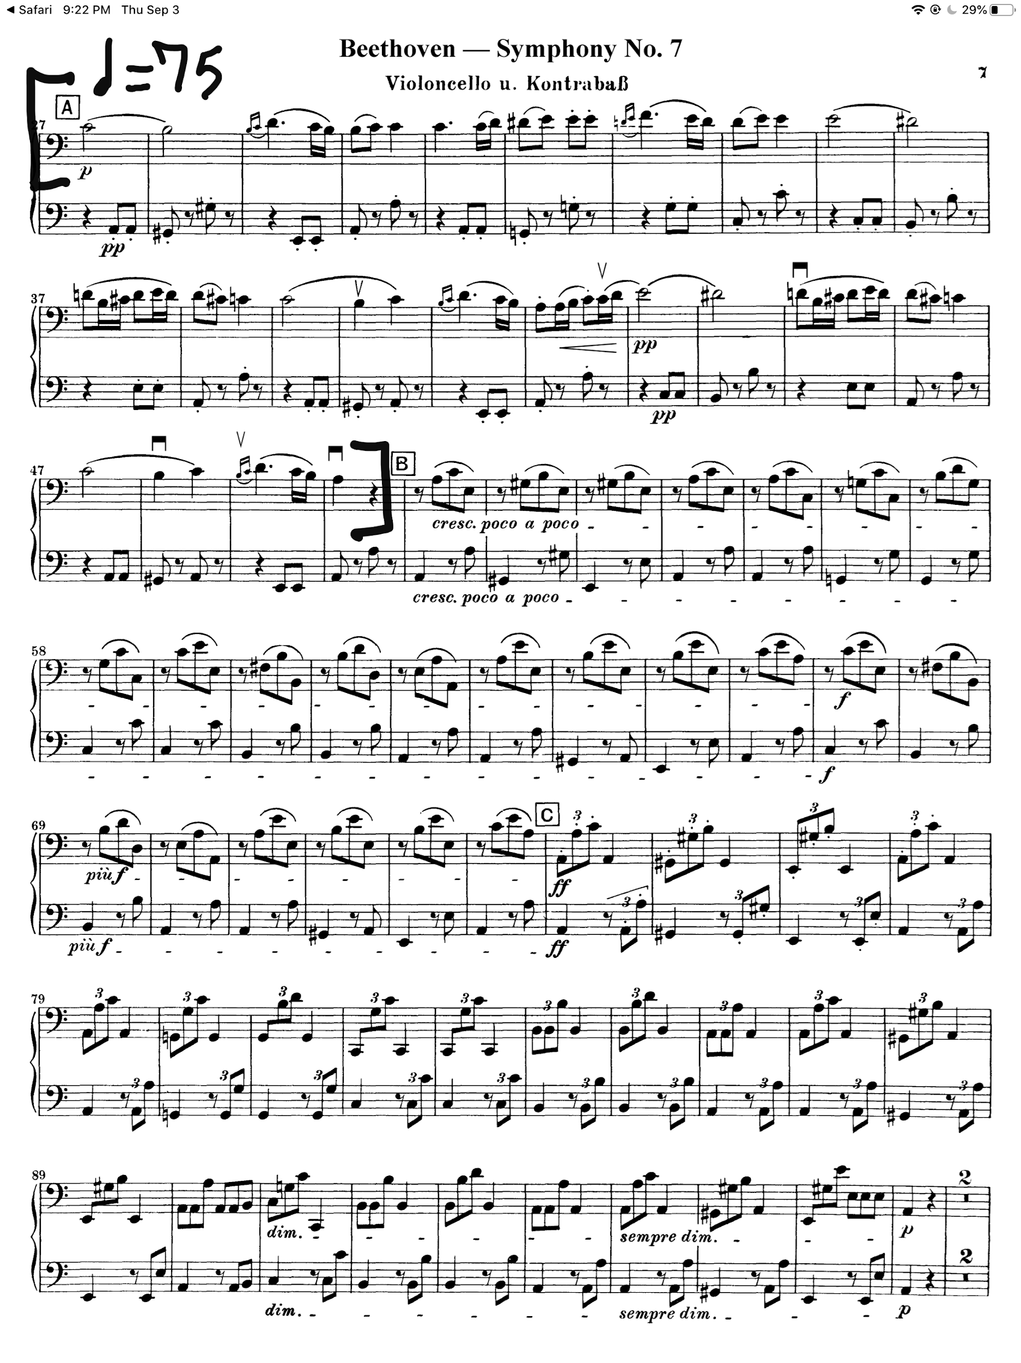

Bass Audition Excerpt