METACOMET GREENWAY NEWS
Issue NO. 1 | July-August | 2022

I hope you all have had an enjoyable summer! With the COVID-19 pandemic seemingly under control, it has been great to gather with friends and family and enjoy the outdoors. My family took our annual trip to Cape Cod this summer and enjoyed a great ride down the Shining Sea Bikeway. There is something very special about having a dedicated recreational path – everyone is friendly with similar goals of enjoying the outdoors and being active. Whether you are out with the kids, or your bike club, having this space away from traffic is extraordinary. Thank you all for your continued support – we look forward to some very exciting months ahead and are truly honored that you’re along for the ride!
-Zack McKeever, President, Metacomet Greenway Association
MGA at Firefighters Kids Day – North Attleboro
Members of the MGA attended the annual Kids Day in North Attleboro on July 23rd at the North Attleboro Middle School at 575 Landry Ave. It was a very hot afternoon, but time well spent promoting awareness of our project, and supporting other local community agencies like the North Attleboro Firefighters.
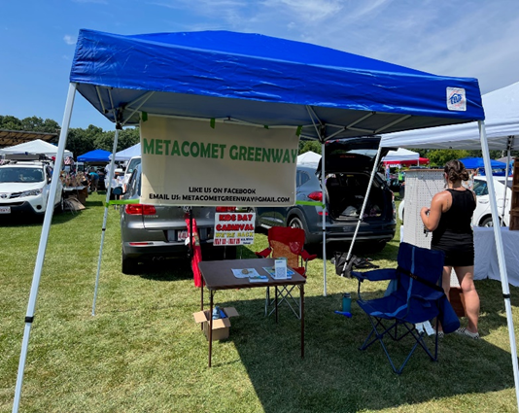

One Year Anniversary Cookout!
We had a cookout to celebrate our One Year Anniversary at our spring General Membership meeting on June 4th at the RICE Complex at 54 Emerald Street in Wrentham. It was a great way to meet newer members, reconnect with previous members, and answer questions and discuss the progress of the project. We are very proud of the progress we have made in just one year! Thank you to everyone who was able to attend, bring a snack and help make this a fun family event!
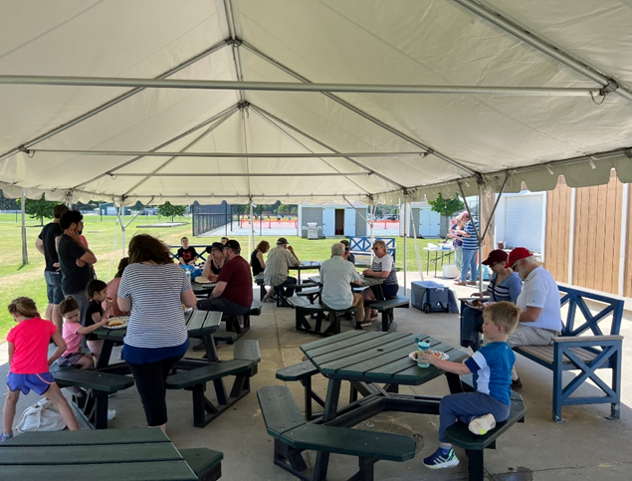
Special thank you to Jeff Plympton, Wrentham Recreational Director, for working the grill!
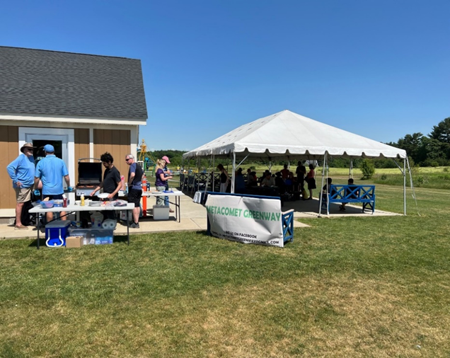

Important Project Updates
Walpole: MGA has been working closely with the Walpole Trails Committee to keep the Metacomet Greenway on the radar to the North. Most recently, we have engaged the folks in Walpole with a few engineering firms to discuss some options for design of the trail and forgo any type of feasibility study. The Walpole Trails Committee will be asking for funding in a meeting this August, with potential for a vote to approve funds this fall at town meeting!
Norfolk: MGA has been working with the town and BETA Group to discuss the drafting of the Norfolk feasibility study. Most recently, a town Community Workshop on May 26th included concerns and ideas from members of the community that can be incorporated into the feasibility study. Currently we are awaiting comment from local agencies, including Police and Fire, to be incorporated into the study. We hope to have a draft ready for public consumption early in September.
Wrentham: MGA has been working with the town, Recreation Department and VHB to discuss the drafting of the Wrentham feasibility study. Most recently, a draft of the feasibility study was sent to town Technical Review Committee (TRC) and awaiting input from Wrentham Public Safety to prepare for a upcoming community public workshop. We anticipate the public workshop to take place early in September, and a draft of the feasibility to follow shortly thereafter.
Plainville: MGA has been working steadily with the town planner to incorporate the abandoned rail bed in Plainville into the proposed Metacomet Greenway. While there are no plans currently for any feasibility study, the town has been working with developers to incorporate design and construction. Soon, a parking area will be finalized off Cross Street that could one day be utilized to access the Metacomet Greenway.
North Attleboro: MGA has had preliminary discussions with town members from Open Space and Recreation who are supportive of the project. Because a majority of the proposed route is privately owned property, there has not been a big push to approach the town to pursue a feasibility study. Currently, our goal is to continue to build community support and excitement for the project.

Volunteer Opportunity
Interested in getting more involved in the project? Consider volunteering at one of our upcoming events!

Upcoming Events
September
Sat 9/10 -9am | Wrentham Day 2022 | Wrentham Center | Volunteer Opportunity
Mon 9/19 -7pm | Board of Directors Meeting | Virtual
Wed 9/28 - 7pm | General Membership Meeting | Norfolk Public Library
October
Mon 10/17 -7pm | Board of Directors Meeting | Virtual
November
Mon 11/21 -7pm | Board of Directors Meeting | Virtual
Wed 11/30 - 7pm | Annual General Membership Meeting | TBD | Review Budget, Vote Members, Project Goals

MGA Subcommittee Opportunities
Trail Maintenance
Trail maintenance will include all facets of maintaining the trail. We will discuss with other local trails organizations what resources are being used to maintain the trails, and what funds are allocated for this task.
Engineering
Review the reports from the associated Towns consulting engineers. Make recommendations for cohesion and how to modify one for another to make the trail a single entity, not town by town. Reach out to utility providers, or equipment manufacturers for potential partnerships within each community for the trail development.
Community Outreach
The purpose of the Community Outreach Committee is to provide information about the Metacomet Greenway Association to town boards and community groups in order to gain local support for our proposed recreation path through the five towns.
Public Relations/Social Media
Everyday outreach to community - easy walks, mom’s groups, vision of the green space
Grants
Research all potential funding opportunities for planning, design, and construction of the Metacomet Greenway
Solicit support from local, state, and federal agencies regarding potential programs and funding resources to support trail development

Remembering Ken Graves
Kenneth Graves passed away on July 20th 2022 at the age of 86. Ken was a longtime active member of the Original Congregational Church in Wrentham. He enjoyed staying active and was an avid runner and cyclist. Ken was part of the Community Outreach subcommittee, and most recently was involved in making sure the MGA was taking part in the Wrentham Day festivities. It was at Wrentham Day 2021 where Ken became more heavily involved with the Metacomet Greenway Association. He was a valued member and will be missed by many.

METACOMET GREENWAY 2022
Corporate Sponsors

Level Design Group - NESRA Engineering

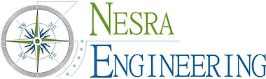

This message was sent to you by Metacomet Greenway Association

