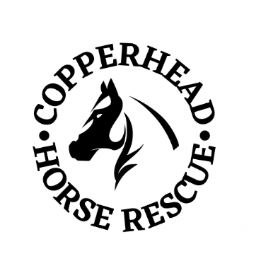
COPPERHEAD HORSE RESCUE
KICKBALL TOURNAMENT
TEAM SIGNUP

Team Name: Click or tap here to enter text. Contact Person:Click or tap here to enter text.
Address:Click or tap here to enter text.
Phone Number:Click or tap here to enter text. Email:Click or tap here to enter text.
Team Fees $150 per team.
Fee paid by:
☐ PayPal ($153.48 – 1.99% + $0.49 transaction fee added)
Paypal link on website www.copperheadhorserescue.org
☐ Check ($150.00 payable to Copperhead Horse Rescue)

Team Form must be completed and turned in by Wednesday, June 1st, 2022. Team Form can be turned in by emailing it to copperheadhorserescue@outlook.com or by mailing it to 3751 249th St. NE McKenzie, ND 58572.
Each team must complete Team Roster and turn in roster by the morning of tournament. All players must sign the “Waiver and Release” on Team Roster. Tournament schedule and bracketing will be completed by Friday June 3rd, 2022 and will be posted on CHR’s website and Facebook page.
All teams will be responsible for obtaining their own Alcoholic Beverage Team Permits for the day of the tournament. They can be purchased at the Bismarck Parks and Recreation Office, 400 East Front Avenue.
If you have any questions email them to copperheadhorserescue@outlook.com or
text/call (218) 779-1391.

