Following the steps below will ensure that your status is corrected.
Please keep in mind that the entire process could take three (3) months. It all depends on how quick you move through the steps, however, there are some steps that you cannot rush, as there is a specific time period you must wait for, before you can move to the next step.
Be patient, but never stop learning.
In order to complete the status correction process, you need a "Certificate of Live Birth" that contains both a birth number and a local file number, or registration number. Contact the department that issues birth certificates for your state on how to get a Certificate of Live Birth (also known as a "Book Copy" of your birth certificate, or "Long Form" birth certificate). You will need it for your Deed of Reconveyance.
If you are waiting for a time period to lapse, start reading up on things like the Constitution, the USC, and the Bible.
You cannot benefit from being a State National, if you do not know what it means.
Before you can record any of your papers, you must wait 21 calendar days after your affidavit has been received by the current Secretary of State of the United States.
If after 21 days you have not received your green return receipt card, go to the USPS.com website and print off the tracking history and the delivery confirmation. Use this as your proof of service
Important: Do not print your papers double-sided. Treat this as a legal document. Legal papers are single-sided.
It is advised to add a scripture verse to the back of your papers.
This is to prevent the corrupt judges from turning over your papers and claiming "I don't see anything here".
It is why the put the blind-fold on the lady justice.
Justice is blind.
We recommend putting the scripture verse of John 8:36
"If the Son therefore shall make you free, ye shall be free indeed." - John 8:36
Also put "See other side" a few inches below it. You may need to write this on all of your pages.
What to keep in mind with these parchments: They have been formatted and highlighted in a way to hopefully answer questions on how to fill them out. For instance, where you see First Name should be replaced with your actual first name, and changed back to black text. Also, there are comments placed throughout all of the papers instructing on how that particular text should be filled out. Before printing your parchments, be sure to delete any remaining comments.
An example:

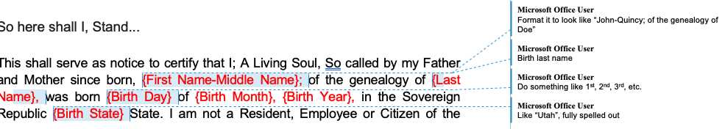

Correct Your Status

1) Affidavit of Truth and Assertory Oath, Repudiation and Revocation of Citizenship
- This should be the first paper you look at and fill out. Before you can do anything else, you have to get this done first. Please read the paper thoroughly, and follow the instructions on how to fill this paper out
- Depending on the number of recipients receiving your affidavit, you will need to print out that number of copies of your affidavit, plus 2 additional
  - 1 - 6 copies will go to the recipients of your affidavit. Keep in mind, you only have to send to the US Secretary of State, but David states he likes to notify everyone.
  - 1 copy you will get notarized and keep in your records, you should never have to touch it.
  - 1 copy you will get notarized and use for recording. You will also make certified copies of this copy, once recorded, to use for any agency requesting proof of your status correction, such as the Passport Agency. Before you head to the Passport Agency, have a certified copy on hand, you will need to hand it in with your passport application

2) Deed of Re-Conveyance
The Affidavit of Repudiation notifies the United States Secretary of State of your intention to declare and correct your status, the Deed of Re-Conveyance takes ownership of your vessel, and all variations of your name.

3) Proof that you belong on the land and soil of the United States of America
You have 2 options on this part, and you can start working on this at anytime. When it comes to your Patent of Nativity, there are several sources that you can use to trace your lineage. There is FamilySearch.org, or a paid genealogy site, like Ancestry.com. The problem I have found with FamilySearch.org is the accuracy. Since anyone can edit, the connected lines of ancestors is unreliable. I have had to use a pay service like Ancestry.com to trace my lineage. FamilySearch.org had multiple errors that show incorrect relationships.
The lineage has to be direct. So parents of your parents, etc. Not cousins.

- Patent of Nativity (option 1)
  - Trace your genealogy back to before 1776 of when your ancestors where on the shores of America, before the ratification of the Constitution. This proves you belong on the American soil before the government was created
- Declaration of Status (option 2)
  - Write a Declaration of Status to state your case of why you are not a citizen (municipal slave) of the corporate UNITED STATES. You are a living breathing soul with a heartbeat!

4) Proof of Service
Once you receive back your Affidavit of Repudiation return receipt cards, you need to make them now a court of record that your affidavit was received.

5) Judgment of Un-Rebutted Affidavit
This parchment makes it a court of record that the affidavit was received and after 21 days was unrebutted. Get two(2) witnesses to sign this one as well. This validates the parchment as true and fact.

Record Your Parchments

- Fill out the cover sheet entering in the county where you plan on recording your papers. Any county in America can be used, does not need to be your county, or even a county in your state.
- Enter your name and address as outlined in the example cover sheet.
- Enter all of the parchments, by correct title in the papers, on the cover page. As long as all of your papers are listed on the cover page, the recording is considered a single "document" and charged for a single recording.
- Count the number of pages of all papers, including the cover sheet, and mark that on the cover sheet.
- Remove any paperclips, document clips, and staples. Since this is considered a single document, there should be no separation of any of your papers.

At the point of dropping off your papers, regardless of same day processing or not, You are officially a State National!
Regardless if you are dropping it off face-to-face, or mailing it off, get 3 certified copies of your bundle. You will need one to give to the passport office.

Pitfalls to Watch For
  - Your papers should all be on 8.5 x 11 paper
  - Masks may be required at your county recorder

