Steps to Correct Your Status
Following the steps below will ensure that your status is corrected. Please keep in mind that the entire process could take three (3) months. It all depends on how quick you move through the steps, however, there are some steps that you cannot rush, as there is a specific time period you must wait for, before you can move to the next step. Be patient, but never stop learning. If you are waiting for a time period to lapse, start reading up on things like the Constitution, the USC, or even the Bible. You cannot benefit from being a State National, if you do not know what it means.
Before you can fully complete this process, there are a few things you will need first. Best to get them now so you have them available when it's time to use them.
- Your Certificate of Live Birth
  - This can also be called the long form birth certificate, although it is not the same as the long form certificate that will never be released to you. Regardless of what it is called, you need the birth certificate that has your registration (birth) number and local file number, along with the signature of one ( some have both) of your parents, the doctor, and sometimes the recording agent of your county vital statistics/health department.
    - This birth certificate will also have signatures on it. Should be the informant (mother or father) signature, doctor signature and registrar's signature. It may only have one, or it has all. Regardless, you know if you have the right birth certificate based on if it has signatures.
    - You will need to contact the county you were born in at either their health department or vital records department.
Some counties will require you to order it through vitalchek.com. You will need to go to their website and find out, or call them.
Update 7/21/2023Do not use VitalChek.com to get your CoLB. You will need to contact the county where you were born on how to get it through them, regardless of what they tell you.
Some states do not issue with CoLB for 100+ years. You will need to get a court order to get it. We cannot help you do this. You will have to do your own research as each county may be different
- A Red Ink Pad
  - This will be used to place your thumb print on your Affidavit of Truth and Assertory Oath, Repudiation and Revocation of Citizenship. It is used as your SEAL. You will need to make sure your thumbprint touches your signature.
- Registered Mail Labels ( aka Mail Label 200)
  - You have to pick these up from the post office, they do not offer them for ordering through their website. The labels available on their website are only stickers for your package, they do not contain the bond number for shipping your paperwork.
  - You will need to pick up at least 4. Most post offices will do what they can to not let you take the labels with you. They claim they cannot let you take them out of the building, but that is untrue. They just do not like people using them.
    - If they are giving you a hard time taking them out of the post office, you can ask to speak to a supervisor about it and ask him why you are not allowed, and/or ask them to show you where in their policy it states that you are not allowed to take them out of the building. They wont be able to produce anything, as there is nothing.
  - There is also the receipt that goes with the label. It is a white paper with a carbon copy duplicate attached to it. Although not completely necessary at this time, if they do not give you one, do not fret. They will have to fill one out when you go to mail your paperwork.
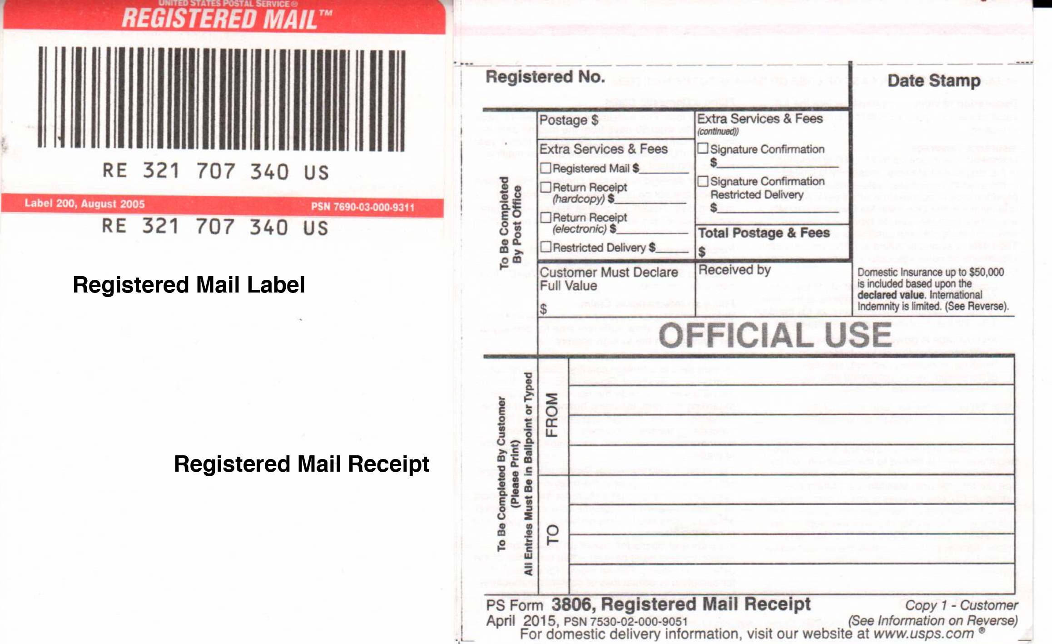
- Green Return Receipt Cards (aka Form 3811)
  - These are available at the post office and should be available to grab without having to go to the counter. They are also available online, if you wish to go that route, however, it can take a week (or more) to get them.
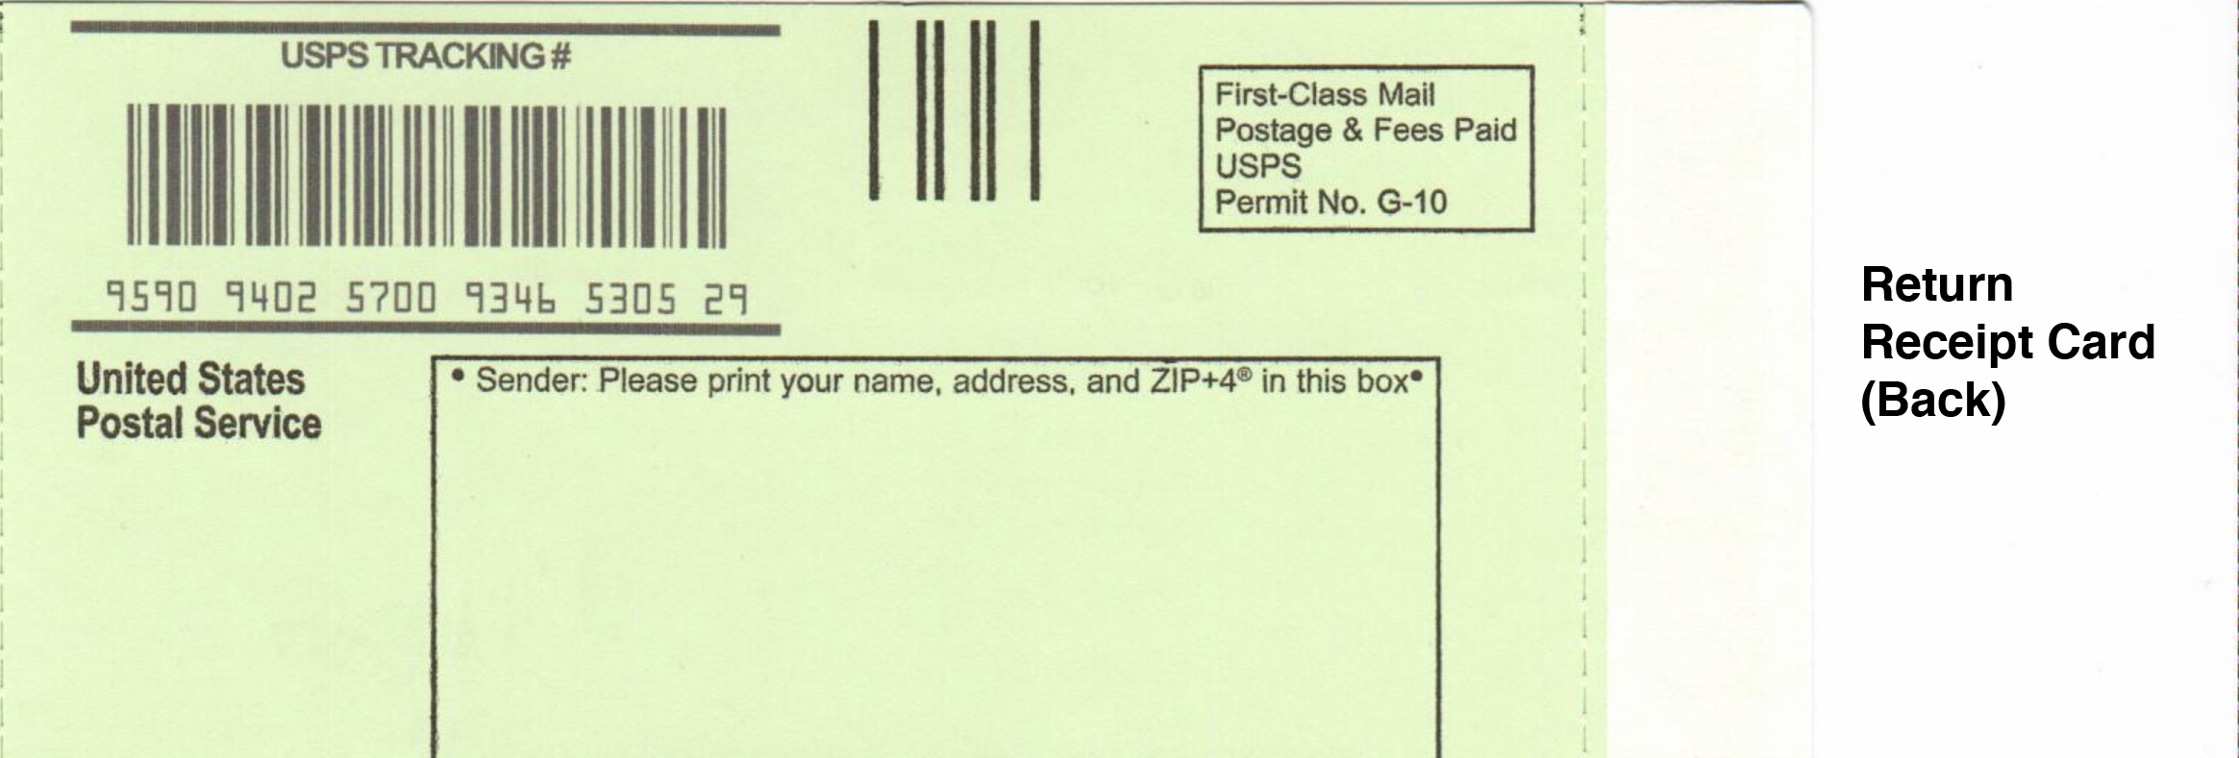
- Certified Mail Labels/Receipt (aka Form 3800)
  - If you decide to send your affidavit to some of the recipients via certified mail, you will need to get these from the post office, or order them online. They are free to order.
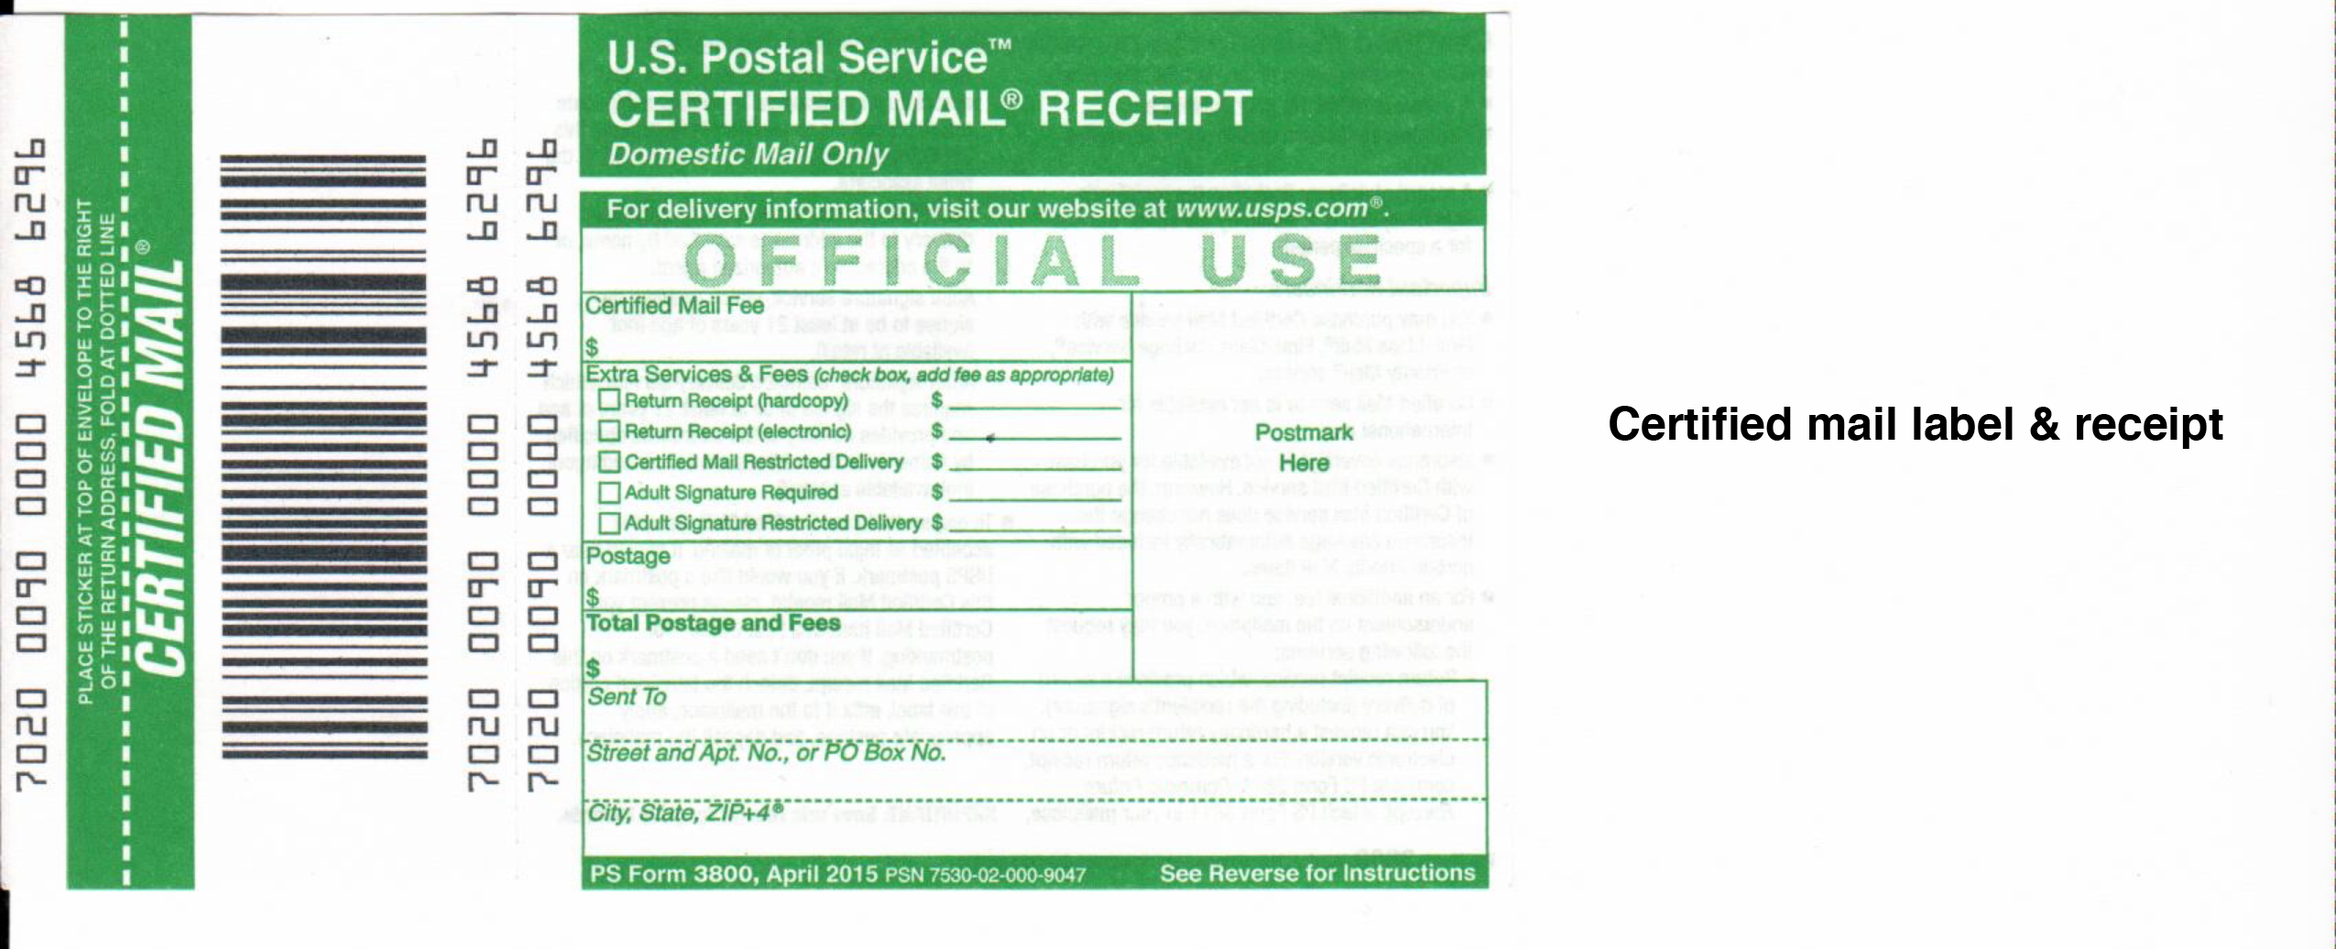

The list below outlines the order in what you need to do for status correction, up to getting your passport.

Be sure to autograph all papers using Red ink
- Repudiation and Revocation of Citizenship
  - DO NOT just put your name on it and send it in. Read it through thoroughly and add/remove sections of the affidavit that applies to you and your situation. Some of the content in the affidavit are specific to the original author, and do not apply to anyone else. Also, by reading through the affidavit means you understand everything that is in it, as there may come a time that you have to defend its contents.
  - Sign your affidavit in RED. Use a RED thumbprint as your seal, making sure it touches your signature.
  - Upon completion, have one original copy for yourself and get your affidavit notarized by a Notary. So, if you are sending your affidavit to all four individuals, you will get 5 copies notarized, so you have an original copy (will be used to record with).
    - The differences in the type of notary is based on the notary language in your document. You can use any notary.
    - If you are having difficulties with a notary who wants to use a different document, other than the notary language specified in your affidavit, find a new notary. You do not want the notary language in your document modified. Do not let them cross anything out in the notary section, just find a new notary.
    - If you were born in a different state than where you currently live, you can send an affidavit to the Secretary of State of your Birth State, so in this case, you would need to get 6 copies notarized
  - Print your affidavit single-sided.
  - It is up to you who you send the affidavit to, but the one person that MUST receive it is the Secretary of State of the United States. If you choose, here is who you can/should send it to:
    - Secretary of State of the United States
      - MUST be sent Registered Mail (Red Label)
    - President of the United States
      - Although you may not recognize the current standing president, the point of this affidavit is notifying the corporation that you are correcting your status.
      - Registered Mail (Red Label) or Certified Mail (Green Label)
    - Attorney General of the United States
      - Registered Mail (Red Label) or Certified Mail (Green Label)
    - Secretary of State of your current state (or Lieutenant Governor, if your state does not have a Secretary of State)
      - Registered Mail (Red Label) or Certified Mail (Green Label)
    - Secretary of State of your birth state (or Lieutenant Governor, if your birth state does not have a Secretary of State) (Optional)
      - Registered Mail (Red Label) or Certified Mail (Green Label)
  - At the top of the affidavit, put down the Registered Mail and Certified Mail numbers.
  - On the back of your affidavit, it is recommended you write a scripture verse on it.
    - Corrupt judges will turn over your affidavit and claim "I don't see anything here". Lady liberty wears a blindfold. Justice is blind.
    - Write in the scripture of John 8:36
      - "If the Son therefore shall make you free, ye shall be free indeed." - John 8:36
    - Underneath the scripture verse, a few inches down, write "See Other Side"
  - Always send the affidavit with a return receipt card (Form 3811), for proof of service
  - Upon receipt to United States Secretary of State, you must wait 21 calendar days to make it an official judgement from an unrebutted affidavit.
    - 'Non Rebutted Affidavits are "Prima Facie Evidence in the Case, "United States vs. Kis, 658 F.2d, 526, 536-337 (7th Cir. 1981);'
  - FAIR WARNING: It can take 3 weeks, or more, for your affidavit to actually be delivered to United States Secretary of State.
  - Not everyone receives back their Green return receipt card. If you do not receive it back, you can go to the usps.com website and print off the full tracking history of your affidavit up to the date it was received, and use this for your Proof of Service, or you can go in to a Post Office and get a print off of the full tracking history, along with the signature/stamp of your return receipt card. Use this as your Proof of Service.
- Deed of Re-Conveyance & Patent of Nativity
  - Deed of Re-Conveyance
    - While you are waiting on the return of the delivery receipt cards, there are a few other papers that need to be filled out. The affidavit repudiates your citizenship as a dead entity, lost at sea, the Deed of Reconveyance put's you back on the land as a living soul and your status as an American State National. It takes ownership of your all caps name to your real name.
    - Replace the original author's information with your own, paying attention to the mention of 'he' and 'his'.
    - Add all variations of your name in uppercase and upper/lowercase. If married, put in both your married and maiden name, as well as hyphenated maiden-married name.
    - Get notarized applying your autograph in RED ink
  - Proof that you belong here
    - Option 1 – Patent of Nativity
      - Trace your genealogy to before 1776 of when your ancestors where on the shores of America before the ratification of the Constitution. This proves that you belong on the American soil before the government was created.
    - Option 2 – Declaration
      - Write a Declaration to state your case of why you are not a citizen of the corporate UNITED STATES. You are a living breathing soul with a heartbeat.
- Recording your paperwork
  - Proof of Service
    - Take all return receipt cards, or just the return receipt card from the UNITED STATES SECRETARY OF STATE and attach them to the proof of service document. Glue the cards down securely as if any come of the document, they will more than likely throw it away, and your document will either be recorded without the card, or returned to you without the card.
  - Judgement of Unrebutted Affidavit
    - This is a document proving that your Affidavit of Repudiation was unrebutted. Get two witnesses to sign the document, this is to prove that you are who you say you are, and get notarized.
  - Redact your Papers!
    - Before you record all of your paperwork, you will want to redact any information in your paperwork that is considered sensitive, like your social security number. You can also redact your birth number and local file number
      - DO NOT REDACT YOUR ORIGINAL PAPERWORK. Make a copy of the pages you intend to redact. With a sharpie, blot out the information, like your SSN, and write 'Redacted' above it, along with your initials.
      - Some counties will redact it for you, but do not count on your county doing it for you.
      - Keep the original un-redacted pages in a filing cabinet, you will need them later.
  - Record all paperwork
    - Fill out the cover sheet entering in the county where you plan on recording your paperwork. Any county in America can be used to record your paperwork, does not need to be the county you live in, or even a county in the state you live in.
      - Enter your name and address as outlined in the example cover sheet.
    - Count all the pages you plan on recording, so this will be the total of pages from your affidavit, proof of service, and judgement of unrebutted affidavit. Also include the cover letter that will be attached to your paperwork
      - As long as all of your papers are listed on the cover sheet, your recording will count as a single document.
      - Recording fees vary from state to state, and in some places, county to county. Check your county recorders website, or call, to get the current price. Some counties charge by the page, some charge by the document.
    - Remove any paperclips, or document clips, as since they record your paperwork as a single document, they will just need to verify the number of pages being recorded
    - Your paperwork will stay with the recorder until they do the actual recording.
In some counties, they will want to hold on to them to scan and record them. This process can take up to 3 weeks, then your paperwork will be mailed back to you with the official recording stamp on it. You can at this point order certified copies, as you may need to mail them off, in case of a status dispute. This is not necessary, but could be beneficial later.
Some counties will record on the spot, and hand back your paperwork.
    - At the point of dropping your paperwork off at the recorder, you are now officially a State National. Congrats!
- Get your passport
  - Plan a trip to a Passport Agency
    - Check the travel.state.gov website for current passport prices.
    - Download DS-11 from United States Secretary of State.
    - View the 'Passport Process' article in the University about how to fill out the application
    - Get your two passport photos and two forms of I.D. as required
    - As of Dec. 2020, some passport agencies are currently accepting a limited number of expedited passports without requiring a life-or-death emergency. For months, they have been restricting expedited appointments because of the farce COVID-19 ‘plandemic'.
    - Book an appointment in the future at the a passport agency, choosing a travel date within the next week or two. Currently the passport agency is only allowing appointments over the phone
    - Book a reservation at a hotel in Canada (or Mexico), as it is required to have a reservation (hotel or plane itinerary) in order to justify your reasoning for an expedited passport. You can cancel it after you get your passport, as your passport will be received on the same day.
    - I recommend booking a hotel with a service that offers free cancellations with over 24-hour notice. This way it doesn't cost anything to book the hotel, and you can still offer it as expediting proof.
    - If you walk into the passport agency with your unexpired/recently expired passport (within 5 years), they will try to push the DS-85 renewal form on you. They will claim the DS-85 is cheaper, and that you should do it. The problem with the DS-85 is that it has nothing in the document about citizenship.
    - When you arrive at Passport Oﬃce you take with you all of the above items including the Affidavit of Repudiation and you say:
      - "Here is my application properly ﬁlled out, here is my photos and my I.D. Here is my reservation for expedited service and here is my Aﬃdavit of Status as a State National deﬁned in USC title 8 sec 1101(a) (21) (23) Please issue me a passport that reﬂects that reﬂects that status" (then shut up this is all you say)
      - They may try to tell you that they do not issue State National passports, and may even hand you a letter, just tell them that is fine, and let them proceed with the process. They are correct in saying they do not issue a state national passport. The agent nor agency has anything to do with your status correction.
    - When signing the passport application, you will sign it in BLUE. It is a contract
  - The following is from my personal experience at the Colorado Passport Agency (Scott Krelo)
    - The clerk at the first window has no idea what you are talking about, when you are asking for a State National passport. They will ask for additional info. This may be a legitimate person who has no idea, or they want to see if you know what you are talking about. Just repeat that because of your Aﬃdavit of Status as a State National deﬁned in USC title 8 sec 1101(a) (21) (23) that you need a passport to reflect your status. It really doesn't matter what you say to this person, as they may not be the one who ends up helping you in the end. They had me sit down to wait to speak to a specialist
    - Not everyone who works for a government agency are surely people. The specialist I worked with was actually a nice kid. He was extremely helpful, and very kind. Give the specialist agent your recorded affidavit and ask them to make a copy to include with your application.
    - After turning in your application and affidavit, you will be instructed to come back after a certain time to pick up your passport. Because I went on a Friday, and had a hotel reservation in Canada on Monday (and I told them I was driving), I was able to pick up my passport in 1 hour.
    - If you filled out the application asking for a book and a card, pay attention that the specialist actually orders a card. I had Book and Card checked, and I was only charged for the Book. I added up the cost for the Book, the Card, and the expedited fee before heading to Denver. The total cost for all is $200
      - $110 book fee
      - $30 card fee
      - $60 expedited fee
I was charged $205. Specialist said something about some $35 fee. I didn't ask, although I should of. When I went to pick up my passport, I was handed an envelope that contained only the book. When asking about the card, I was told "Colorado passport agency does not issue the cards. They come from the Department of State".
I headed home, and waited 2 weeks before calling the Department of State inquiring about my card. Apparently, the agent never ordered my card, and because I filled out a DS-11, I was charged a $35 fee, thus the $205. At the time I went to Denver, it was not listed on the travel.state.gov that there is a $35 administration fee.
NOTE: Denver has stated that they will only issue US citizen passports. This is correct. The passport agency has no decision on what is on your passport. The information on your passport does not indicate anything about your citizenship. The information about you ("State National" status, and "Do not detain, do not interrogate") is corrected in D.C.

