Depending on how many affidavit's you sent, you should be receiving back a return receipt card. In order to state your claim that your affidavit was served, you have to record that it was served by proof of service.
The way to do that is by recording a Proof of Service with your county recorder.
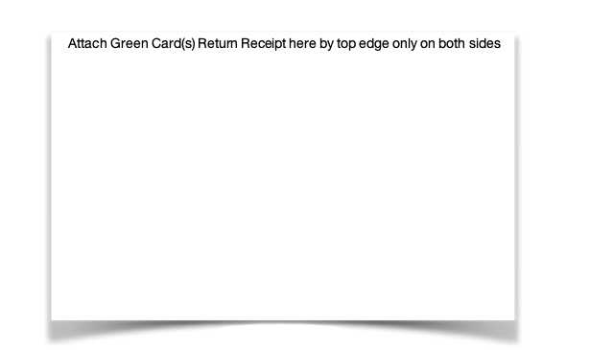
Take all the return receipt cards and attach them to the proof of service document. Glue the cards securely to the paper as if any of the cards fall off the document, they will more than likely be lost forever.
*** Update 2/16/2022***Some counties will not allow you to attach the green cards to the document. They claim the way your paperwork are scanned would cause an issue with the attached cards.
In this case, you will need to make a photocopy of your cards attached to the proof of service, and then get it filled out, with witness signatures
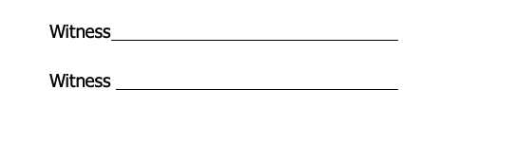
Get two (2) witnesses to sign at the bottom. This certifies that two (2) people can verify that the cards were received on the date on the card, and that it has been at least 22 days since the affidavit was received. So, to reiterate that, the date on this document needs to be at minimum 22 days from the date of your return receipt card.
Note:The Secretary of State office is notorious for not properly stamping the return receipt card with a legible date. Either the stamp wasn't properly used on the return receipt card where the full date is imprinted on it, or they have stamped over a section of the card containing printed text, so the date is illegible. If the date on the card is illegible, you can print off a delivery confirmation page from the USPS site that indicates the date it was received. This is not necessary though.
Download DisclaimerYou agree by downloading this document that no guarantee is given on the efficacy of it's use.
The American Nationals is not responsible for any use or misuse of this document.
You agree that any modifications you do to this document in any form, are done at your own peril and the American Nationals takes no responsibilities for any denial or loss of efficacy of your document.
We are not lawyers nor will we provide legal advice or assistance. Any download and/or use of these documents or papers constitutes that you agree with these terms and can in no way hold the owner of this website nor any affiliates associated responsible.
If you are seeking legal advice, we recommend you contact an attorney.

