Any text highlighted in red indicates text that needs your attention of either changing, or completely deleting the section, depending on the condition.
Some examples of text that needs to be changed is "man/woman". If you are a man you need to change it so it reads just "man".
In order to fill out this document, you need your Certificate of Live Birth, also known as the "Book Copy" or "Long Form" birth certificate

Page 1
Recording requested by (name):  FirstName MiddleName LastName①  After Recording Return To:  FirstName MiddleName LastName①  In Care Of Rural Route Address,  City, State Spelled Out Republic  Zip Exempt Near [Zip Code②] | Recorder’s Use Only

DEED OF FULL RECONVEYANCE
FIRST MIDDLE LAST, FIRST MI LAST, First Middle Last③, as Known and Unknown ENTITIES, under the Birth Registration #birth number⑩ and Linked to Social Security Registration #SSN originating at Birth hospital in City of birth city, birth county County, State④ of birth state and Originally requested by ALL CAPS FATHERS NAME and ALL CAPS MOTHERS NAME⑤ as Parents, Legal Guardians, Signatories, and Trustee(s), And as held in CESTUI QUE VIE Trust dated birth day Day of birth month, birth year and as recorded on the recorded day, Day of recorded month, recorded year⑥ as Local File No. Local File #⑪, of Official Records of Birth county County⑦, Department of Human Resources⑧ of the State④ of birth state, Republic, On and for the behalf of the United States; covering the following described properties:
ALL VARIATIONS OF NAME⑨, and any Other unknown variation thereof;
Having received from holder of the obligations thereunder a written request to reconvey, reciting that all sums secured by the Deed of Trust have been fully paid, and said Deed of Trust and the note or notes secured thereby having been surrendered to said Trustee for cancellation, does hereby RECONVEY without warranty, to the living soul legally entitled thereto, do hereby CLAIM the entire estate, including the minor account, now held by it or by successors, Parent Corporations or subsidiaries of the United Nations, United States, State④ of birth state, or Variations thereof, Shall Convey all Known and Unknown said Trust and Property to;
① - Fill in with your current name as "John Quincy Doe"
② - Leave zipcode in brackets ③ - If you have more than one Birth Certificate, use the first one issued, or first one you know about
④ - Change to 'Commonwealth', if you live in one versus a 'State'
⑤ - Write as "FIRST MIDDLE (MAIDEN) MARRIED", if parents were married at time of birth, otherwise, use your mothers maiden name
⑥ - Your Certificate of Live Birth will have 2 dates on it. Your date of birth, and the date the certificate was recorded. Use the recorded month, day, and year for this value. ⑦ - Change to "Parish", if you live in one versus a 'County'
⑧ - Look at the top of your BC. It may say "department of health and vital statistics" or some other variation. Change this to what your BC specifically says
⑨ - Enter all variations of name in all caps, upper/lowercase, and all lowercase, including middle name initial, and first name initial. If female include both maiden, married and ‘maiden-married’ variations. Include all names through previous marriages as well. This could end up being over a few dozen variations.
⑩ - 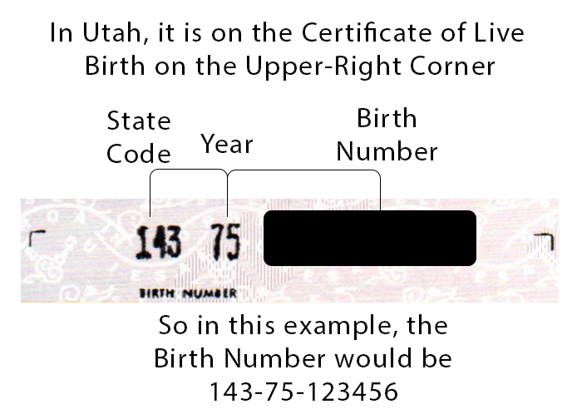
⑪ - 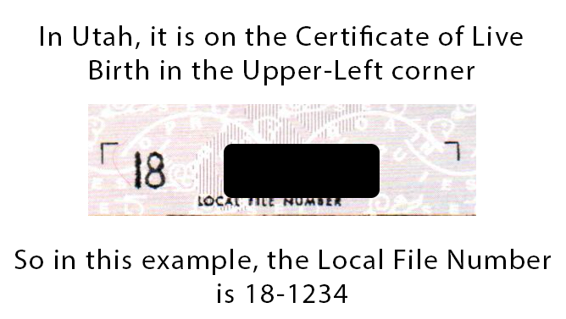

Page 2
IN WITNESS WHEREOF, First Middle Last①, as Trustee, has caused its Autograph as witnessed below.
Date: ___________, day of _______, in the year of our Lord Two Thousand Twenty one FirstName MiddleName LastName②, As trustee Sui Juris, Jus Soli By:_____________________________________________③
① - Use current name on your ID
② - Use current name on your ID
③ - Do not sign until in front of a notary. Sign document in Red

Page 3
_____________________________.①
CAPACITY CLAIMED BY Autograph
as a Living Soul, Sui Juris, Jus Soli
① - Notary will write in here what was used to identify you. This can be any govt. issued ID, like a Drivers License, Passport, etc.

