Getting your passport should only been done after you have recorded your papers correcting your status.  
Get several certified copies of your bundle from the recorders office, as you will hand them one copy with your passport application.  
Once you have your certified copy of your bundle from the recorders office, you can now head to a passport agency to get your passport.

So once you have received your paperwork back from the county recorders office...

Book Appointment with Passport Agency

DO NOT GO TO THE POST OFFICE!

Although it is easiest to just go to your local Post Office, or some other location that does passports, it is critical that you only go to an actual passport agency.

[Click here to find the nearest passport agency to you](https://travel.state.gov/content/travel/en/passports/get-fast/passport-agencies.html)

[Click here to get information about friendly passport agencies](https://americannational.app/agencies)

The reason being for doing this is because of the lost in translation of what you are trying to achieve with your passport application, and including your Affidavit of Repudiation. You want to be able to address any issues with your application right away, with a passport agent, instead of dealing with these issues through the mail, because you used a Post Office. There have been cases as well that a Postal worker does not always include your Affidavit with your application, thus, the State Department will not properly indicate on your passport that you are in fact an American State National.

You will be asked about a reason for requesting an expedited passport. You will tell them you have to travel out of the country. Tell them Canada, or Mexico.

~~Once you have your passport appointment booked, you will now need to book a reservation at a hotel in the country you told the appointment rep on the phone.~~ See update below

Update 10/14/2021

The passport agency will work with what ever date you have booked for a hotel reservation. You should go onto expedia.com, or some similar site, where you can book a hotel room somewhere in Canada or Mexico for free, and has free 24 hour cancellation. It is best to pick a time that you can prepare for a trip to the passport agency. Once you have that booked, now call the appointment number. They will get you an appointment around the time of your reservation

Print out a copy of the itinerary and take with you to the passport office

Existing Passport Holders

~~Important!~~

~~If you currently have a passport, or your passport has expired within the last 5 years, you will need to report it lost  
go here to call the passport office and report it lost~~[https://travel.state.gov/content/travel/en/passports/passport-help.html](https://travel.state.gov/content/travel/en/passports/have-passport/lost-stolen.html) ~~Then you will need to fill out a DS-64 for a lost passport~~<https://eforms.state.gov/Forms/ds64.PDF>

Update 2/14/2022  
We are no longer reporting our current passport lost or stolen. Bring your current passport, in case the passport agent wants to see it but you are requesting to do a new DS-11 to update your information on your passport.  
Passport FeesUpdated 2/21/2021

The current passport fees for those 16 and older is listed below:

* Passport Book: $110 + $35 Execution (Acceptance) Fee
* Passport Card: $30 + $35 Execution (Acceptance) Fee
* Passport Book + Card: $140 + $35 Execution (Acceptance) Fee
* Expedited Fee: $60

The current passport fees for those under 16 is listed below:

* Passport Book: $80 + $35 Execution (Acceptance) Fee
* Passport Card: $15 + $35 Execution (Acceptance) Fee
* Passport Book + Card: $95 + $35 Execution (Acceptance) Fee
* Expedited Fee: $60

These prices are per passport. If you are needing to get an expedited passport for two (2) people, you will be paying to passport fee and expedited fee twice.

[Click here to get the current passport fees](https://travel.state.gov/content/dam/passports/forms-fees/Fee%20Chart%202023.pdf)

Passport ApplicationFollow these steps exactly to get a passport that reflects your status correctly.  
Download the DS-11 from the State Department website [here](https://statenational-downloads.s3.amazonaws.com/documents/ds11.pdf)  
Fill out the application EXACTLY as shown below:  
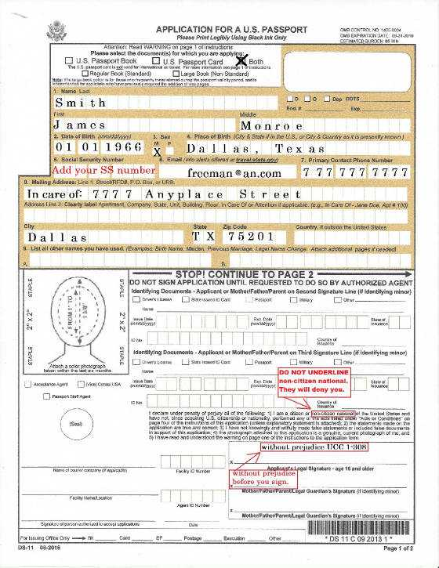  
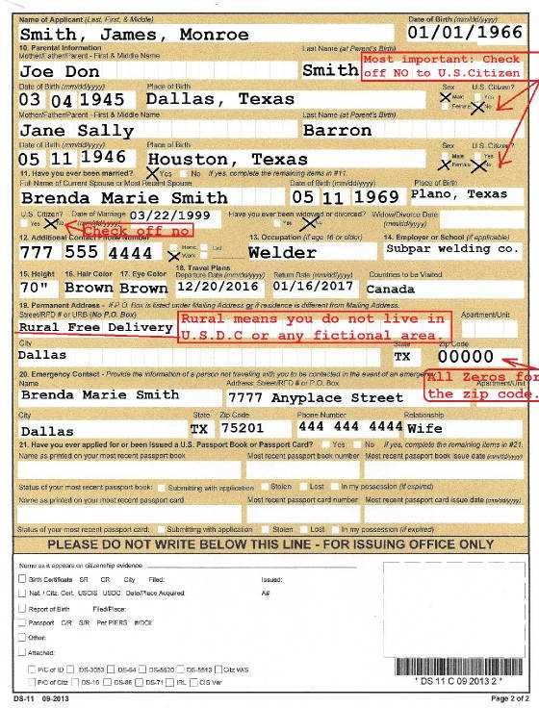  
Do not put down that you are a U.S. citizen on anything. Checking off no to U.S. citizenship does not prevent you from benefits or rights.

Your social security number is voluntary. But again, if you do not put it on the passport application or you will be denied. So it does not hurt you to use it if you need to. But it is a felony for anyone to compel your social security number from you. See... 42 USC 408 A-8. I am told that you can get a EIN number for banking purposes only. Then use that with your passport to get a bank account. Do not give them your SS number when getting an EIN number or it will be denied.

DO NOT SIGN THE APPLICATION. You will not sign the application until you are at the Passport Agency.

Get your passport photo, and a certified copy of your birth certificate, or some form of secondary proof of citizenship, that can be found [here.](https://travel.state.gov/content/travel/en/passports/how-apply/citizenship-evidence.html) In the past, 2 passport photos were required to obtain a passport book and/or passport card. As of this article, the passport agency only requires a single passport photo.

~~Do not give your drivers license as proof of citizenship. This will invalidate the process.~~  
Update 9/7/2022  
If the only picture identification you have is your driver's license, you may use it

Book an expedited appointment with the Passport Agency. At the time of this article, because of COVID restrictions, passport agencies are only allowing a limited number of expedited appointments. It may be difficult to get an appointment, as they fill up quickly. If you are having difficulties getting an appointment, the best thing to do is to wait till midnight for the next day 2 weeks out becomes available, and try and book it.

Once you have your appointment booked at the passport agency, book a reservation at a hotel in Canada or Mexico. Book the reservation 3 days out from your appointment at the passport agency, as the passport agency will want to see proof of your international visit. I recommend booking with Orbitz or Expedia, and book at a hotel that requires no payment up front, and a 24 hour cancellation policy with 100% reimbursement. I recommend booking some place that is driveable, as if you have to fly, they will want to see a flight itinerary.

At the Passport Agency

At the time of this article, Passport Agencies require masks. There is no way around this. Be prepared to bring your own, or take the one offered. You have the right to refuse, and fight it, but you will not be getting your passport. It is best to pick your battles. This is one you will not win.

Approach the 'Information' window when entering the agency. Give a greeting, saying 'Hi', 'how is your day', be pleasant! They will ask what they can help you with. This is where you will state:

*"Here is my application properly filled out, here is my photos and my I.D. here is my reservation for expedited service and here is my Affidavit of Status as a State National defined in USC title 8 sec 1101(a) (21) (23) Please issue me a passport that reflects that reflects that status"*

**Your "Affidavit of Status" is your certified copy of your freedom bundle from the recorders office.  
Be sure to include that with your application and let them know that you are wanting it included with your application.**

Per State Department instructions, those who are nationals and not citizens may include proof of such. This is what we are doing with including the freedom bundle with the application.

When you are asked to sign the application, always put the phrase 'without prejudice UCC 1-308' with your signature.

Sign the application in BLUE ink

You will be asked to come back at 3:00 (or sometime later that day) to pick up your passport.

**They may try to tell you that they do not issue State National passports, and may even hand you a letter, just tell them that is fine, and let them proceed with the process.  
They are correct in saying they do not issue a state national passport. The agent nor agency has anything to do with your status correction.**

Once you get your passport, autograph it with RED ink and place your RED thumbprint on it, touching your autograph

**IMPORTANT**

If you are getting a passport book for child, and both parents cannot appear in-the-flesh at the passport agency, the parent not appearing must provide a signed, notarized letter that you bring with you to your appointment. The letter must detail permission that that parent is aware of upcoming travel plans and consents to them. They must also provide a copy of one form of I.D. for you to take with you to show them.

In lieu of providing birth certificate, you can take a copy of the recorded birth event recorded the Family Records section of the KJV The Bible, that has been signed by 3 witnesses. As well. you could bring an Affidavit of Truth document that assert’s your youngster’s christian name and BIRTHDAY (use this verbage, not date of birth) certifying your son or daughter as a living soul. This document needs to be signed by 2 witnesses.

The State National NON U.S. CITIZEN Passport, has the exact same look, feel, and color as the U.S. CITIZEN Passport. If you look on the first page of the inside cover, it does say that all whom you pass by, "to allow the following National/Citizen" respect, protection, and aid, etc etc. National/Citizen means National OR Citizen; as the Booklet itself nor the Cover does not tell anyone looking at it, WHICH of the two you are. So as you see the passport is already designed to be identical for BOTH Nationals and Citizens.