Follow this process if you are able to trace your genealogy back before 1776.
Your Patent of Nativity is used as evidential proof that your ancestors were on the land and soil of America, prior to the ratification of the forming of the United States of America.

If you are unable to trace any of your ancestral lines prior to 1776, it is recommended that you instead use the Declaration of Status. You can find those papers at the bottom of this article.

So what is the best way to trace your lineage? So a lot of people use familysearch.org since it's free, and a lot of the work may already be done for you. I personally give caution to those using Family Search because of hte high possibility of being inaccurate. I have traced down my ancestry on Family Search only to find quite an alarming number of inaccuracies, to the point where I could not rely on any of it being accurate.

When I traced my lineage, I used Ancestry.com. Some people don't like it because of the time it takes to build out your ancestral line. However, since it's you doing the work, you can rely more on the accuracy. It does take some time though. If you are not wanting to spend the time doing it, or just don't have time, then the fall back would be Family Search. But again, use at your own risk.

The Patent of Nativity is pretty self explanatory. Use a word processing program that you can embed images into the document, and use a picture of yourself in it.

Your ancestral line should be a direct line. So it should look like Parent - Grand Parent - Great Grand Parent, etc.

Get 2 witnesses to sign at the bottom, and include it with the rest of your paperwork you are preparing to get recorded.

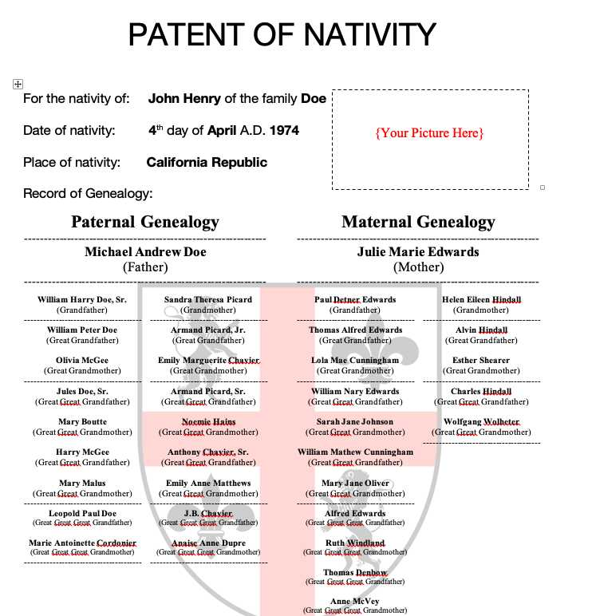

Use the 'Declaration of Status', if you are unable to trace back your genealogy before 1776
Do not use both papers, use one or the other

