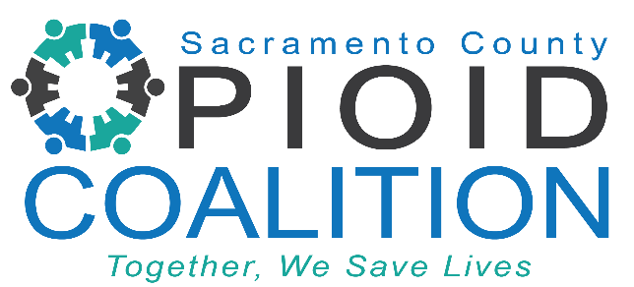

**Sacramento County Opioid Coalition Meeting**

Time: January 13, 2025 02:00 PM PT

[Link Here](https://us02web.zoom.us/meeting/register/tZAtceGrqTkiH9wL4LjZsTWNCC8wfITOAjbR)

Meeting ID: 840 6837 2858

Passcode: 920931

**Mission:** The Sacramento County Opioid Coalition’s mission is to save lives by reducing opioid misuse, overdose, and stigma through community collaboration.

AGENDA

1. Welcome by Facilitators
   * Lindsay Coate, *Co-Chair, Sacramento County Opioid Coalition*
2. Community Updates
   * Lori Miller *LCSW, Division Manager, Sacramento County Department of Health Services, Substance Use Prevention and Treatment*
3. Mental Health First Aid Training Overview
   * Pamela Hawkins, *Health Program Manager, Sacramento County Substance Use Prevention and Treatment Services*
4. P36 – Penalties to Fentanyl Dealers and Impact on the Community
   * Leland Washington, *Principal Criminal Attorney, Supervisor Major Narcotics Unit, Sacramento County DA’s Office*
5. Safer Sacramento Videos