|  |  |  |
| --- | --- | --- |
| DATE | DESCRIPTION | COMMISSION |
| ***Closing on or about***  (Date) | (Sales Price)  *For Real Estate Services related to the Sale of the property listed above.* | (Commission Total)  *Please make check payable to:*  ***Keller Williams Realty Empire.*** |

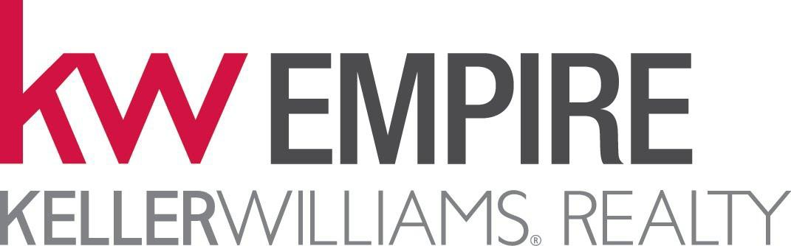

$

8508 Third Avenue, Suite 1

Brooklyn, NY 11209

(718) 954-8400

Keller Williams Lic# 10991210866

ACH/Wire Instructions CHASE Account # 908838191

August 28, 2017

Routing # 021000021

Keep Winning Realty LLC

DBA Keller Williams Realty Empire

RE:

*Thank you for your business*

*It was a pleasure working with you!*