**5 Tips to Help Keep Your Home Secure**

May 2024

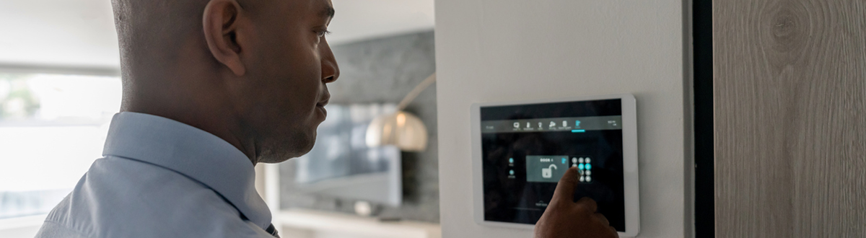

**Whether you’re approaching a busy travel season, will be away from your home more often, or just want peace of mind, securing your home and belongings against burglaries and other types of property crime is always a good idea.**

There are several best practices you can put into place to protect your home and belongings, and some of them can even make you eligible for a discount on your homeowners insurance policy.

**1. Install a security system**

It’s hard to argue against the facts. In a study from University of North Carolina’s Department of Criminal Justice and Criminology, researchers found that 83 percent of burglars took the time to look for a home security system, and, ultimately, another 60 percent said that if there was a burglar alarm in the home, they would choose another target.1

For these compelling reasons, many insurance carriers offer discounts on homeowners insurance if you have a security system in place. If you’re a member of Mutual of Enumclaw and have a security system, you may be eligible.

**2. Make it a habit to lock doors and windows**

Many burglaries don’t require forced entry—around 30 percent of thieves simply walk through the front door.2 You may feel comfortable leaving the front door unlocked during the day or while you’re at home, but this can easily turn into a bad habit. Lock your doors and windows when you’re coming and going, and if you have a full household, make sure everybody makes an effort to lock up after themselves.

**3. Install exterior burglary deterrents**

Use those twinkling lights to your advantage. Burglars typically avoid well-lit homes, so installing lights on your porch, pathways, and over any entrances is a good idea. Motion-activated floodlights are also a great way to discourage potential burglars and alert you to any activity going on outside.

Other outdoor burglary deterrents include signs or stickers announcing you have a security system. Even security cameras mounted in obvious spots can drive away potential thieves.

**4. Maintain your landscaping**

To prevent home break-ins, your landscaping should balance privacy with visibility. Any overgrown hedges or shrubbery that blocks sight of your entrances provides cover for potential thieves as they figure out how to get into your home. Keep trees trimmed so burglars can’t climb them to get to your second-story windows, and maintain your landscaping in a way that allows neighbors to spot anything fishy going on.

**5. Keep your home inventory list updated**

This is an important step in protecting your home and belongings that people often let slide. As you make significant purchases or receive inherited items, you should [**update your home inventory list**](https://www.mutualofenumclaw.com/helpful-resources/home/home-inventory) to reflect those acquired belongings. Your homeowners insurance agent can use this list to assess your coverage needs, and in the event that your home is burglarized, you can lean on that list to help make the claims process smoother.