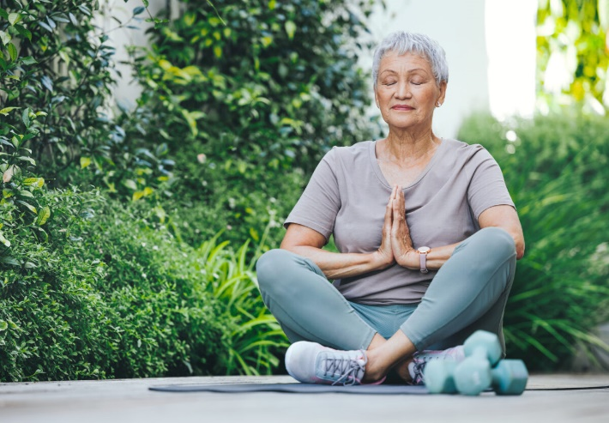

*Published: December 1, 2022*

**6 Self-Care Habits to Start the New Year Off Right**

**Deb Hipp**

The last few years have been a bumpy ride for many Americans due to the pandemic, rising inflation and other stressors. As the new year begins, many of us are eager to find ways to enhance our overall physical and mental [wellness](https://extramile.thehartford.com/wellness/).

By adopting self-care habits, you can tap into optimism, relaxation and a more positive outlook. Practicing self-care regularly can also help you manage stress, lower your risk of illness and boost energy, according to the [National Institute of Mental Health](https://www.nimh.nih.gov/health/topics/caring-for-your-mental-health).

Not sure how to start adding self-care habits to your daily routine? Find inspiration in these practices you can adopt to start enhancing your life this year.

1

**Practice Gratitude**

It’s easy to get caught up in the chaos of daily life. Making a habit of practicing gratitude can help train our brains to notice the positive rather than focusing on the negative aspects of life.

Feeling gratitude on a regular basis can boost immunity, reduce risk for depression and anxiety, and lead to a better night’s sleep, according to the [Mayo Clinic](https://www.mayoclinichealthsystem.org/hometown-health/speaking-of-health/can-expressing-gratitude-improve-health). Taking time to be grateful may also lower the risk for disease and help ease chronic pain.

To get started on your gratitude practice, all you need is a spiral notebook and a few minutes a day. Write down five to 10 things you’re grateful for each morning. Your gratitude list might include items small or large, such as “I’m grateful that the sun is shining today,” “I’m grateful for my good health,” or “My coffee is delicious.”

Want a double dose of daily gratitude? Try writing a second gratitude list before going to bed to put positive thoughts in your mind before you drift off to sleep.



2

**Restore Body and Mind with Massage**

Getting a monthly massage can be a great self-care habit to start the new year off right.

The benefits of massage are many, according to the [Mayo Clinic](https://www.mayoclinic.org/healthy-lifestyle/stress-management/in-depth/massage/art-20045743), and may include:

* Stress, tension and muscle pain relief
* Relaxation
* Improved immune function
* Lowered blood pressure
* Reduced anxiety
* Better sleep

To reinforce your dedication to this new self-care habit, consider signing up for a monthly subscription at a local massage studio. That way, you’ll get in at least one massage a month, with possible discounts on additional massages.

If the cost of a massage is prohibitive, check with local massage schools for discounts on massages performed by students. You can also look into self-massage techniques using foam rollers, tennis balls, massage guns, massage chairs or other massage tools.

3

**Enjoy Daily Walks**

By taking one [30-minute walk](https://extramile.thehartford.com/wellness/fitness/walking-exercise/) a day, you’ll meet the Centers for Disease Control’s [minimum recommendation](https://www.cdc.gov/physicalactivity/walking/index.htm) for at least 150 minutes of moderate-intensity aerobic activity per week.

In addition to providing time to clear your mind, walking daily can help you lose or maintain weight, ease joint pain and boost immunity, according to [Harvard Health](https://www.health.harvard.edu/staying-healthy/5-surprising-benefits-of-walking).

Daily walks could even potentially add years to your life. One [study](https://jamanetwork.com/journals/jamanetworkopen/fullarticle/2783711) found that adults who walked at least 7,000 steps a day experienced a 50 percent to 70 percent lower risk of all-cause mortality compared to adults who walked fewer than 7,000 steps per day.

You don’t have to walk alone, either (unless you want to). Ask a neighbor to join you on daily walks, or join a walking group that meets one or two times a week to build a social aspect into your routine.

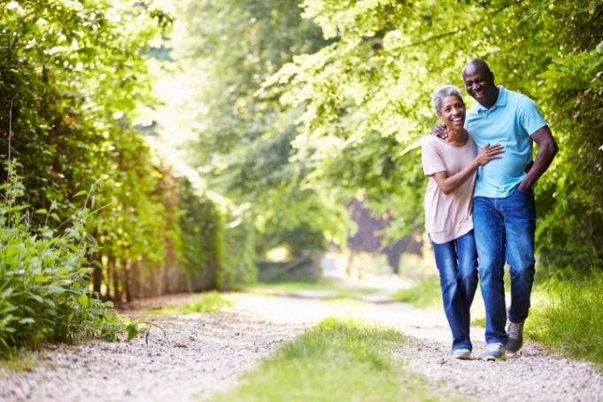

4

**Get a Good Night’s Sleep**

Getting enough [sleep](https://extramile.thehartford.com/wellness/sleep/improve-sleep-quality/) each night is essential to maintaining good physical and mental health. An adequate amount of sleep can help you maintain a healthy weight and avoid diseases such as diabetes and heart disease, according to the [Office of Disease Prevention and Health Promotion](https://health.gov/myhealthfinder/healthy-living/mental-health-and-relationships/get-enough-sleep).

People in their 50s and 60s who don’t get at least six hours of sleep each night may also be [more likely to develop dementia](https://www.nih.gov/news-events/nih-research-matters/lack-sleep-middle-age-may-increase-dementia-risk) as they age.

If you struggle to fall asleep or sleep through the night, you can take steps to stave off insomnia. Try avoiding caffeine in the evening and turning off your phone, laptop and other blue-light-emitting devices at least one hour before bed.

Does your mind race with thoughts the moment your head hits the pillow? Learn to let thoughts go by focusing on taking 10 deep breaths with long exhales. This signals to your body and mind that it’s time to relax and restore with a good night’s sleep.

A white noise or nature sounds sleep machine may also help you fall asleep faster. You can also download a sleep, meditation or relaxation app to your phone for guided assistance.

5

**Join a Fitness Class**

Going to the gym at least a few times a week does more than help with your physical fitness. There are social benefits, too—especially if you participate in group exercise classes such as yoga or aquatics.

Fitness classes provide an opportunity to meet new people and make new friends. Just being around people on a regular basis can boost your mental health, especially if you’re retired and lack a structured social network. Socializing regularly can also decrease feelings of loneliness and help keep your mind sharp as you age, according to the [Mayo Clinic.](https://newsnetwork.mayoclinic.org/discussion/mayo-clinic-minute-the-benefits-of-being-socially-connected/)

In addition to cardio workouts, incorporate two or three days of strength training using weights, your body weight or resistance bands to build muscle and keep bones strong as you age. By participating in this regular self-care regimen, you’re taking good care of both your body and mind.

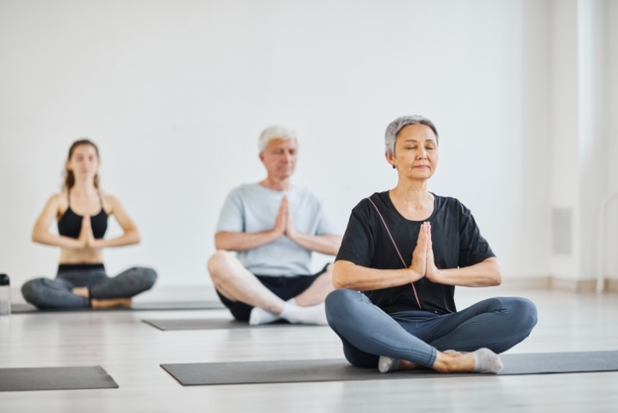

6

**Perform Random Acts of Kindness**

Performing a daily random act of kindness doesn’t just benefit the recipient. When you’re kind to others, [your actions can also impact your own body and mind](https://www.mayoclinichealthsystem.org/hometown-health/speaking-of-health/the-art-of-kindness).

Being kind to others can:

* Increase self-esteem
* Boost serotonin, dopamine and feel-good endorphins to improve mood
* Decrease levels of the stress hormone cortisol
* Lower blood pressure

The best part about this self-care habit is that it’s easy: Hold the door for someone. Smile at people on the street, in the coffee shop or at the grocery store. Compliment a customer service employee for their service.

The kinder you are to others, the better you’ll feel about yourself. Plus, the recipients of your kindness may be inspired to pay it forward, creating a ripple effect of kind acts.