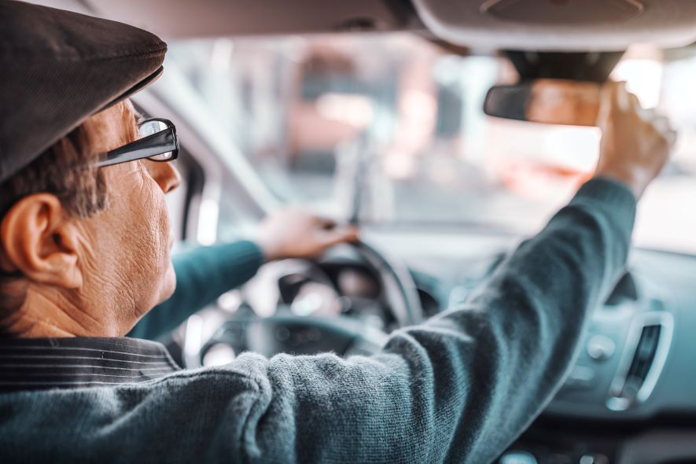

**Auto**Maintenance

Why Is My Check Engine Light On?

Deb Hipp

Maybe you once sang along with Meatloaf’s “Paradise by the Dashboard Lights” song without considering what those lights meant. Of course, now you know that your vehicle’s dashboard warning lights serve an important function that goes well beyond just a backdrop for nighttime auto romance.

It may seem daunting to decode all those symbols and colors alerting you to potential safety hazards, mechanical issues or even minor things that need attention. Fortunately, you don’t have to be baffled by dashboard warning lights.

This guide to seven important dashboard lights can give you a jump start on the road to [safer driving](https://extramile.thehartford.com/auto/driving/driving-wellness-2/) and help you stay on top of vehicle maintenance and repairs.

What Do Dashboard Alert Colors Mean?

Warning symbols differ among makes and models, but dashboard lights typically appear in three or four different colors, each signaling the level of urgency.

* Green or blue lights notify that certain features of your car — cruise control or headlights, for example — are active and working properly.
* Yellow or amber lights often signal a less urgent potential safety issue or hazard, such as a prompt to engage traction control on icy roads or air up tires.
* Red warning lights can indicate a serious problem with important auto components such as the engine or transmission.

Dashboard Warning Lights Guide

While dashboard lights vary depending on the type of car or truck, below are seven warning lights that should catch your attention.

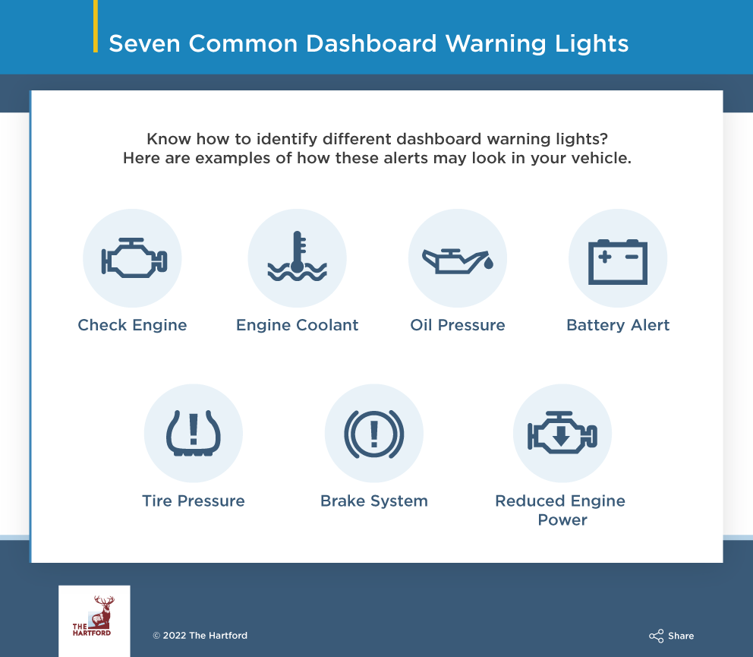

1. Check Engine

When the [check engine light](https://www.caranddriver.com/features/a35865614/dashboard-warning-lights-explained/) appears and stays on, the warning can signal a serious problem with your car’s engine. But the warning light can also come on due to minor issues such as a loose wire or gas cap not being fully closed.

**What to do:**Don’t ignore your vehicle’s check engine light and never continue driving when this light comes on if it’s accompanied by worrisome noises or other obvious problems. Even if your car displays no other symptoms of an engine issue, visit your mechanic for a full diagnostic test to get to the source of the problem.

2. Engine Coolant

This red warning symbol often appears when your car’s engine overheats due to running out of engine coolant (antifreeze). The engine temperature light may also indicate other serious issues that can create problems in need of repairs.

**What to do:**Don’t ignore this important warning, or your vehicle’s engine could sustain major damage. Pull over, and let the car cool down for 15 minutes without popping the hood to avoid steam burns and injuries. Call roadside assistance for a coolant top-off or a tow to your auto mechanic to check out the problem.

3. Oil Pressure

That dripping oil can icon might simply let you know that you need to top off your engine’s oil supply. But this warning can also indicate serious issues, including an engine leak or a broken piston ring or oil pump. Ignoring this dashboard warning and continuing to drive without checking it out can lead to significant repair bills.

**What to do:**Check your oil with the engine dipstick, adding more if necessary. If topping off the oil doesn’t shut off the warning light, take your vehicle to a mechanic for a checkup.

4. Battery Alert

The battery warning light appears when there is an issue with your vehicle’s charging system, including the battery itself or other electrical components such as wiring or the alternator. Ignoring this light could leave you stranded with a car that won’t start.

**What to do:**Most auto parts stores will check your car’s battery for free and replace a drained battery when you purchase a new one. For a full battery and electrical system check, make an appointment with your mechanic to rule out other electrical issues.

5. Tire Pressure Monitor

This amber, partial circle with tire tread at the bottom and an exclamation point inside lets you know when tire pressure is low or overinflated, which can affect driving safety and fuel consumption. The gauge could also display each tire’s air pressure.

**What to do:**Pull into a service station to check the pressure of each tire. Refill air in the affected tires to the recommended pressure level displayed in your owner’s manual or listed on your driver’s side door.

6. Brake System

The brake system warning light can appear if you try to pull out while the parking brake is still engaged. But the alert can also signal serious brake problems that may need to be repaired or replaced or an issue with the vehicle’s anti-lock braking system.

**What to do:**Disengage the parking brake if that’s the reason the light is on. If the light continues to glow, visit a mechanic for a thorough brake inspection.

7. Reduced Engine Power

This [warning light](https://www.t3atlanta.com/blog/car-tips/reduced-engine-power-warning-light/) alerts you to problems with air or fuel flow to the engine. The reasons could be as simple as an air filter that needs replacing. But the light can also indicate low oil pressure, leaks in hoses or engine performance issues in need of repair.

**What to do:**Take your vehicle to a mechanic for a diagnostic test to locate causes.

Review Your Owner’s Manual

This list covers some of the most important dashboard lights and notifications. However, there are many additional alerts to pay attention to, including low fuel, door ajar, low windshield washer, power steering, airbags and more.

Take a few minutes to look up your car’s dashboard lights and manufacturer recommendations in the vehicle’s owner’s manual. That way, you’ll know how to gauge warnings and notifications and when to visit a mechanic.