 |  |  | 731 Berkshire Rd.  Southbury, CT. 06488 | (203) – 565 - 6435  Chandlerj@wcsu.edu jchandlerartistry@yahoo.com  www.JChandlerArtistry
Janelle Chandler |  |  | I aspire to be a Professor of Visual Arts in a program that is culturally and ethnically diverse. A program that not only educates, but also supports opportunities to interact and grow with students and faculty alike through community projects and engagement.
- Curriculum Vitae |  |  | 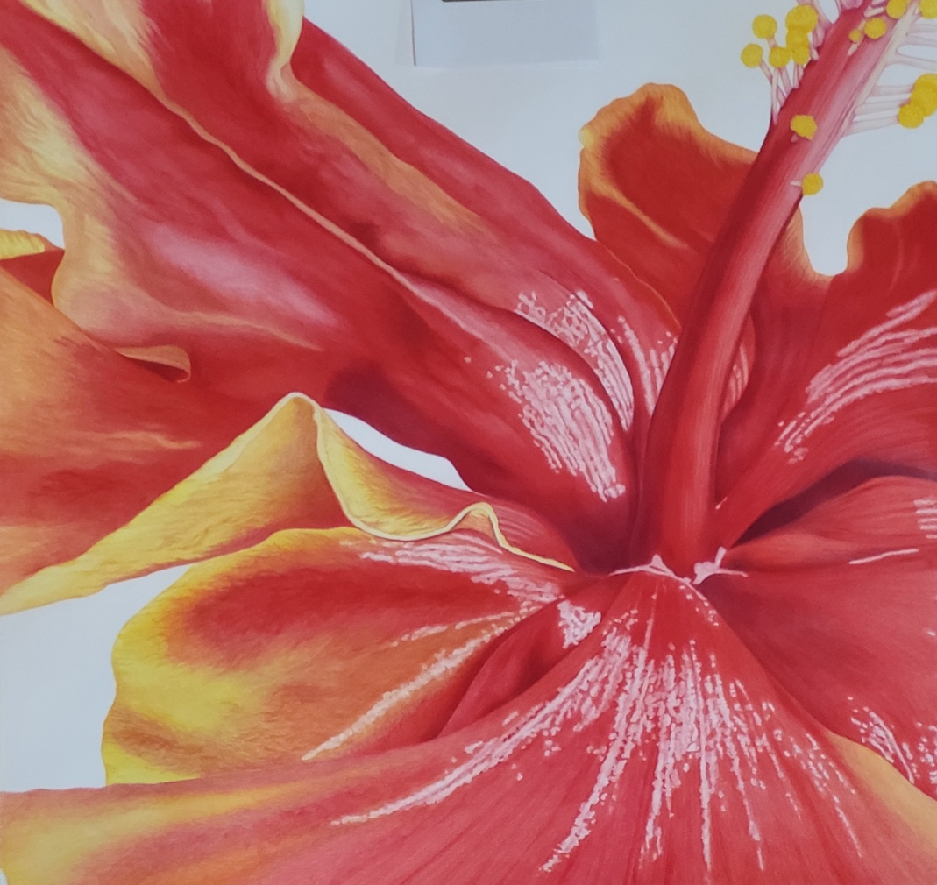
Specialized Training & Skills  Online teaching certificate  inc. Blackboard and Kaltura  Microsoft Office  Adobe Products  Botanical Illustration  Painting  Colored Pencil  Memberships  Society of Botanical Artists UK DipSBA-Dist (SBA-UK)  Society of Botanical Artists USA  (SBA-USA)  New England Society Botanical Artists (NESBA)  Botanical Art Society of the National Capital Region (BASNCR)  Colored Pencil Society or America (CPSA)  American Women Artists  (AWA)  Colored Pencil Society UK  (CPSA-UK)  These memberships consistently have training in person and online. I use these memberships to further my skills and personal development. Topics range from artistic techniques, teaching methods, business financials, community projects and more.  Communication  Excellent, and timely communicator, in person or via written correspondence.  Leadership  Ability to manage several projects simultaneously and effortlessly. Often working solo as a small piece to a bigger puzzle where I must take charge of my own work and then integrate said work with the work of others for everyone’s benefit. Sound leadership is dependent on teamwork. |  |  | Education  Society of Botanical Artists UK Jan. 2021 – May 2024  Distance Diploma: Botanical Illustration  Western Connecticut State University Aug. 2020 – May 2022  Master of Fine Art: Illustration  Western Connecticut State University Aug. 2017 – May 2020  Bachelor of Fine Art: Major Illustration, Minor Photography  Tunxis Community College Aug. 2013 – Aug. 2017  Associate of General Studies  Housatonic Community College Aug. 2005 – May. 2010  General Studies  Naugatuck Valley Community College Aug. 2000 – May 2005  General Studies  Experience  Aug 2023 – Present - Adjunct Professor – Western Connecticut  State University, Danbury, CT.  Instructor of Foundation Art courses, Drawing I, 2D Design. Responsible for teaching a range of courses, evaluating, assessing and supporting students. Develop curriculum in accordance with course descriptions. Tailor class subject matter and or materials for students with accessibility needs to ensure their experience is equally encompassing as it is for other students. Maintaining detailed records of student communications and work. Making time and space to display student work and provide constructive, positive feedback to keep students engaged and heading in the direction of learning objectives. Large focus on fostering a sense of community within the classroom and in the department.  Sept. 2024 – Present - Art Instructor – NYC Parks, New York, NY.  Lead weekly classes in varied art subjects at Park & Rec facilities in Manhattan and Harlem. Each class is 2hrs long and provides an in-depth lesson followed by an assignment. I continually work with each student and provide feedback to ensure an understanding of the material and to provide the student with a sense of accomplishment. Students had a wide range of skill sets from beginner to advanced. Class size has ranged from 5 – 80 students, effective time management is crucial in these classes.  April 2024 – Present - Art Instructor – Katonah Village Library, Katonah, NY.  Leads series-based workshops within class and out of class content. Classes offered to date: Drawing from Nature and Journaling, Pen and Ink, and still life Drawing. Majority of the students are advanced students.  Feb. 2025 – Present - Art Instructor – Hammond Japenese Stroll  Museum, North Salem, NY.  Leads workshops based on museums requests. Classes offered to date: Botanical Illustration with botany in colored pencil. Wide range of student abilities are catered to. Students are offered out of class assignments with feedback given to further add to their experience and learning.  April 2023 – Present - Artist Workshop instructor – Red Clover Farm, Seymour, CT.  Led cross functional workshops on a farm to share relationships between art and farm products. Each class was a 2hr intensive study of either a botanical study, fruit or vegetable, or landscape of the farm. All skill levels taught.  April 2023 – May 2024 - Artist Workshop Instructor – Art in Common, Ridgefield, CT.  Led workshops to students of all ages in all ability levels. In the classroom and out in the field. Subjects offered: Nature Sketchbooking, Colored Pencils 101, Intro to Color Theory.  Aug. 2020 – May 2022 - Graduate Assistant – WCSU – Danbury, CT.  Teaching assistant for Foundation classes. Classes assisted Drawing I, 2D Design, and Color Theory. Worked closely with Dept. Chair, Professor Ken Scaglia to present fun and engaging content online and in person amid the Covid crisis and after. This experience was monumental in making me a well-rounded instructor who can teach in multiple formats on the fly if need be. Thinking outside the box was crucial and flexibility was essential.
Exhibitions

2025 - Solo Exhibition – Katonah Village Library, Katonah, NY.

2025 - Group Exhibition – Hammond Japenese Stroll Museum, North Salem, NY.

2024 - Tiny Works Exhibition - Gloria Cachion Art Gallery, Southbury, CT.

2023 - Alumni Exhibition – WCSU, Danbury, CT.

2023 - 100 for 100 Exhibition – WCSU, Danbury, CT.

2023 - Solo Exhibition – Art in Common, Ridgefield, CT.

2023 - Solo Exhibition – Gloria Cachion Art Gallery, Southbury, CT.

2022 - Group Exhibition – View Arts Center, Old Forge, NY..

2022 - Solo Mural Unveiling – Danbury Fair Mall, Danbury, CT.

2022 - MFA Thesis Exhibition – Blue Mountain Gallery, New York, NY.

2022 - MFA Thesis Exhibition – WCSU, Danbury, CT.

Publications & Media

Southbury News: Aug 1, 2023
https://www.southbury-ct.org/news-feed/?FeedID=8563

Southbury Library to Showcase Artwork of Botanical Illustrator: July 2023
https://www.primepublishers.com/voicesnews/arts_and_living/antiques_and_art_gallery/southbury-library-to-showcase-artwork-of-botanical-illustrator/article_d40fd9f6-2b30-11ee-9f53-bfd50e28c380.html

Mural Unveiling at Danbury Fair: July 2022
https://www.hamlethub.com/southbury-connecticut/5857-wcsu-student-artists-murals-at-danbury-fair-mall-reveal-dates-announced

Danbury Fair Mural time lapse promo video: July 2022
https://www.youtube.com/watch?v=VcwLYPnHTx8

Review of thesis show: Efflorescence, the Sea, and Sacred Geometry: March 2022
https://www.galleryand.studio/2022/10/06/efflorescence-the-sea-and-sacred-geometry/

WestConn MFA graduates exhibit their art at Chelsea gallery in NYC: June 2022
https://www.newstimes.com/things-to-do/article/WestConn-artists-exhibit-NYC-gallery-17237972.php

Bethel, Bristol and New Haven MFA artists to exhibit in NYC gallery: June 2022
https://news.hamlethub.com/danbury-connecticut/49709-wcsu-m-f-a-original-artwork-to-be-shown-in-new-york-art-gallery-june-21-july-9

