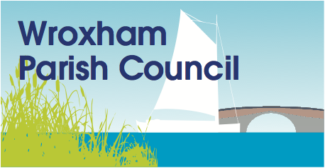
Wroxham Parish Council Finance Committee
Terms of Reference
The primary objective of the Finance Committee is to assist the Parish Council in overseeing the proper financial management, financial risks, management strategy, internal and external audit, policy and transactional matters. This includes the preparation of the annual budget and making recommendations on major financial transactions and the annual Precept to full Council.
The Committee will meet as called by the Clerk/R.F.O, on a monthly basis. It will consist of five members; the Chair is an ex-officio member. Other Councillors may attend but will not have voting rights. A quorum will be three councillors present.
The committee has decision making authority from the Council and will report to Council with monthly minutes that record all decisions made.
Work undertaken at Committee will include, but is not exclusive to the following;
- Annual estimates of expenditure and income and control & monitoring of the Council’s approved budget throughout the year, including the monitoring of CiL money.

- Recommendation of precept to full Council.

- To review insurance of all the Council’s property and liabilities.

- Tendering and purchasing arrangements – to review all policies governing process.

- Appointment of an independent Internal Auditor and monitoring of the audit process.

- Maintenance of adequate systems of internal control and internal audit.

- Review of annual financial reports, ensuring evidence of adequate systems of internal control and audit throughout the year and presentation for external audit.

- Develop and monitor the Council’s Risk Management Strategy.

As per the Financial Regulations the Committee is not empowered to delegate certain specified decisions. The following matters will be a matter for Full Council decision only:
- setting the final budget or the precept (council tax requirement);
- approving accounting statements;
- approving an annual governance statement;
- borrowing;
- writing off bad debts;
- declaring eligibility for the General Power of Competence; and
- addressing recommendations in any report from the internal or external auditors,
- any single purchase or contract with a value over £5,000,
Draft minutes will be available to the next full Parish Council meeting and will be ratified at the next Finance Committee Meeting.
Clare Male, Clerk & RFO
Updated & agreed: 28th March 2018
Review date: April 2019

