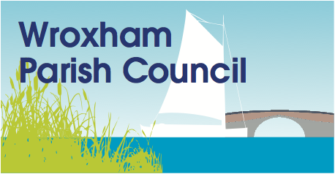

Greater Norwich Local Plan (GNLP) – March 2018 consultation responses
Thank you for your representation and comments which we received as
follows:
Representation ID: 13180
Document: Site Proposals document
Section: Broadland, Broadland - Wroxham, GNLP0041
Support/Object: Comment
The village does not require another speculative development of larger
family detached dwellings. Wroxham is overwhelmingly chosen by its
residents as a retirement village and has a population substantially older
than most similar sized communities in the GNLP area. We have an urgent
demand for retirement properties, bungalows and apartments in the village
for existing residents to downsize into while they remain in the village.
This would help free up sizeable properties in the heart of Wroxham
currently occupied by one or two elderly people. This site would be ideal
for this purpose.
--------------------------------------------------
Thank you for your representation and comments which we received as
follows:
Representation ID: 13181
Document: Site Proposals document
Section: Broadland, Broadland - Wroxham, GNLP0504
Support/Object: Object
A development on this scale is unsustainable. This would represent a 50%
increase in Wroxham properties already with minimal infrastructural
support. It would further increase traffic movement on the A1151 measured
by our equipment at 5.5 million vehicle movements per year leading to
reduced air quality and unacceptable traffic congestion and split the
village community in two. It would threaten the iconic nature of Wroxham as
the historic capital of the Broads. The location could be better used for
public open space giving the local area and the village a much needed
amenity.

