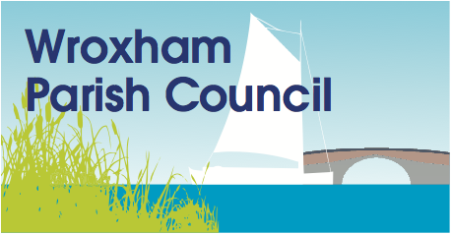

GNLP response to Regulation 18, stage B consultation on new, revised and small sites.
2131 – east of Wherry Garden
It remains the Parishes wish that any development should be to the west of Salhouse Road and south of Wherry Gardens.
Firstly to create a more viable community for Wherry Gardens by the creation of additional public spaces, community facilities and a public crossing as part of this scheme. The Council would insist on the relocation of the existing 30mph zone on the Salhouse Road to sit outside the boundary of this proposed development. This would enhance the public realm in the southern end of the village.
Secondly as the Wroxham Neighbourhood Plan identifies (COM1 & ENV4), this area forms part of the character of the village. The vistas in this area are characteristic of the Norfolk Broads.
Thirdly any development east of Salhouse Road would create an unsustainable increase in traffic for The Avenue which is barely a single track road. See Neighbourhood Plan policy TRA1.

2135 – south of Wherry Gardens
Firstly to create a more viable community for Wherry Gardens by the creation of additional public spaces, community facilities and a public crossing as part of this scheme. The Council would insist on the relocation of the existing 30mph zone on the Salhouse Road to sit outside the boundary of this proposed development. This would enhance the public realm in the southern end of the village.
Secondly as part of the Neighbourhood Plan consultation there was strong public support for development to take place south of Wherry Gardens (pp23).
12th December 2018

