TRAFFIC ANALYSIS REPORT SAM 2A (Serial Number HR-BT-10565), 28th March 2025

For Project: 28.03.25 SAM 2A
Project Notes/Address: Salhouse road facing traffic from Salhouse
Location/Name: Incoming
Report Generated: 28/03/2025 21:22:24
Speed Intervals = 5 MPH
Time Intervals = 5 minutes

Traffic Report From 28/02/2025 13:00:00 through 28/03/2025 14:59:59

85th Percentile Speed = 35.3 MPH
85th Percentile Vehicles = 42,682 counts
Max Speed = 70.0 MPH on 07/03/2025 16:55:30
Total Vehicles = 50,214 counts
AADT: 1788.0

Volumes - weekly vehicle counts
Time 5 Day 7 Day
Average Daily 1,821 1,736
AM peak 8:00 to 9:00 171 147
PM peak 5:00 to 6:00 161 142

Speed
Speed limit: 30 MPH
85th Percentile Speed: 35.3 MPH
Average Speed: 29.2 MPH

Monday Tuesday Wednesday Thursday Friday Saturday Sunday
Count over limit 2941 2967 3122 3011 3130 2649 2211
% over limit 40.7 39.6 40.1 39.6 39.5 40.1 39.6
Avg speeder 35.2 35.1 35.2 35.2 35.1 35.1 35.0

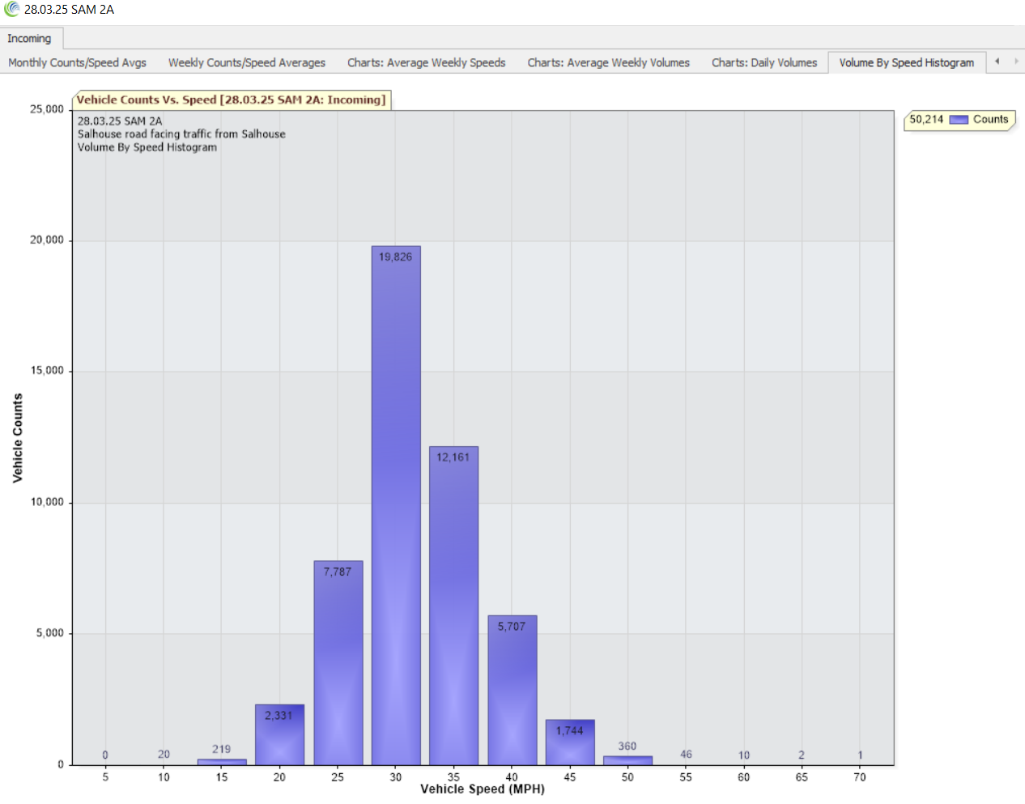3

