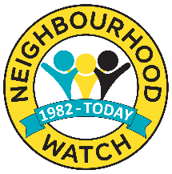
Cheshire Neighbourhood Watch Association
Committee Nomination Form
Cheshire Election 2023
Form to be returned by midnight Friday 27th October 2023

If you wish to be put forward as a CNWA Committee Member in the forthcoming election please complete the Nomination Form below. Nominations must be accompanied by two references (excluding family members) from either of the following:
- Your current scheme members
- A colleague from an organisation you have been involved with or have worked for.

Please provide your referees with a copy of the Role Profile.
To The Nominee:
In line with the CNWA constitution, I confirm I have read, understood and accept the role and responsibilities associated with becoming a CNWA committee member.
Name
Contact Phone No.
Email Address
In order for your application to be considered by all voting members in your CNWA Group Area, please detail your skills and experience below e.g. membership of other committees, volunteering, work/other experience. Details will be circulated to CNWA voting members. Return your completed form to: cheshirenw@outlook.com
(100 words max)

