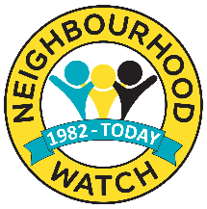
Cheshire Neighbourhood Watch Association
Committee Member – Role Profile

Role of a CNWA Committee Member (Association Officer)
The Committee focuses on the strategic direction of the CNWA and promotes the running of effective Watch Schemes to achieve the aims of the Association. They engage with members to represent their views and promote partnership working with the Neighbourhood Watch Network, Cheshire Constabulary and other community safety organisations. The Committee works in a strong partnership with Cheshire Constabulary to ensure the effective management of membership data.

Commitment
We estimate Committee representation will take the equivalent of half a day per month.
As well as committee meetings, there may be sub-committees, with authority delegated to them by the committee, meeting at other intervals. Occasionally you may be asked to represent the CNWA at outside meetings with potential influencers, or funders, or work alongside volunteers at other events.

Key Responsibilities
To formulate a strategic direction for Neighbourhood Watch in Cheshire based on guidance from the national Neighbourhood Watch Network, Cheshire Constabulary, the Police and Crime Commissioner and other community safety organisations. Association Officers will ensure the brand and members’ data are managed effectively and consult with members.

Tasks
Attending committee meetings (up to one per month), the annual Cheshire AGM and at least one local member coordinator meeting per year and engage in various activities to consult with members e.g. Ad hoc member communications, face to face, AGM, raising awareness of Neighbourhood Watch in Cheshire, etc.

