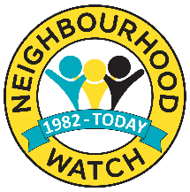
Cheshire Neighbourhood Watch Association
Committee Nominee Supporting Reference Form
Cheshire Elections 2024

To the Referee:
Please read the Committee Role Profile and complete the form below, to tell us why you think this person is a suitable candidate e.g. membership of other committees, volunteering, work/other experience and return to the Nominee. NB Nominees must forward all forms to the CNWA Secretary no later than Friday 25th October 2024.

Nominees Name (Candidate)
Your Name
Your email
Neighbourhood Watch Scheme Name, or road you live in, or organisation you belong to
How do you know the Nominee?
How long have you known the Nominee?

(100 words max)

