
Cheshire Neighbourhood Watch Association
Week ending 21st December 2025
Cheshire News & Appeals
Latest Cheshire News
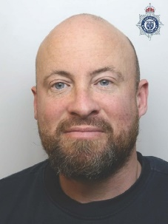
Man sentenced after campaign of harassment against victim
A man who harassed his ex-partner and repeatedly breached a Non-Molestation Order has been jailed.
John Broadhurst-Dodd appeared at Chester Crown Court on Friday 19 December where he was sentenced to 37 months in prison and handed six restraining orders against him. The 40-year-old, of Bunbury Lane, Bunbury, pleaded guilty to harassment with fear of violence and breaching a Non-Molestation Order at earlier hearings.
The court heard how the victim had previously been in a relationship with Broadhurst-Dodd, who had displayed volatile behaviour and had made numerous attempts to contact her after their relationship ended. In May 2024, Broadhurst-Dodd was served with a Non-Molestation Order prohibiting him from communicating with the victim. But, despite this, he continued to contact her, using all possible methods of communication, which included making disguised social media accounts, and withheld calls, of which 14 numbers were attributed to Broadhurst-Dodd as being used to contact the victim. In one of Broadhurst-Dodd’s calls to the victim, he threatened to shoot and kill her, leaving her fearing for her safety.
Broadhurst-Dodd, after pleading not guilty at the first hearing, pleaded guilty on the first day of his trial, admitting to further behaviours, such as making indirect comments to her online and also having organised for a family member to make a call to the victim’s place of work. Broadhurst-Dodd did not stop at this, when in January 2025, the victim awoke to find a baby goat had been tied to a fence at the side of her house. Broadhurst-Dodd later phoned the victim and confessed to her that he’d arranged for the delivery of the animal as she ‘loved goats’. Detectives were unable to trace the original owner of the goat delivered to the victim’s address but were able to confirm that the animal was safe and well, having been adopted by a local farmer.
Broadhurst-Dodd was arrested and interviewed in February 2025 by officers from Cheshire Police’s dedicated stalking investigating team – The Harm Reduction Unit. Following questioning, he was later charged with stalking involving serious alarm/ distress and breaching a Non-Molestation Order. However, upon appearing in court, the Crown Prosecution Service accepted a plea for a charge of harassment with fear of violence. Whilst Broadhurst-Dodd was remanded in custody, the Harm Reduction Unit successfully obtained an interim Stalking Protection Order protecting the victim and requiring him to wear a GPS tag should he have been released from custody.
Following the sentencing, investigating officer PC Morgan Eyre said: “I welcome the sentence handed to Broadhurst-Dodd today by the court. I wish to thank the victim in this case for their courage throughout this investigation, and I hope this sentence allows them to finally rebuild a life that was damaged by Broadhurst-Dodd for too long. Broadhurst-Dodd believed he was invincible to any order placed on him, which he continuously breached throughout his course of conduct. Broadhurst-Dodd’s actions towards the victim were escalating in nature prior to him being remanded, making the victim fear for their safety. I also wish to acknowledge each and every officer who worked tirelessly on this case, leading to Broadhurst-Dodd pleading guilty on the first day of trial due to the amount of overwhelming evidence against him.”

Three men jailed for cross-border burglary series
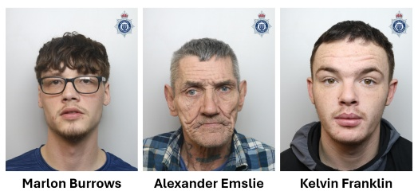
Three men have been jailed for a combined total of over 17 years following a complex investigation into their involvement in a burglary series across Chester, Ellesmere Port and Wirral.
Kelvin Franklin, Marlon Burrows and Alexander Emslie appeared at Chester Crown Court on Friday 12 December 2025, where they were sentenced. Frankiln, 24, of no fixed address, was sentenced to seven and a half years imprisonment. He was also handed a ten-year Criminal Behaviour Order. Burrows, 24, of Maud Street, Liverpool, was jailed for seven years and four months and was handed a ten-year Criminal Behaviour Order. Emslie, 64, of Birchmuir, Chester, was handed a two-and-a-half-year custodial sentence.
Franklin and Burrows admitted conspiracy to commit burglary, conspiracy to steal motor vehicles, being concerned in the supply of class A drugs (heroin and crack cocaine) and the possession with intent to supply heroin and crack cocaine. Emslie admitted to being involved in one burglary, conspiracy to steal and allowing his home to be used for the distribution of class A drugs.
The court heard that Cheshire Police launched a cross-border investigation, known as Operation Hijacker, in relation to a series of burglary and car thefts that occurred between Tuesday 18 February and Sunday 23 February 2025. Franklin and Burrows had subsequently been identified as the burglary suspects, with enquiries into their mobile phones revealing that Franklin had been in the area of all the incidents when they had occurred.
The pair struck at night, with the burglars accessing properties that had been left insecure by residents and stealing car keys from inside whilst they slept. The vehicles would then have their vehicle registration plates altered using black tape, making them appear different to those stolen. CCTV enquiries at the addresses where the pair had struck were also conducted and, in several instances, the footage of the car thefts occurring revealed that a man wearing a distinctive coat and black thick-rimmed black glasses had been directly involved in the theft of the vehicles.
Following this extensive investigation, officers from Cheshire Police conduced a section eight warrant at Emslie’s home on Birchmuir on Tuesday 11 March. All three suspects were located inside, with Franklin being found with class A drugs on his person and Burrows, wearing the same pair of thick, black-rimmed glasses seen in the CCTV footage, with noticeably wet arms upon his arrest. It would later be revealed Franklin had flushed a mobile phone and SIM card down the toilet as officers entered the property, which was then recovered from a drain outside.
The trio of men were taking into custody to be questioned by officers in relation to the burglaries and car thefts. Whist reviewing data take from their seized phones, officers found a number screenshots of cars and their prices on the phone of Franklin. The images of the cars and their prices matched all of those that had been stolen. The 24-year-old had also sent a number of messages out to perspective buyers advertising the stolen cars for sale, directly making reference to the fact that they were “hot” (stolen). Other messages found across their devices also made direct reference to the sale of class A drugs. In custody, the trio would answer ‘no comment’ to all questions put to them, but despite this, and due to the substantial weight of evidence proving otherwise, they would subsequently plead guilty at court.
DI Graeme Carvell, of the Major Crime Team, said: “I welcome these sentences, which reflect the organised criminality of those involved. Burglary is a deeply personal crime that can leave victims feeling unsafe and insecure in their own homes. Operation Hijacker was set up in direct response to these cross-border offences and the investigation team worked tirelessly to identify key evidence and locate, arrest and secure convictions against Franklin, Burrows and Emslie, which I hope will provide the victims with closure and reassurance”.

Man to appear in court to face sexual assault charges
A 49-year-old man has been charged with a number of sexual assaults following an investigation by Eastern Area Investigation Team.
John Shaw, from Moss Lane, High Leigh was charged with six counts of sexual assault. Two counts relate to sexual assaults in 2022 involving a teenage girl, and four counts relate to sexual assaults in 2024 involving a woman. Shaw is due to appear at Crewe Magistrates on 2 February 2026.

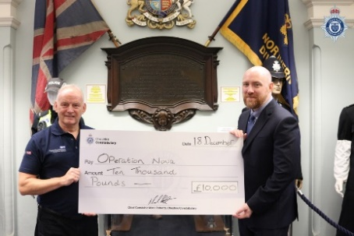
Constabulary donates £10,000 to Cheshire veterans’ charities
A locally active veteran’s charity has been awarded £10,000 as part of the Cheshire Constabulary in the Community Christmas initiative in recognition of their work in supporting former service personnel after they return to civilian life.
Cheshire Constabulary has been spreading the festive cheer this week, as Chief Constable Mark Roberts has been donating £50k to five worthy charities whose work supports the community for our local residents. This £50k comes from funds recovered under the Police Property Act and will go directly to supporting the communities the Constabulary serves.
On Thursday 18 December Chief Inspector Tom Hall presented Andy Preece of the Forces Employment Charity's Operation Nova with a cheque for £10,000 to support their work in Cheshire on behalf of the Chief Constable. The Forces Employment Charity stands by ex-Forces personnel, many of whom work within the Constabulary as officers or staff members, providing life-long, life-changing support, jobs and training opportunities to Service leavers, veterans, reservists and their spouses, partners and children. This support is delivered by experienced advisors, many of whom also served, who are committed to helping veterans succeed by harnessing their military skills for new jobs outside of the service.
By working with them, veterans are in the best position to transfer these skills into other sectors, giving them the confidence to advance in their careers and demonstrate to employers their value in the workforce. The charity also works very closely with veterans who have come into contact with the justice system, providing specialist support that takes into account their veteran identity and experiences. Andy Preece is an Operation Nova caseworker for both Cheshire and Staffordshire
CC Mark Roberts said: “We highly value the skills, attributes and experience of those with an Armed Forces background – including many of our officers and staff members who have been involved with the military – and the fantastic work they have done, and continue to do, to keep our country safe. Returning to non-military life can bring a number of challenges for veterans and their families, but the work Forces’ Employment does is vital to those who have fought for their country, by getting them onto the road of success in all elements of civilian life once their service ends. The charity’s NOVA justice services programme in particular has consistently proved that identifying, engaging and supporting veterans can have both life-changing and life-saving outcomes, so I am more than pleased to present them with this cheque for £10,000 to help them in continuing to look out for our former servicemen and women."
Andy Preece, NOVA Caseworker, Forces Employment Charity said: “Cheshire Police has a phenomenal understanding and awareness of the challenges facing Service leavers, and we look forward to investing this money back into the community through our work with local veterans.”
To find out more the work The Force's Employment Charity does, you can visit their website.

Man convicted of sexually assaulting a woman in Winsford
A man from Lithuania has been convicted of sexually assaulting a woman in Winsford.
At around 12.30am on Saturday 28 June 2025, the victim, a 19-year-old woman, visited the Hive in Winsford with two friends. While at the premises the group were approached by a man who introduced himself as ‘Tommy’, who was an acquaintance of one of the victim’s friends. At around 2.30am the group, including Tommy, decided to go back to the victim’s friend’s house nearby. After returning to the address the group continued to drink, before the victim fell asleep in bed. She awoke a short time later to find Tommy sexually assaulting her, he only stopped when victim’s friend returned to the room. Following the incident the victim fled the address with her friend and reported the matter to police.
An investigation was launched by officers from Northwich CID who quickly identified Tommy as Arturas Galinauskas. The 29-year-old of Nelson Street, Southport, was subsequently arrested and during questioning he claimed that all the sexual activity was consensual. Despite his claims, he was later charged in relation to the allegations. Galinauskas was found guilty of one count of sexual assault following a four-day trial at Liverpool Crown Court which concluded on Friday 12 December 2025. He was also found not guilty of one count of rape and a second count of sexual assault.
Following the verdict, DC Bethany Green, who led the investigation said: "Sexual assault is an horrific offence, which affects victims in the most profound way. This incident has had a major impact on the victim, and I would like to thank her for the courage and resilience she has shown that has enabled us to secure this conviction. Despite everything that happened, she had the strength to report this incident and give evidence in open court. As a result of her bravery Galinauskas has now been held accountable for his actions, and people can see him for who he really is - a sexual predator, who took advantage of a vulnerable woman.”
Galinauskas has been remanded in custody and is set to be sentenced at Liverpool on Friday 30 January 2026.
DS James Elliot, of Northwich CID, added: “Nobody should have to experience what the victim has been though and if anything can come from this case, I hope that it encourages other victims of sexual offences to come forward and report them to us. We treat all reports of sexual offences extremely seriously, and any allegation will be thoroughly investigated, with the wishes and needs of the victim as our main priority. Victims should never feel ashamed to talk about what they have been subjected to. They will receive the help and support they need from our specialist officers, as well as from other support agencies we work alongside, and all victims of sexual offences have the right to anonymity.”

Warning issued following reports of a potential car meet in Alderley Edge
Drivers planning to take part in an illegal car meet this holiday weekend are being warned that anyone found flouting the rules of the road will face the consequences of their actions.
Over recent days Cheshire Police has been made aware of an unauthorised car meet which is rumoured to be taking place in Alderley Edge on Saturday 20 December. The meet has not been authorised by the local council or by police, and previous incidents have caused huge disruption in the local area. The meets are known to attract hundreds of people, many in high powered motor vehicles driving dangerously causing excessive noise and anti-social behaviour, all of which have caused alarm and distress to residents.
A number of operations have taken place over recent months to tackle the issue, which has resulted in several vehicle seizures, multiple fines for numerous road related offences and a number of warning notices issued. Any criminal offences being committed will be dealt with robustly both during and post event.
CI Zoe Bowden, head of Macclesfield Local Policing Unit, said: "Whilst these events may seem harmless, car meets are an ongoing problem that cause significant disruption to local residents and the business community. Alderley Edge is a small village and there simply isn’t the road capacity for an event of this nature to take place. Not only do the attending vehicles cause significant traffic disruption, but also many attendees park their vehicles on grass verges, roundabouts and pavements causing obstructions to pedestrians and damage to the village infrastructure.
“We’ve also previously had reports of illegal drag strip style racing to take place in the village. Therefore, we would like to warn those planning on attending this event that we are aware it is taking place, and we are already actively working with our intelligence team. Both uniformed and plain clothed officers will be present in the area throughout the day, and they will be actively targeting antisocial behaviour. We have a zero-tolerance approach and will take action against those who break the law. This includes vehicle seizures, penalty notices, notifying insurance companies, dispersal notices, or even arrests and subsequent prosecution. Our message is clear – anti-social behaviour and anti-social use of vehicles will not be tolerated.”
If you have any concerns or information on any criminal activity taking place, please contact us on 101 or dial 999 if it is an emergency.

Constabulary's Drone Unit assist in rescuing man from River Weaver
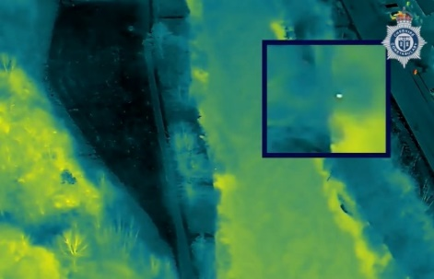
An 85-year-old man was rescued from the River Weaver in Winsford thanks to the quick actions of Cheshire Constabulary’s Drone Unit.
At 2.13pm on Tuesday 16 December, police were called to reports of a person in the River Weaver. Officers, along with colleagues from Cheshire Fire, plus paramedics, immediately attended the scene and tried to locate the individual in the fast-flowing water.
Due to the urgency of the situation, PC Andrew Walker and PC Sarah Brockley from Cheshire Constabulary’s Drone Unit jumped into action and lifted a drone to aid officers and firefighters on the ground in locating the person. Thanks to the thermal imaging camera on the drone, operators were able to locate an 85-year-old local man in the river, clinging to a tree. This was communicated to firefighters who rescued the man and brought him to safety before passing him to the care of paramedics. The man remains in hospital currently as a precaution but has not suffered any serious injuries.
Insp Paul Heatley, of Northwich LPU, said: “This was an urgent situation and officers immediately deployed to the scene. Due to the fast-flowing water, we needed eyes in the sky to be able to assess the exact location of the man. The Drone Unit’s help was absolutely vital in finding him and there is strong probability that their expertise saved his life. I would like to thank them for their assistance in this incident, as well as the officers who attended the scene and our colleagues from Cheshire Fire and Rescue Service and North West Ambulance Service.”
PC Andrew Walker, of the Drone Unit, said: “Our unit uses modern drone technology to assist with many types of incidents in the force and as this particular incident demonstrates, it can be extremely useful in locating people when it’s difficult for those on the ground. The unit plays a vital role in supporting officers and staff, helping to keep the communities of Cheshire safe. We wish the man a speedy recovery after this ordeal.”

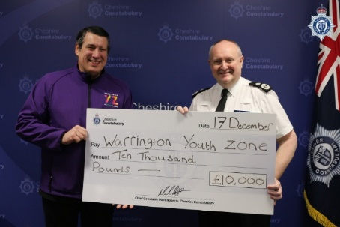
Warrington Youth Zone receives £10,000 donation from Cheshire Chief Constable as part of ongoing Christmas charity initiative
Chief Constable Mark Roberts has donated £10,000 on behalf of Cheshire Constabulary to the Youth Zone in Warrington as part of the ongoing Constabulary in the Community Christmas project.
It is day three of the Constabulary in the Community Christmas charity initiative, which will see Police Chief Constable Mark Roberts donating a total of £50k of funds to five worthy charities and organisations from across Cheshire.
Warrington Youth Zone is one such charity which has supported the young people of the town from its state-of-the-art facility since 2022, but its history spans over 70 years, having first been established as the Warrington Boys Club in the 1930s. Over the next seventy-plus years, the club adapted and operated out of several locations across the town and welcomed generations of young people from all walks of life, genders and backgrounds, before changing its name to Warrington Youth Club in 2003 and becoming a registered charity.
The Warrington Youth Zone has built upon the legacy of the Youth Club and offers a variety of different activities and initiatives to support young people’s development, offering opportunities to gain, increase and develop skills, knowledge, self-awareness and confidence. Whether young people want to meet old friends, make new ones, work out or get involved in a sport, or simply find somewhere where they can relax and have a hot meal, the Youth Zone is available to them for just 50p a visit.
Today, Wednesday 17 December, CEO Dave McNichol was presented with a cheque for £10,000 by Chief Constable Mark Roberts to support their upcoming projects for the new year and the continued day-to-day running of the facility.
Chief Constable Mark Roberts said: "The Youth Zone is integral to the children of Warrington and has a long legacy of helping them become the best version of themselves, which is why I am delighted to present their team with this cheque for £10,000 to support them in doing so through the next 12 months. Their work also helps us as a force, as the opportunities the Youth Zone provides gives these young people an alternative to engaging in crime or anti-social behaviour, instead giving them a safe environment where they can freely express themselves and have fun with others of a similar age. It is very important that the young people have a safe place to go to where they can develop their skills and abilities, pick up a new sport or hobby, or meet up with friends and socialise, but most importantly, enabling them to make positive and healthy life choices."

Man jailed for four years for sexually assaulting a child
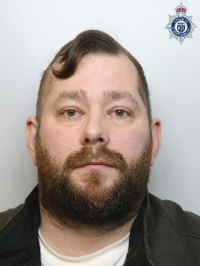
A man has been jailed after being found guilty of sexually assaulting a child.
Adam Hardman, 39, from Norley Road in Leigh appeared at Liverpool Crown Court on 16 December to be sentenced. Hardman was found guilty at an earlier hearing of two counts of assault by touching which had occurred in Warrington. He was sentenced to four years in prison, ordered to sign the sex offenders register and handed a Sexual Harm Prevention Order.
DC Caroline Wharmby said: “Hardman took advantage of his situation to sexually assault a child betraying the trust of the child and the family. I’d like to commend the victim for showing such bravery in coming forward to report the two incidents and bringing this man to justice for his despicable actions.”

50,000 illegal cigarettes seized, shops closed and arrests made during forcewide immigration crime operation
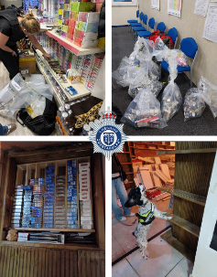
Officers working under Operation Azelea, a proactive force-wide operation lead by Beat Teams with support from community partners, have seized over 50,000 illegal cigarettes and arrested several people.
Between Monday 8 December and Friday 12 December, officers working under Operation Azelea targeting the sale of illegal vapes and cigarettes at retailers across the county well as those committing immigration offences through the exploitation of vulnerable people.
Lead by Neighbourhood Beat Teams across Cheshire’s nine Local Policing Units, officers were also joined by Constabulary Foreign National Offender and Protecting Vulnerable People Exploitation teams as well as colleagues from Trading Standards, HMRC and Immigration. Over 50 premises were visited across the region and searched by officers and their partner colleagues, four of which are now set to be prosecuted for the sale of duty free and illicit cigarettes.
Approximately 50,000 illicit cigarettes were seized by the team and, on top of this, four people were arrested in connection to immigration and fraud offences. Two immediate closures have also been enforced against retailers in the Western and Northern areas of the county and, following a number of enquiries, officers and their colleagues are now looking to seek closure orders at a further three retailers.
Alongside this proactive work, high-visibility and plain-clothed patrols across the region, officers engaged with members of the public regarding ongoing issues in their areas and provided safeguarding advice in relation to topical issues such as the usage of ketamine amongst young people.
T/ACC Carlos Brunes said: “Our officers work hard to root out organised criminals operating in our shops, high streets and communities and today’s operation demonstrates just some of the work that we do 365 days a year to keep the people of Cheshire safe. Whilst the sale of illicit tobacco and illegal cigarettes and vapes may seem like a trivial crime to some, oftentimes, officers find that where these offences are being committed, immigration offences and the exploitation of some of the most vulnerable people in our communities are occurring.
“Those involved in such activities often have links to drug trafficking and distribution, organised immigration crime, modern slavery and human trafficking, which is why we are committed to running regular operations such as this and doing all we can to identify those involved. I hope that the results from this operation will provide some reassurance to our communities and also act as a warning to those who are considering taking part in this type of activity.”
Anyone with concerns about organised immigration crime can contact Cheshire Police via 101 or visit https://www.cheshire.police.uk/tua/tell-us-about/soh/seen-or-heard/ and a member of their local PVP Exploitation Team.

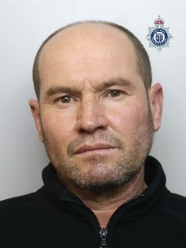
Man jailed for Ellesmere Port Cannabis farm
A man who admitted running a cannabis farm in Ellesmere Port has been jailed.
Blerim Kamberaj appeared at Chester Crown Court on Tuesday 16 December, where he was sentenced to ten months in prison. The 42-year-old of Whitby Road, Ellesmere Port, had earlier pleaded guilty to production of Class B drugs (Cannabis).

The court heard how one Saturday 22 November, officers from Ellesmere Port Local Policing Unit executed a warrant at a former retail store on Whitby Road after receiving intelligence about the property. Upon entering the building officers found that the premises had been converted into a professional cannabis farm, with nine grow zones, set up over three floors. While searching the address officers also located Kamberaj, who was found hiding under furniture. He was subsequently arrested in relation to the discovery. In total officers recovered 496 plants from the address, with a potential street value of up to £371,750.

Following the hearing, PC Paul Malcolm, of Ellesmere Port Local Policing Unit said: “I welcome the sentence handed to Kamberaj, and I hope that it provides reassurance to the local community. The negative impact that illegal drugs have on our communities are well known and we are committed to doing all that we can to ensure that those responsible are held accountable for their actions and our ongoing battle against those who are involved in the production and supply of illegal drugs continues. I urge anyone with any information about suspected drug related activity in their community to get in touch. You will be listened to, and we will investigate the matter.”
There are a number signs that could indicate that a property is being used as a cannabis farm, including:
- A strong and sickly sweet smell
- Equipment to grow cannabis being taken into a property, such as lighting and ventilation equipment
- Constantly covered or blocked-off windows – cannabis farms often have constantly closed curtains, black-out blinds or foil coverings
- People coming and going at all hours or neighbours you never see
- Strong and constant lighting day and night
- High levels of heat and condensation – cannabis farms often give off heat and the windows stay misted up
- A constant buzz of ventilation – listen out for a whirring sound as the growers try to create an ideal climate for cannabis plants to grow.
- Lots of power cables – offenders often dig underground to lay cables that hook up to things like lamp posts so they do not have to pay for the enormous amounts of electricity they use.
To report a suspected cannabis farm or any other type of drug-related offence, call us 101, give the details via our website or contact Crimestoppers anonymously on 0800 555 111.


South Cheshire Amateur Boxing Club receives £10,000 donation as part of Cheshire Constabulary in the Community Christmas initiative
The South Cheshire Amateur Boxing Club, which has long been supported by the force, has received a £10,000 donation as part of this year’s community charity initiative.
On the second day of the Cheshire Constabulary in the Community Christmas initiative, Chief Constable Mark Roberts met with Detective Chief Inspector Christian Morris and Force Personal Safety Trainer Nathan Clarke to present them with a cheque for £10,000 to go towards the continued development of the South Cheshire Amateur Boxing Club.
Founded by Head Coach Nathan in 2012 and supported by the efforts of Trustee and Assistant Head Coach Christian, the club officially began its construction of a purpose-built gym and boxing centre in August of last year, with the Chief Constable in attendance for the ground-breaking ceremony. Since then, the team has transformed the previously derelict and unused piece of land into a hub for young people in the area to take up the sport, meet up with friends and meet new people, while helping to reduce anti-social behaviour in the town.

The Constabulary has been a long-time supporter of South Cheshire ABC since its conception, with Nathan and Christian telling Chief Constable Mark Roberts that the donation will help them with the continued expansion of the club and their varied programmes for young people, general maintenance and upkeep of the building and purchasing of new fitness equipment. As a thank you for his support in the clubs ongoing development, Nathan and Christian surprised Chief Constable Roberts with his very own framed boxing shirt during the handing-over of the £10,000 cheque.
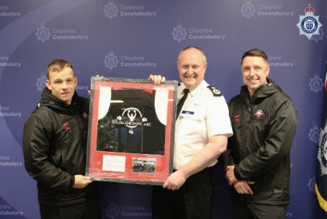
Chief Constable Mark Roberts said: "I am always delighted to support local Cheshire initiatives such as this, especially when they benefit young people. Aside from the benefits of regular exercise, boxing teaches discipline and valuable life skills, and the team at the club do fantastic work, all as volunteers. The facility is also getting broader use from the local community and is an incredible venue for local people in and around Crewe.
“South Cheshire ABC has close ties to our Constabulary, with our own Nathan Clarke, Christian Morris, Lisa Haughton and a number of our officers and staff regularly visiting and helping out. It is important we do everything we can to support these incredible people and the commitment they show in supporting their community. As the project continues to develop, I am really pleased to be able to present them with this cheque for £10,000 as a small contribution to this great club. The funds come from the Police Property Act, which must be used to support such activities."
Nathan Clarke, Founder and Head Coach of South Cheshire Amateur Boxing Club, said: "South Cheshire ABC was, once again, delighted to receive the news of the generous donation given by Chief Constable Roberts on behalf of the Constabulary - we cannot thank them enough for the continued support of the club and its staff in what really has been a huge year for us since the opening of the new gym in April. The club’s open-door policy meant we outgrew our previous location, and donations such as this will ensure we can provide a safe and positive environment for the residents of Cheshire as the club continues to expand and reach new young people."
DCI Christian Morris added: "The Chief Constable and the wider Constabulary have been on this journey alongside South Cheshire ABC since its conception, and the partnership between the two continues to go from strength to strength as we enter the next chapter in the club’s story in 2026. We would not be where we are today without the aid of the Constabulary and, as we continue the development of our purpose-built boxing facility and wider community outreach programmes, we are forever grateful for their continued support of our vision of providing a safe and effective environment for the young people of Cheshire.”

Woman barred from shops in Ellesmere Port
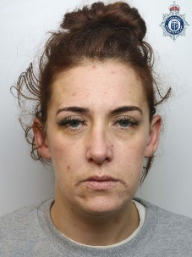
A woman has been barred from a number of shops in Ellesmere Port for five years.
Jade Ellams, 34, from Sutton Way in Ellesmere Port was handed a Criminal Behaviour Order at Chester Magistrates on Thursday 4 December 2025, following a spate of shoplifting at the Co-Op on Overpool Road, and Holland and Barrett on Marina Drive in August this year. Under the terms of the CBO Ellams has been placed under restrictions to curb her criminal behaviour.
The five year Criminal Behaviour Order prohibits Ellams from:
- Entering the Co-Op on Overpool Road and Holland and Barrett in Marina Walk, both in Ellesmere Port.
- Entering any retail premises where she has been banned, barred or excluded, verbally or in writing – including any stores that form part of the Business Crime Reduction Partnership.
- When entering any retail premises in Cheshire she must not place any items in carrier bags or rucksacks or any other article capable of concealing items prior to payment being made, unless it is a basket or trolley belonging to the store.
- She must remain at any premises immediately when asked to do so by staff or security.
If Ellams fails to comply with the CBO, she will be committing a criminal offence which may result in being imprisoned or fined.
PC Lucy Hawkins said: “I am grateful that the courts have recognised the significant impact that this individual's persistent offending has had on staff and businesses. I hope this can provide some reassurance to local retailers and residents that we are doing all we can to deter anti-social behaviour and criminality like this from occurring in our communities. This CBO sends a clear message that repeated targeting of retail premises will not be tolerated.”

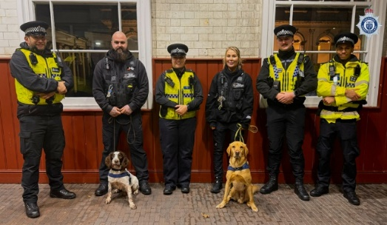
Passive drug dog operations take place in Chester
Officers in Chester have carried out almost 100 stop searches in the city in the past few weeks thanks to the keen noses of its four-legged partners.
Passive drug dog operations have been carried out in Chester city centre and Chester Railway Station across the last three weekends in the run-up to Christmas. Officers have been working with both the British Transport Police and Cheshire Police’s Special Constabulary to target those carrying and supplying drugs, while providing a highly visible policing presence across Chester.
The results so far include:
- 93 stop searches
- 11 arrests, including for possession with intent to supply drugs, possession of knives, assault and people who were wanted on warrant
- 22 Community Resolutions issued
- Two summons issued
- One Youth Justice Services referral
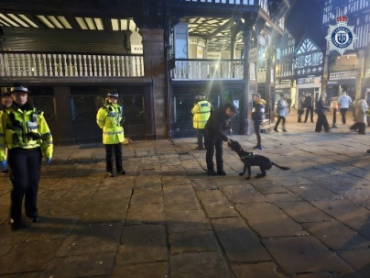
Inspector James Wilson said: “Over the last three weekends passive drug dog operations have been carried out in Chester City Centre and outside Chester Railway Station which have achieved some excellent results. These operations provided a visible presence which sends a clear message that the use of drugs will not be tolerated in Chester and has resulted in the detection of several offences, removing drugs, weapons and wanted people off the streets. We regularly carry out operations such as this to keep our communities safe and ensure they remain a hostile place for criminals.”

Man jailed for rape and sexual assault
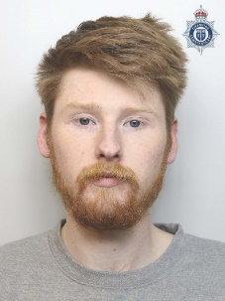
A man has been jailed for more than seven years after admitting multiple counts of rape and sexual assault.
George Brusby, of no fixed abode, appeared at Chester Crown Court on Friday 12 December. The 28-year-old was sentenced to seven-and-a-half years after pleading guilty to five counts of rape, one count of assault by penetration, one count of causing a female aged 13 or over to engage in non-penetrative sexual activity and one count of sexual assault.
On 3 March 2023, police received reports of non-recent sexual abuse which occurred when the female victim and Brusby were both children in the Warrington area. This report was made after seeing a video of Brusby’s arrest which was posted online by a paedophile hunter group who used a decoy to catch him sending sexual communications to a whom he believed was a child.
Following seeing this, the victim told police Brusby had sexually abused her between the ages of 11 and 14, when Brusby was aged between 12 and 16. Brusby would rape the victim and sexually assault her, also inciting her to engage in sexual activity. She stated she never consented to any of it, but Brusby would use force to rape or assault her.
Brusby was arrested and interviewed about these allegations and tried to claim that any sexual activity they engaged in was consensual. However, despite his denials, he was charged with the offences and ultimately pleaded guilty at court. On top of his custodial sentence, Brusby must sign the Sex Offender Register and is subject to a Sexual Harm Prevention Order and a restraining order to protect the victim.
DC Byng said: “Even though Brusby was a child himself at the time of the offences, he knew what he was doing was wrong and tried to claim that it was consensual. But thankfully he didn’t put the victim through the stress of a trial and pleaded guilty at court. I hope the conclusion of this case will provide the victim with some closure after carrying this on her shoulders for a large portion of her childhood and into adulthood.
“Brusby’s sentence is thanks to her bravery in talking to police about what happened to her, and I also hope that her courage will help others in coming forward and reporting any incidents of sexual abuse, no matter how long ago the offences took place. You can report information to us by visiting our website to report online or by calling 101.”

Christmas comes early at Constabulary's 2025 Carol Concert
Last week, Cheshire Constabulary welcomed over 800 people to Chester Cathedral for the force’s annual Christmas Carol Concert.
The Constabulary’s annual Christmas Carol Service at Chester Cathedral is not only one of the hottest tickets in town but is also one of the most looked-forward to events within the force’s entire calendar. Held on Tuesday 9 December, esteemed guests including the Chief Constable, the Deputy and Assistant Chief Constables, Police and Crime Commissioner, Lord Lieutenant, High Sherriff, officers and staff filed into the historic cathedral alongside members of the public to officially kick off the festive season in style.

Welcoming guests to the service, Chief Constable Mark Roberts said: “I look forward to this event every year and I always come away feeling festive and ready for the Christmas period. I know this is the same for many of you so I hope you enjoy the evening once again.
“Tonight gives us chance to come together and reflect on the events of 2025, personally and nationally too, whilst looking forward to 2026 with optimism, hope and thankfulness. I wish you all a wonderful evening with your family and friends, and would like to take this opportunity to say merry Christmas. I hope you all have a safe and joyous celebration and a very happy new year.”
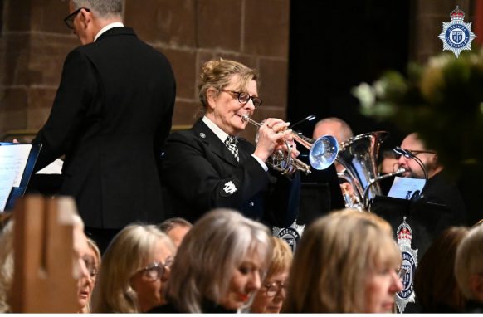
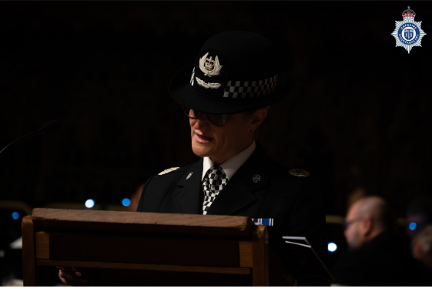


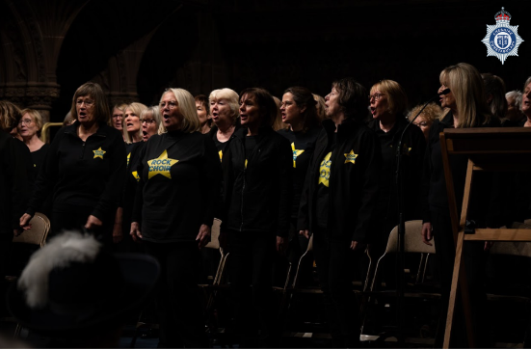

Over the course of the evening, alongside the carols, attendees were treated to performances by the Constabulary’s very own band and Rock Choir Cheshire led by Kathryn Davies, who delivered a spell-binding rendition of ‘Carol of the Bells’.
The children of St Philips Westbrook Primary School also delighted the audience with their own performances of songs including a soloist performance of ‘Once in Royal David’s City’ and a wider group rendition of Keane’s ‘Somewhere Only We Know’. The children of St Philips had been chosen to perform at the concert after beating 17 other primary schools from across the county in a competition held by the Constabulary.
In between the music, readings re-telling the Christmas story were delivered by Chief Constable Mark Roberts, DCC Mike Evans and Assistant Chief Constable Alison Ross, reminding everyone of what the true spirit of the season is all about.

MyCWA awarded £10,000 as part of Constabulary’s Christmas charity initiative
The Crewe-based domestic abuse charity has been awarded £10k from Chief Constable Mark Roberts on behalf of the force on the first day of the Cheshire Constabulary in the Community Christmas initiative.
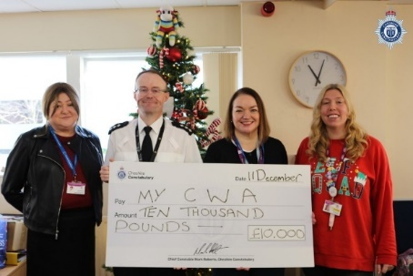
On Friday (12 December), the Constabulary announced that it would again be supporting the Cheshire Constabulary in the Community Christmas charity initiative. As part of the initiative, Mark Roberts will be donating a share of £50,000 on behalf of the force to five county-based organisations that focus on supporting residents and local communities.
In the run up to Christmas this year, we will be looking at the work the Chief Constables’ chosen charities do for the people of Cheshire as they are presented with their share, which will go a substantial way to helping them continue the often vital community work they offer into 2026.
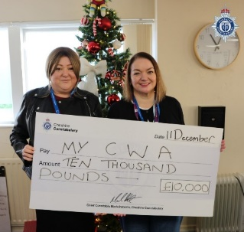
The first of the chosen charities for 2025 is MyCWA (formerly My Cheshire Without Abuse). Since 1977, their family-oriented service has provided victims and their families affected by domestic abuse with everything from designated helplines, crisis accommodation and recovery programmes, to practical support and behaviour change programmes.
Last Thursday, Crewe Chief Inspector Andrew Baker visited the Lily Jones Support Centre on Mill Street, Crewe, and presented the team from MyCWA with a cheque for £10,000 on behalf of Chief Constable Roberts.
Speaking about My CWA, Chief Constable Mark Roberts said: “Domestic abuse is an issue that can have devastating effects on everyone within a family setting. Which is why, when victims and their children find themselves in crisis and feel as if they have nowhere to turn, MyCWA provides them with that vital lifeline to help them find a safe space where they can begin to take steps to break the cycle of domestic abuse. MyCWA has been an institution in Crewe for nearly 50 years and the work of their staff during those five decades has helped so many people across Cheshire rebuild better lives for them and their families, so I am delighted to present them with a donation of £10,000 to support the fantastic work they do into 2026.”
Saskia Lightburn-Ritchie, CEO of MyCWA (Cheshire Without Abuse), added: “We’re incredibly grateful to Cheshire Constabulary for this generous support and ongoing commitment to tackling domestic abuse. This funding will help us provide safety, stability and hope for families across Cheshire at a time when demand for our services has never been higher. Our partnership with the Constabulary is vital - by working closely together, we can reach people earlier, support them more effectively, and help prevent abuse before it escalates. It’s strong relationships like this that make lasting change possible, and we’re so grateful for the Constabulary’s support.”

Man guilty of attempting to cause a female to engage in sexual activity
A Merseyside man has been found guilty of attempting to cause a female to engage in sexual activity after offering her a lift.
Paul Williams, 58, from Rosebery Avenue, Liscard was found guilty following a trial at Liverpool Crown Court. The jury returned a guilty verdict on 11 December. Williams was remanded in custody to appear at Liverpool Crown Court on 3 February 2026.
The victim was walking along Willaston Road in Neston on the morning of 21 June 2025 when she stopped for a rest. A car came to a stop a little further up the road and the driver, Williams shouted to her if she wanted a lift. She got in the car and asked to be taken to an address further up the road. Williams drove past the address and took her to a secluded one track road. He told her she had to pay, to which she told him she had cash. But he said no you need to pay. He then exposed himself and tried to block her from leaving the car. She managed to escape and ran to a house to get help. Police enquiries led to Williams being put at the scene at the time of the incident and he was arrested. His car was also seized.
DS Tom Philpotts said: “Williams is a dangerous predator who took the opportunity while conducting his job as a delivery driver to take advantage of a vulnerable woman walking on her own. The victim has been left traumatised by the danger she was in that morning alone in the car with Williams and is struggling to process this. I hope this conviction will help her in her recovery.”

Latest Cheshire Appeals

Appeal to trace missing man last seen in Leighton
Officers are appealing for help in tracing a missing man who was last seen in Leighton.
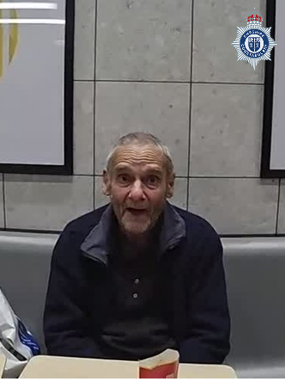
Clive Galley was last seen at around 7.12am today (Friday 19 December), leaving Leighton Hospital. At the time he was last seen, Clive, 67, was believed to be wearing a grey and black jacket and black trousers.
Inspector Robert McCubbin said: “A number of enquires are already underway to locate Clive and, as part of those enquiries, we are now appealing to anyone who may have seen him on his travels to please get in touch. I would also like to address Clive directly and ask him, if he is reading this, to get in touch with us as we are growing concerned for your safety. Anyone with any information regarding Clive’s whereabouts is asked to contact Cheshire Police via the website, or on 101, quoting IML-2235699."

Appeal to trace wanted man from Ellesmere Port
Officers are appealing for help from the public in locating a wanted man from Ellesmere Port.
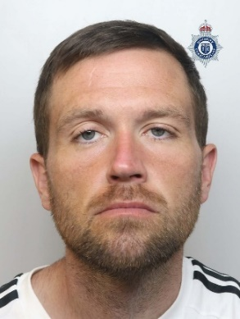
Daniel Critchley is wanted on recall to prison. The 34-year-old is described as white, around 5' 10" tall, of slim build, with brown hair, blue eyes and a short beard. He is sometimes known to wear glasses. Critchley is originally from the Ellesmere Port area but is believed to be in Chester, particularly Blacon.
Anyone with any information should contact Cheshire Police on 101 or through our website, quoting 25001015037. Alternatively, contact Crimestoppers anonymously on 0800 555 111.

Appeal renewed following suspicious incident in Northwich
Police renewed their appeal for witnesses and Dash Cam Footage following reports of a suspicious incident in Hartford, Northwich.
At around 8.30pm on Sunday 7 December, a vehicle stopped at the junction of Chester Road and Bradburns Lane opposite Willows Veterinary Centre. A woman then attempted exit the vehicle by the passenger door. As she was doing so, a man also got out of the vehicle and assaulted her, before pushing the woman back into the car. The man was described as Asian, around 5’ 7” tall, and of a slim build. He had dark hair, a goatee beard and was wearing a white t-shirt. The woman was described around 5’4" to 5’5”, and of small build. She had dark hair and was wearing a green scarf and a pink coat. Following the incident the man got back into the car and drove off on Chester Road, towards Northwich. Enquiries in relation to the incident are ongoing and officers are urging anyone with any information to come forward.
DS Neil Mooney, of Western CID, said: “Enquiries in relation to this incident remain ongoing and we’re doing all we can to establish exactly what took place. As part of our investigation we’re continuing to ask residents on Chester Road, Beach Road, and Moss Lane to check their CCTV and video doorbells to see if they have any footage which may aid our investigation. The same going for anyone who was driving in the area between 8pm and 9pm and may have captured footage of the vehicle involved. I would also like to appeal directly to the occupants of the vehicle to get in touch directly so we can clarify what took place and confirm that you are all safe and well.”
Anyone with any information in relation to the incident is asked to contact Cheshire Police on 101 quoting IML-2229016 or visit Appeal for information following reports of suspicious activity in Hartford | Cheshire Investigate | Community Portal Information can also be reported anonymously, via Crimestoppers, on 0800 555 111.

Appeal for information following indecent exposure in Macclesfield
Police are appealing for witnesses and video footage following reports of an indecent exposure in Macclesfield.
Shortly after 8am on Tuesday 16 December, a 15-year-old girl was walking along the A537, Buxton Road. As she approached the junction of Lark Hall Road, she noticed a white lorry/ box van which was parked facing Buxton Old Road. The teenager noticed a man sat inside the vehicle and could see that the window was down. As she walked past, the man appeared to say something to the girl, so she turned to say ‘good morning’. However, as she turned to speak to the man, she witnessed him stood at the side of the vehicle exposing himself. The teenager quickly turned away and continued walking down Buxton Road.
The man was described as white, of average build, aged between 30-40 with short brown hair. He was also wearing a black coloured jumper. Enquiries in relation to the incident are ongoing and as officers are keen to hear from anyone with any information which may aid the investigation.
DC James Read, of the Eastern Area Protecting Vulnerable Persons unit said: “This was an absolutely terrifying ordeal for the victim, and we’re committed to doing everything we can to identify the person responsible. The incident itself occurred at rush hour, and as part of our enquiries we’re keen to hear from anyone who was in the area and believes they may have witnessed the incident. The same goes for anyone who was driving on Buxton Road and may have any dashcam footage which could aid our investigation.”
Anyone with any information is asked to contact Cheshire Police on 101 or at www.cheshire.police.uk/tell-us quoting IML-2234474

Police appeal following ATM attack in Warrington
Officers are appealing for information following an ATM attack in Warrington.
In the early hours on Monday 15 December, police were called to Longshaw Street in Bewsey, following reports that an ATM had been targeted. It’s believed that a group of unknown offenders arrived at the address at around 1.30am. They then used their vehicle and other tools to rip the ATM machine out. While they caused significant damage, they left empty handed approximately five minutes later. Enquiries in relation to the incident are ongoing and officers are keen to hear from anyone with any information which may aid the investigation.
DS Gary McClatchey said: "Enquiries in relation to this incident are in the early stages and we are committed to doing all that we can to trace the people responsible. As part of our investigation we would like to hear from anyone who witnessed the incident or saw anything suspicious in the area. The same goes for anyone with any CCTV or dashcam footage which may aid the investigation.”
Information and video footage can be submitted online via the website, or by calling 101, quoting IML 2233654. Alternatively, information can be reported anonymously, via Crimestoppers, on 0800 555 111

Appeal for information following multi-vehicle collision in Cheshire
Police are appearing for witnesses and video footage following a serious collision on the M56 in Cheshire.
At around 7.10pm on Monday 15 December, police were called to reports of a collision on the westbound carriageway of the M56 between junctions 7 (Altrincham) and 6 (Hale Barns). Officers attended and on arrival they found that there had been a collision between three vehicles, a red Ford Transit van, a green Ford Mondeo and a blue BMW 3 series. Three lanes were closed while officers dealt with the incident, but thankfully there were no reports of any serious injuries.
The driver of the BMW, a 29-year-old man from Warrington, was arrested on suspicion of driving while unfit and dangerous driving. He has since been released on bail. Enquiries in relation to the incident are ongoing and as part of the investigation officers are keen to hear from anyone who witnessed the incident, or anyone with any dashcam footage of the collision. Anyone with any information is asked to contact Cheshire Police on 101 or at www.cheshire.police.uk/tell-us quoting IML 2234151.

Appeal for information following serious collision in Ellesmere Port
Officers are appealing for witnesses and video footage following a serious collision in Ellesmere Port.
Shortly after 6.30pm on Tuesday 2 December, police were called to reports of a collision on Wellington Road. Officers attended and found there had been a collision between a grey Vauxhall Astra and an e-bike outside Ellesmere Port Fire Station. The rider of the e-bike, an 18-year-old local man, sustained serious injuries and was taken to hospital where he remains at this time. The driver of the car, a 38-year-old local man, was uninjured.
Enquiries in relation to the incident are ongoing and as part of the investigation officers are keen to hear from anyone who witnessed the incident, or anyone with any dashcam footage of the collision. Anyone with any information is asked to contact Cheshire Police on 101 or at www.cheshire.police.uk/tell-us quoting IML 2225912.

Appeal for information following collision on Warrington
Police are appearing for witnesses and video footage following a serious collision in Warrington.
Shortly before 7.30pm on Friday 12 December, police were called to reports of a collision on Springfield Street, Warrington. Officers attended and on arrival they found that there had been a collision between a blue Mercedes and a pedestrian. The pedestrian, a woman, suffered injuries to her foot and was taken to hospital, she has since been discharged. The driver of the car was uninjured.
Enquiries are ongoing and as part of the investigation officers are keen to hear from anyone who witnessed the incident, or anyone with any dashcam footage of the collision. Anyone with any information is asked to contact Cheshire Police on 101 or at www.cheshire.police.uk/tell-us quoting IML-2232261.


To find out further information about the Cheshire Neighbourhood Watch Association, to log into your account or for Cheshire Neighbourhood Watch Literature please visit our website: www.cheshirenw.org

