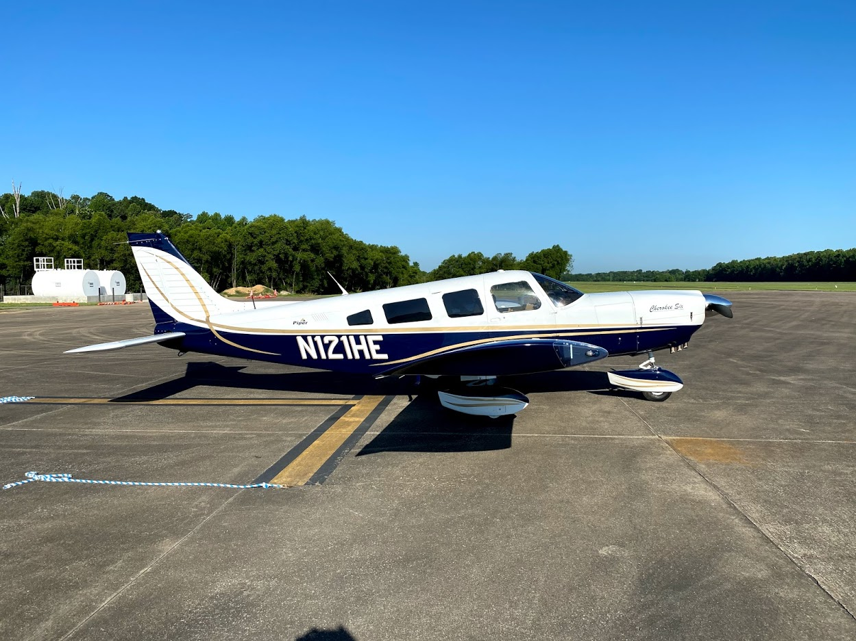

**1979 Piper Cherokee Six 300**  
Based in Murfreesboro, TN (KMBT)

**N121HE**

**Owner**

**Cannon Loughry  
615.347.3464**