RURAL WATER DISTRICT #2
MONTGOMERY COUNTY
Member of Kansas Rural Water Association

PO Box 135 Billing: 620-331-0904
Independence, KS 67301 Water Operations: 620-332-3037
Website: www.rwd2mg.com Drop Box Location: 1521 S 10th St.

June 18, 2026

IMPORTANT: New Meter – “End-Points”

Dear District Member:

We have recently installed new meters and “End-Points” meters within our district. You may have noticed a white circular piece on the water meter lids. This white circular piece is called an endpoint and is used to wirelessly transmit the meter reading by satellite into our billing system. There are electrical components in the endpoint.
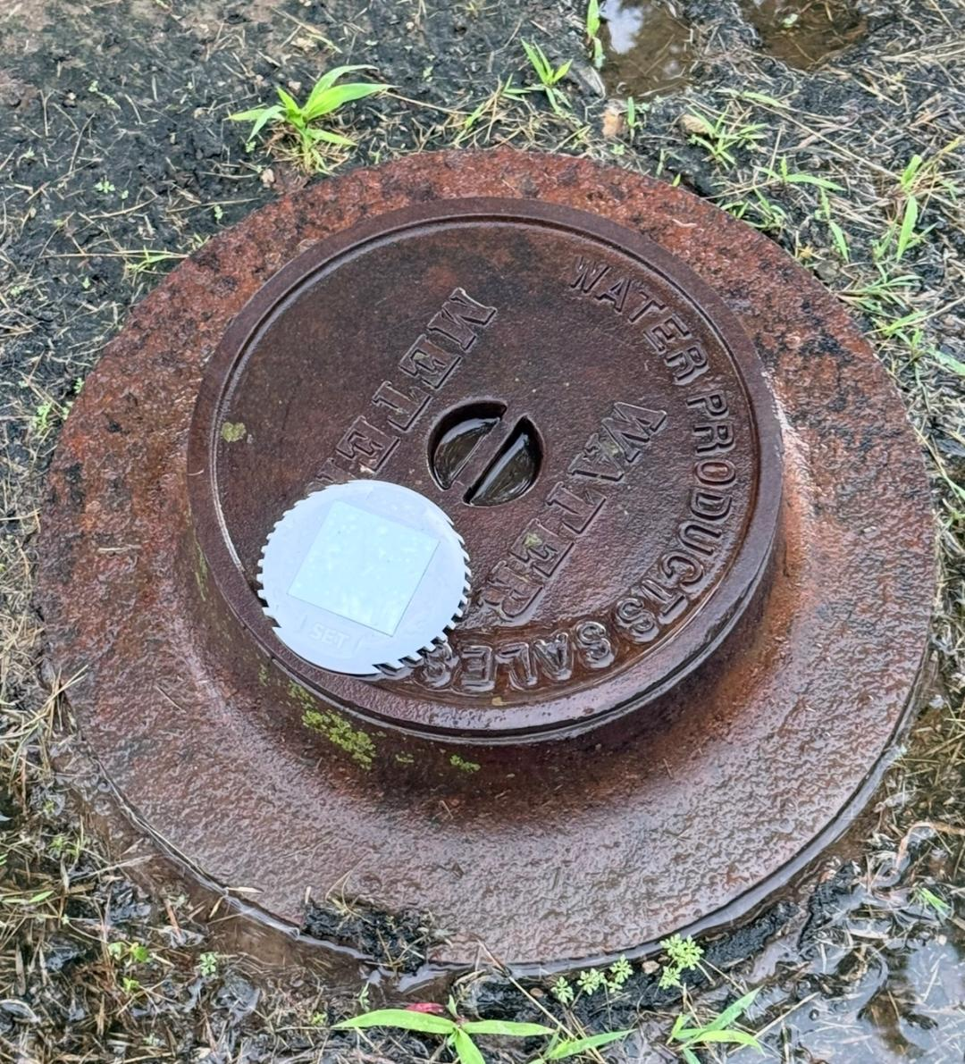

End-Point

(The white disc on lid)
Meter Lid

PLEASE be cautious when mowing, raking, driving, allowing large animals, equipment, etc., near the water meter. In the event your End-Point gets damaged and needs to be replaced, we, as a district, will replace it once. If the End-Point gets damaged after the 1st time, you will be responsible for cost to replace it, if it is not damaged from an Act-of-God event, or a malfunction of the equipment. The price of the End-Point device is currently $450 installed.

I highly recommend, but not required, that you flag or mark your meter somehow, so it is easily seen and/or protected. It would also help, if you are able to, keep the meter lid and the area around the meter lid trimmed up/visible.

Sincerely,
Rural Water Dist# 2
Montgomery County, Kansas
By: Amy Henry, Bookkeeper
620-331-0904
620-205-9349
office@rwd2mg.com

