 Board Meeting Minutes from September 18, 2025

The meeting was called to order by Mike McDermott @ 3:00pm
Attendees: Mike McDermott, Dean Anderson, Paula Odom

Motion to Pay Bills:
1st Motion made by: Dean Anderson
2nd Motion made by: Mike McDermott
Motion approved by all

Motion to Approve Minutes from August:
1st Motion made by: Dean Anderson
2nd Motion made by: Paula Odom
Motion approved by all

Motion to Absorb Collection Fees by the HOA for small amounts of: $4.80 & $1.87 – Total of: $6.67
1st Motion made by: Dean Anderson
2nd Motion made by: Mike McDermott
Motion approved by all

Motion to Approve 2026 HOA Budget:
1st Motion made by: Dean Anderson
2nd Motion made by: Mike McDermott
Motion approved by all

Continued . . .

Board Meeting Minutes from September 18, 2025
Old Business:
The HOA will be switching most accounts, but not all from PNC Bank to the New Community Bank of Delaware.
Mike McDermott will meet with Community Bank on 9/23/25 to set-up those new accounts.
The reason the HOA needs to keep one account Open with PNC Bank at least for the short term, is due to the upcoming 2026 Dues Invoices that will go out in October, to receive on-line payments.
New Business:
Collection Agency:
Mike McDermott will request the official contract for signing for the New HOA Collection Agency “Recovery Solutions in Milford, DE.
Treasurer Odom, will supply “Recovery Solutions” a detailed spreadsheet of delinquent accounts from our HOA CPA.
Expect to have this in place no later than November 1st, if not sooner.
Checks Signed . . .
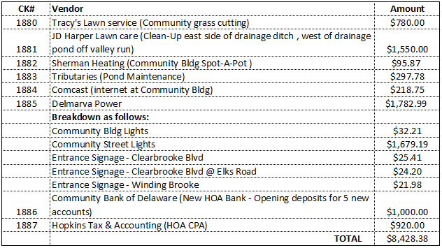

Meeting Adjourned at 4:20pm – Next Board Meeting will be: October 23, 2025 @ 6:30pm

