**Clearbrooke Estates Annual Meeting October 2024**

Hello Neighbors,

The annual October meeting was on **October 7, 2024** at the Elks Lodge.

In case you missed it, here’s the highlights of the meeting.

Mike McDermott – HOA President Welcomed Everyone and Introduced the other Board Members

Paula Odom – Treasurer

Dean Anderson – Vice President/ Code Enforcement / Architectural Committee

The Board also addressed other topics:

Gwen Jarmon resigned her position as Secretary. Therefore, A Special Election will be held at the April 2025 meeting to fill that position.

The Board will mail an announcement in February, to receive candidates until March 15, 2025, to fill the vacated position in April, and then fill the remaining open position at an Election in October. None of the current board members will be up for election at that time.

There will be limited projects for 2025 for Paving with money carried over from 2024. Those areas to be determined.

Paula Odom – Treasurer handed out A

Sample of the Website that shows

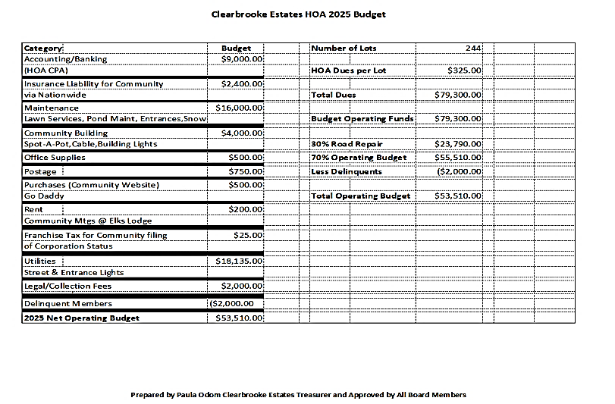**“How to** **Pay Dues On-Line”** 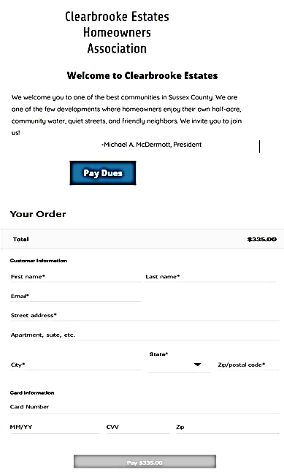

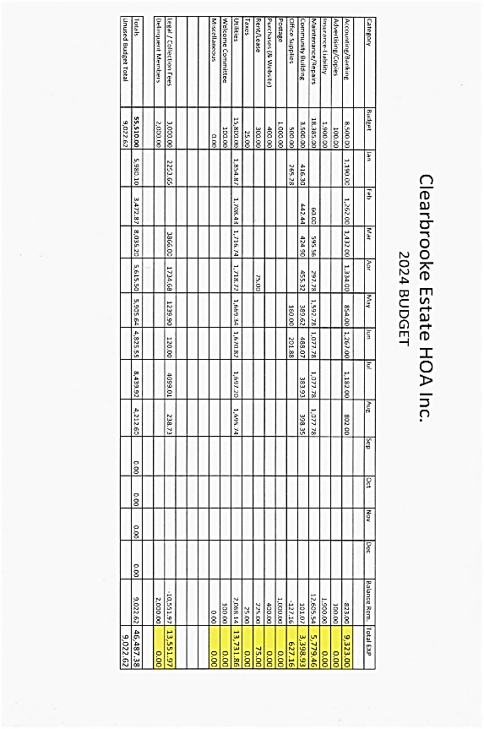The Current 2024 Budget Spreadsheet and the 2025 Budget

See the Full versions on the Website **clearbrooke.com**

**Street Lights:**

As you recall a few years ago, Delmarva Power agreed over a 3 year period to update our Street Lights from the old Amber bulbs to more efficient LED bulbs.

The last phase of that project hasn’t been completed as of yet.

Paula Odom – Treasurer sent an e-mail to Delmarva Power before our meeting and received information back on what to do to complete that project.

**Violations:**

Dean Anderson – Vice President/ Code Enforcement/ Architecture Committee talked about the basic Violations that still need to be reminded of homeowners. A sample of the Card that will go out was passed around and will be mailed out shortly.

Walking or Riding your bike at night – **PLEASE WALK WITH A FLASHLIGHT OR REFLECTIVE VEST**.

**Quotes:**

For Tree trimming at all the Entrances are being sought, as well as taking down all the Trees in the median from Elks Road to clean that area up.

**Questions raised by Residents:**

Where can I find Information?

**Suggestion:** Create a Frequently Asked Questions Page that will be on the Website. This will be done in the near future.

**What can be done about all the Geese . .**

How to keep them from coming onto properties etc. Dean Anderson will contact DNREC to see if anything can be done.

**Facebook Page for the Community:**

Please forgive me but I didn’t get the name of the person that asked this question.

There was a Facebook page created a few years ago, but it wasn’t kept up.

Mike McDermott will work with that person to see if this can get off the ground again.

**MISC:**

There were 27 people in attendance at the meeting.

Spread the word to your neighbors . . . .

Come and meet the New Board of Directors.

The Board of Directors encourages you to contact us with any questions through one of the following ways:

**Website:** Clearbrooke.com

**Email:** [clearbrookehoa@yahoo.com](mailto:clearbrookehoa@yahoo.com)

**Address:**

Clearbrooke Estates HOA

P.O. Box 1045

Seaford, DE 19973

**Phone#:** 302-536-1327