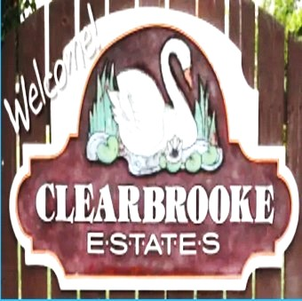 Board Meeting Minutes from August 21, 2025

The meeting was called to order by Mike McDermott @ 10:00am
Attendees: Mike McDermott, Dean Anderson, Paula Odom

Motion to Pay Bills:
1st Motion made by: Mike McDermott
2nd Motion made by: Dean Anderson
Motion approved by all

Motion to Approve Minutes from July:
1st Motion made by: Dean Anderson
2nd Motion made by: Paula Odom
Motion approved by all

Old Business:
None
New Business:
New HOA Collection Agency “Recovery Solutions in Milford, DE. This will replace Bay Area Receivables the previous HOA Collections Agency. Mike McDermott has received information from them and in the process of reviewing, as well as Dean Anderson, and Paula Odom.
Motion to Approve using Recovery Solutions as the New HOA Collection Agency:
1st Motion Made by Dean Anderson
2nd Motion Made by Paula Odom
Motion approved by all – with contingency on the contract

Continued . . .

Board Meeting Minutes from August 21, 2025

Checks Signed . . .
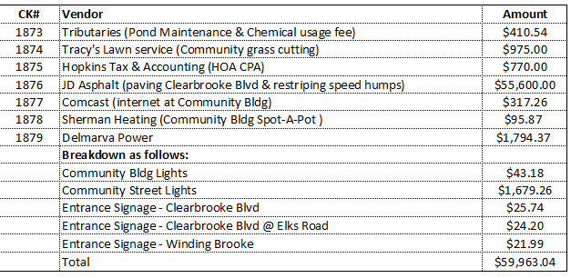

Meeting Adjourned at 10:30am

Next Board Meeting will be: 9/18/25 @ 10:00am

