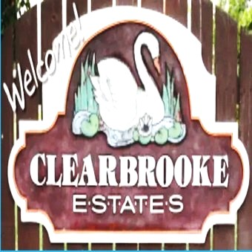 Board Meeting Minutes from April 17 2026
The meeting was called to order by Mike McDermott @ 4:20 pm
Attendees: Mike McDermott, Dana Smith, Diana Engle & James Blumer
Bills
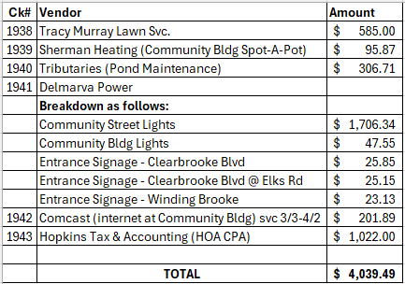

Motion to Pay Bills
1st Motion made by: Diana Engle
2nd Motion made by: James Blumer
Motion approved by all
Motion to Approve Minutes from March
1st Motion made by: Dana Smith
2nd Motion made by: James Blumer
Treasure Report
Deposits as of 4/7
$3,715.62
Motion approved by all
Old Business:
Dana has talked to Kirk Neal and got the contract signed for the drainage issues
So far only 1 person has shown interest in getting the contract for snow removal

New Business
Collection agency sent back around 10 names they are done with stating they couldn’t collect.
Dana and Diana are going to try and collect them before they are sent to another collection agency
Mike and Dean are going to go around checking out what needs to be addressed about property violations and send letters.
We approved writing off small balances less than $1.80
Foodtruck asked if they could set up in neighborhood. The board covenants to do allow commercial vendors to operate on residential properties due to extra traffic and liability purposes. Mike reached out to explain to the homeowner/business owner to explain.
Mike is going to have new signs made for yard sale . The signs will be designed so we can use every year
This years date for yard sale is May 9. Rain date May 16
The late fees and interest for Raul Santos Ramirez will be waived due to misunderstanding. He thought the HOA fee was included in with his mortgage payment . The issue has been cleared up

Architecture
Drive way 101 Sunnyvale

Meeting adjourned at 5:10

Next meeting May 20. At 6 pm
Submited by Diana Engle

