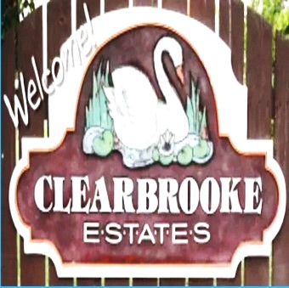 **Board Meeting Minutes from April 24, 2025**

The meeting was called to order by Mike McDermott @ 10:00am

Attendees: Mike McDermott, Dean Anderson, Paula Odom

**Motion to Pay Bills:**

1st Motion made by: Dean Anderson

2nd Motion made by: Paula Odom

Motion approved by all

**Motion to Approve Minutes from March:**

1st Motion made by: Mike McDermott

2nd Motion made by: Dean Anderson

Motion approved by all

**Motion also made to Approve Minutes from the April 7th Community Meeting:**

1st Motion made by: Mike McDermott

2nd Motion Made by: Dean Anderson

Motion approved by all

**Old Business:**

Mike McDermott spoke to Jim Phillips as to when the DNREC Project for Drainage/Pipe work might start on Sunnydale and S. Winding Brooke. Not date as of yet

Continued . . . .

**New Business:**

Mike McDermott and Dean Anderson will meet with Delmarva Paving to look over the paving needed on Clearbrooke Blvd and Highland to get estimates

Mike McDermott received interest from Mary Massey as well as Paul Nichols to serve on the board. Since the Special Election didn’t happen at the Community Meeting on 4/7/25.

Mike will extend an invitation to come to the next Board Meeting on 5/22/25

**Checks Signed:**

|  |  |  |
| --- | --- | --- |
| **CK#** | **Vendor** | **Amount** |
| 1848 | Hopkins Tax & Accounting (HOA CPA) | $865.00 |
| 1849 | Comcast (internet at Community Bldg) | $317.32 |
| 1850 | Tracy's Lawn service (Community grass cutting) | $390.00 |
| 1851 | Tributaries (Pond Maintenance) | $297.78 |
| 1852 | Sherman Heating (Community Bldg Spot-A-Pot ) | $95.87 |
| 1853 | Mike McDermott (reimbursement for hand-outs @ April 7th Meeting of Drainage/Pipe plans from DNREC that will affect resident on Sunnydale and S. Winding Brooke) | $57.00 |
|  |  |  |
| 1854 | Delmarva Power | $1,780.82 |
|  | **Breakdown as follows:** |  |
|  | Community Bldg Lights | $54.03 |
|  | Community Street Lights | $1,654.27 |
|  | Entrance Signage - Clearbrooke Blvd | $25.03 |
|  | Entrance Signage - Clearbrooke Blvd @ Elks Road | $24.32 |
|  | Entrance Signage - Winding Brooke | $23.17 |

Motion to adjourn meeting was made by Mike McDermott @ 11:00am – Motion approved by all.

**Next Board Meeting**: will be May 22, 2025 @ 10:00am