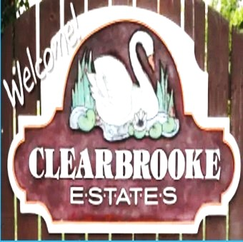 Board Meeting Minutes from October 23, 2025

The meeting was called to order by Mike McDermott @ 10:00am
Attendees: Mike McDermott, Dean Anderson, Paula Odom

Motion to Pay Bills:
1st Motion made by: Dean Anderson
2nd Motion made by: Mike McDermott
Motion approved by all

Motion to Approve Minutes from September:
1st Motion made by: Paula Odom
2nd Motion made by: Dean Anderson
Motion approved by all

New Business:
Mike McDermott will talk to Community Bank of Delaware to get the Full Account #s for the new accounts that were
Set-up on 9/23/25. These Account #s will then be relayed to Tracy Hopkins the HOA CPA.

Recovery Solutions – Collection Agency: The contract was looked over and approved by all board members. Mike McDermott signed the contract that will be e-mailed to Recovery Solutions, as well as an Authorization Letter to act on behalf of Clearbrooke Estates for HOA Dues Collections.

Old Business:
Per a suggestion at the October 6, 2025 Annual Meeting regarding Geese . . .
Dean Anderson will take a look at the cost and possible purchase of at least Two (2) Coyote Decoys to be placed at the edges of the two main ponds on N. Winding Brooke Drive, to try and reduce the droppings on the roadway.

Continued . . .

Board Meeting Minutes from October 23, 2025
Checks Signed . . .
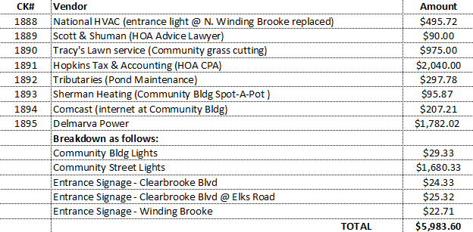

Meeting Adjourned at 11:30am
Next Board Meeting will be: November 20, 2025 @ 6:30pm

