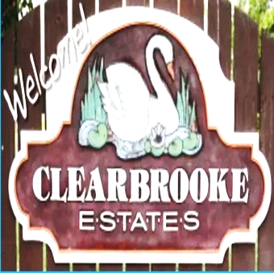

**Board Meeting Minutes from June 19, 2025**

**Attendees:**

Mike McDermott, Dean Anderson, Paula Odom

Meeting came to order by Mike McDermott @ 10:00am

**Motion to Pay Bills:**

1st Motion Made by: Mike McDermott

2nd Motion Made by: Paula Odom

Motion approved by all

|  |  |  |
| --- | --- | --- |
| **CK#** | **Vendor** | **Amount** |
| 1861 | Hopkins Tax & Accounting (HOA CPA) | $760.00 |
| 1862 | Tracy's Lawn service (Community grass cutting) | $780.00 |
| 1863 | Tributaries (Pond Maintenance) | $297.78 |
| 1864 | Sherman Heating (Community Bldg Spot-A-Pot ) | $95.87 |
| 1865 | Comcast (internet at Community Bldg) | $317.18 |
| 1866 | Delmarva Power | $1,753.45 |
|  | **Breakdown as follows:** |  |
|  | Community Bldg Lights | $30.82 |
|  | Community Street Lights | $1,652.53 |
|  | Entrance Signage - Clearbrooke Blvd | $24.97 |
|  | Entrance Signage - Clearbrooke Blvd @ Elks Road | $23.45 |
|  | Entrance Signage - Winding Brooke | $21.68 |

**Old Business:**

None

**New Business:**

None

Motion to Adjourn Meeting by Mike McDermott at 11:00am

Motion Approved by all.

**Next Board Meeting:** July 17, 2025 @ 10:00am