 Board Meeting Minutes from December 18, 2025

The meeting was called to order by Dean Anderson @ 6:52pm
Attendees: Dean Anderson, (note Mike McDermott gave Dean Anderson his proxy for this meeting)
Paula Odom

Invited Guests: James Blumer – absent, Diana Engel – absent - Dana Smith - present
Motion to Pay Bills:
1st Motion made by: Paula Odom
2nd Motion made by: Dean Anderson
Motion approved by all

Motion to Approve Minutes from November:
1st Motion made by: Dean Anderson for Mike McDermott
2nd Motion made by: Paula Odom
Motion approved by all

Motion for the HOA to Absorb $ .99 . . .
Check received from Roger Thrasher for $78.00 but should have been $78.99
1st Motion made by: Paula Odom
2nd Motion made by: Dean Anderson for Mike McDermott
Motion approved by all

Old Business:
Mike McDermott still needs to get the full account numbers for the new accounts set-up 9/30/25 from Community Bank of Delaware to be relayed to Tracy Hopkins the HOA CPA. Mike McDermott still needs to close the old accounts at PNC Bank with the exception of the Operating Account for now.
Continued . . .

Board Meeting Minutes from December 18, 2025
New Business:
Treasurer Odom shared the First Status Report on 12/1/25 from the New HOA Collections Agency – Recovery Solutions.
The collection agency has made some progress in a short amount of time, in getting a few payment plans established, as well as a few payments made.

Treasurer Odom reported Deposits for 2026 Dues so far from:
12/2/25 = $3678.00 (19 people)
12/9/25 = $2925.00 (7 people)
12/15/25/25 = $4825.00 (11 people)
Total: $11,428.00

Nothing new to report from Dean Anderson – Architecture Committee
Checks Signed . . .
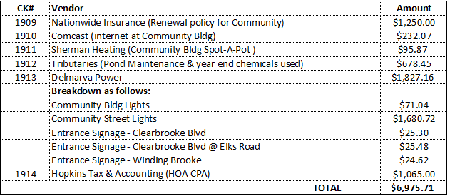
Meeting Adjourned at 8:15pm
ORIENTATION FOR NEW BOARD MEMBERS – January 5, 2026 @ 6pm
Next Regular Board Meeting will be: January 22, 2026 @ 6:30pm

