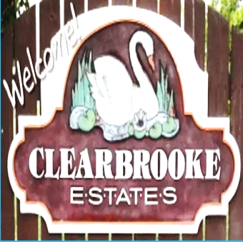

**Board Meeting Minutes from February 20, 2025**

**Attendees:**

Mike McDermott, Dean Anderson, Paula Odom

Meeting came to order by Mike McDermott @ 10:00am

**Motion to Approve Minutes from:** January 23rd meeting that was postponed

1st Motion Made by: Dean Anderson

2nd Motion Made by: Paula Odom

Motion approved by all

**Motion to Pay Bills:**

1st Motion Made by: Mike McDermott

2nd Motion Made by: Dean Anderson

Motion approved by all

**Checks Signed:**

|  |  |  |  |
| --- | --- | --- | --- |
|  |  | |  |
| **CK#** | | **Vendor** | **Amount** |
| 1834 | | Delmarva Power | $1,793.59 |
|  | | **Breakdown as follows:** |  |
|  | | Entrance Signage - Clearbrooke Blvd | $20.56 |
|  | | Entrance Signage - Clearbrooke Blvd @ Elks Road | $25.28 |
|  | | Entrance Signage - Winding Brooke | $23.79 |
|  | | Community Bldg Lights | $73.41 |
|  | | Community Street Lights | $1,650.55 |
| 1835 | | Sherman Heating (Community Bldg Spot-A-Pot ) | $97.79 |
| 1836 | | Comcast (internet at Community Bldg) | $276.55 |
| 1837 | | Tributaries (Pond Maintenance) | $297.78 |
| 1838 | | National HVAC (Community Bldg Unit - diagnosis unit not working properly) | $262.50 |
| 1839 | | Hopkins Tax & Accounting (HOA CPA) | $785.00 |
|  |  | |  |
|  | Continued . . . . . . | |  |
|  |  | |  |
|  |  | |  |
|  | **Board Meeting Minutes from February 20, 2025** | |  |
|  |  | |  |
|  |  | |  |
|  | **Old Business:**  Community Building heating/air conditioning unit replaced and working Great!  **New Business:**  Paula Odom received a letter from DNREC requesting permission to access certain properties in order to do some Drainage and Pipe work. DNREC also supplied floor plans on the affected areas.  I believe the areas that will be affected by this work will be on: Sunnydale and S. Winding Brooke.  Mike McDermott made a Motion to get the work done, sign, and send back paperwork to DNREC.  1st Motion made by: Dean Anderson  2nd Motion made by: Paula Odom  Motion Approved by All  Mike McDermott will get the floor plans blown up to display at the April 7th Community Meeting to show the actual streets and areas that will be affected, and get a preliminary start date from DNREC.  **Street Sign Replacement:**  R&L Irrigation knocked down a street sign & stop sign and damaged it during one of the plowing, and refused to pay for it. | |  |
|  | Continued . . . . . | |  |
|  | **Board Meeting Minutes from February 20, 2025**  Dean Anderson looked into what it would could cost to replace the posts and Stop Sign – Roughly about $400.00  1st Motion made by: Paula Odom  2nd Motion made by: Mike McDermott  Motion Approved by all.  Dean will order the replacement parts needed and will replace as weather conditions improve.  Meeting adjourned by Mike McDermott at 11:15am  **Next Board Meeting will be:** March 20, 2025 @ 10am | |  |
|  |  | |  |
|  |  | |  |
|  |  | |  |
|  |  | |  |