

**Board Meeting Minutes from November 21, 2024**

**Attendees:**

Mike McDermott, Dean Anderson, Paula Odom

**Motion to Approve Minutes from October:**

1st Motion to approve by Dean Anderson

2nd Motion to approve by Mike McDermott

Motion approved by all

**Motion to Pay Bills:**

1st Motion to approve by Dean Anderson

2nd Motion to approve by Paula Odom

Motion approved by all

**Checks Signed:**

|  |  |  |
| --- | --- | --- |
| **CK#** | **Vendor** | **Amount** |
| 1813 | Hopkins Tax & Accounting (HOA CPA) | $2,240.00 |
| 1814 | Tracy's Lawn Service (last cut for the year) | $195.00 |
| 1815 | Community Post Office Box Renewal (12/1/24 - 11/20/25) | $200.00 |
| 1816 | Tributaries (Pond Maintenance) | $297.78 |
| 1817 | Comcast (Community Bldg Internet) | $253.89 |
| 1818 | Sherman Heating (Community Bldg Spot-A-Pot) | $95.37 |
| 1819 | Delmarva Power | $1,739.00 |
|  | **Breakdown as follows:** |  |
|  | Entrance Signage - Clearbrooke Blvd | $25.48 |
|  | Entrance Signage - Clearbrooke Blvd @ Elks Road | $22.37 |
|  | Entrance Signage - Winding Brooke | $23.66 |
|  | Community Bldg Lights | $37.63 |
|  | Community Street Lights | $1,630.76 |

**Motion to Approve Estimate for:**

Tree Trimming at all Entrances, and to take out all the Trees in the median by Elks Road

1st Motion to approve by Dean Anderson

2nd Motion to approve by Mike McDermott

Motion approved by all

Continued . . .

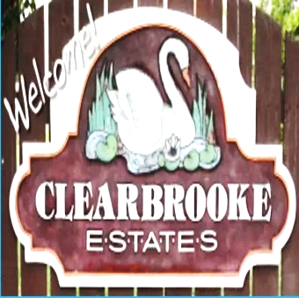

**Board Meeting Minutes from November 21, 2024**

**Old Business:**

R&L Irrigation Snow Removal Contract for the Season was signed by Mike McDermott

and e-mailed to Rick by Paula Odom

Mike McDermott still needs to get the form back to Delmarva Power in order to replace the remaining Street Lights from Amber to LED Lightning

**New Business:**

Noting at this time

Motion to adjourn meeting by Mike McDermott at 7:45pm

Motion approved by all.

**Next Meeting:**

December 19, 2024 @ 6:30pm