 Board Meeting Minutes from March 18 2026
The meeting was called to order by Mike McDermott @ 6:20 pm
Attendees: Mike McDermott, Dana Smith, Diana Engle & James Blumer
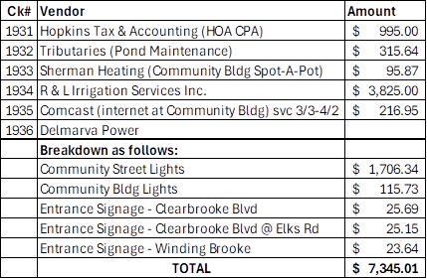
Bills
Motion to Pay Bill
1st Motion made by: Diana Engle
2nd Motion made by: James Blumer
Motion approved by all
Motion to Approve Minutes from February
1st Motion made by: Dana Smith
2nd Motion made by: James Blumer
Treasure Report
Deposits as of 3/7/2026
$6114.56
Motion approved by all
Old Business:
Dana has talked to Kirt Neal and he has agreed to sign the contract to get the drainage issue resolved.

New Business
R & L will fix damage to yards and sprinklers only if they had up lawn markers,
Large tree limb in the empty lot will be cleaned up by J D Harper
Mike is going to get in touch with collection agency in May to find out what action they are going to take on anything over $2000.
Signed new contract with Tracy Lawn Care for same price of $195.00
1st motion Dana Smith
2nd James Blumer
Motion approved all
Agriculture
Shed 502 N Winding Brooke
Fencing 3 Brooke Haven

Meeting adjourned at 7:16

Next meeting April 17 At 4:00 PM

Continued…

ARCHITECTURE
SHEd. 502 North Winding Brooke
Fencing 3 Brooke Haven

Meeting adjourned at 7 16
Next meeting April 17 at 4 pm
Submitted by Diana Engle

