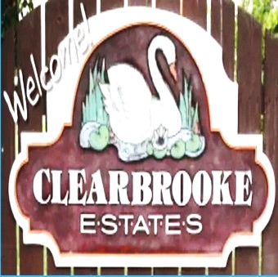 **Board Meeting Minutes from March 27, 2025**

**Attendees:**

Mike McDermott, Dean Anderson, Paula Odom

Meeting came called to order by Mike McDermott @ 10:30am

**Motion to Approve Minutes from February:**

1st Motion made by: Dean Anderson

2nd Motion made by: Mike McDermott

Motion approved by all

**Motion to Approve Bills:**

1st Motion made by: Dean Anderson

2nd Motion made by: Paula Odom

Motion approved by all

**Checks Signed:**

|  |  |  |
| --- | --- | --- |
| **CK#** | **Vendor** | **Amount** |
| 1840 | Hopkins Tax & Accounting (HOA CPA) | $1,165.00 |
| 1841 | J.D. Harper Lawn Service (Finished work at Elks Road Entrance after tree removal) | $2,775.00 |
| 1842 | National HVAC (Community Bldg Unit | $4,692.00 |
|  | **Breakdown as follows:** |  |
|  | New AC/Heat Unit for Community Bldg | $3,642.00 |
|  | Replaced lights from Cannon Road to Clearbrooke Entrance | $1,050.00 |
|  |  |  |
| 1843 | Sherman Heating (Community Bldg Spot-A-Pot ) | $97.79 |
| 1844 | R&L Irrigation (Community last Snow) | $1,925.00 |
| 1845 | Tributaries (Pond Maintenance) | $297.78 |
| 1846 | Comcast (internet at Community Bldg) | $266.55 |
|  |  |  |
| 1847 | Delmarva Power | $1,811.82 |
|  | **Breakdown as follows:** |  |
|  | Community Bldg Lights | $87.92 |
|  | Community Street Lights | $1,651.01 |
|  | Entrance Signage - Clearbrooke Blvd | $24.61 |
|  | Entrance Signage - Clearbrooke Blvd @ Elks Road | $24.98 |
|  | Entrance Signage - Winding Brooke | $23.30 |
|  |  |  |
|  | **Pcard Purchases (Vendors that will not Invoice)** |  |
|  | **Go Daddy Website** |  |
|  | Microsoft 365 for e-mail renewed for 2 years - expires 3/12/27 | $76.56 |
|  | Website Marketing to do Posting renewed for 2 years - expires 3/17/27 | 551.76 |

**Continued . .** .

 **Board Meeting Minutes from March 27, 2025**

**Old Business:**

NONE

**New Business:**

Dean Anderson finally received the remaining paperwork from Tyme Builders regarding the empty lot to be built at

602 N. Winding Brooke Drive

Mike McDermott had the plans enlarged that were received from DNREC for the upcoming Drainage/Pipe Work to be done on Sunnydale and S. Winding Brooke that will impact residents. These plans will be made available at the April 7th Community meeting.

**Motion to adjourn meeting:**

1st Motion made by Mike McDermott

2nd Motion made by Dean Anderson

Motion approved by all

Meeting adjourned at 11:30am

**Next Board Meeting:**

Will be held on April 24, 2025 @ 10am