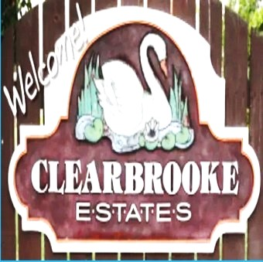 Board Meeting Minutes from May 20, 2026
The meeting was called to order by Mike McDermott @ 6:03 pm
Attendees: Mike McDermott, Dana Smith & James Blumer
Absent: Dean Anderson & Diana Engle
Motion to Approve Minutes from April
1st Motion made by: Dana Smith
2nd Motion made by: James Blumer

Bills

Motion to Pay Bills
1st Motion made by: Mike McDermott
2nd Motion made by: James Blumer
Motion approved by all

Treasure Report

Old Business:

Collection agency sent back around 10 names they are done with stating they couldn’t collect.
Diana has worked with 2 of the those homeowners and payment plans are set in place for them.
Dana & Diana will continue to work on those homeowners before we choose another collection agency.
Mike and Dean are going to go around checking out what needs to be addressed about property violations and send letters.

Architecture
Drive way 101 Sunnyvale

New Business
No new business.

Meeting adjourned at 6:50

Next meeting June 18th at 6 pm

Submitted by: Dana Smith

