 Board Meeting Minutes from November 20, 2025

The meeting was called to order by Mike McDermott @ 6:30pm
Attendees: Mike McDermott, Dean Anderson, Paula Odom
Invited Guests: James Blumer – absent, Diana Engel – absent - Dana Smith - present
Motion to Pay Bills:
1st Motion made by: Dean Anderson
2nd Motion made by: Mike McDermott
Motion approved by all

Motion to Approve Minutes from October:
1st Motion made by: Paula Odom
2nd Motion made by: Mike McDermott
Motion approved by all
Old Business:
Mike McDermott still needs to get the full account numbers for the new accounts set-up 9/30/25 from Community Bank of Delaware to be relayed to Tracy Hopkins the HOA CPA.
Dean Anderson has looked into the cost and possible purchase of at least Two (2) Coyote Decoys to be placed at the edges of the two main ponds on N. Winding Brooke Drive, to try and reduce the droppings on the roadway. Action still needs to be taken on this.

New Business:
Mike McDermott needs to get the full account numbers from Community Bank of Delaware, in order to cancel the old accounts still at PNC Bank with the exception of keeping the PNC Operating Account open till at least April 2026

Tributaries Pond Maintenance Contract for 2026-2027 was signed by Mike McDermott. Treasurer Odom will e-mail the signature page to Tributaries.

Continued . . .

Board Meeting Minutes from November 20, 2025
New Business cont . . .
Treasurer Odom reported Deposits for 2026 Dues so far from:
10/3 – 10/31/25 = $7,700.00 (19 people)
11/8 – 11/17/25 = $8,150.00 (19 people)
Total so far: $15,850.00

Checks Signed . . .
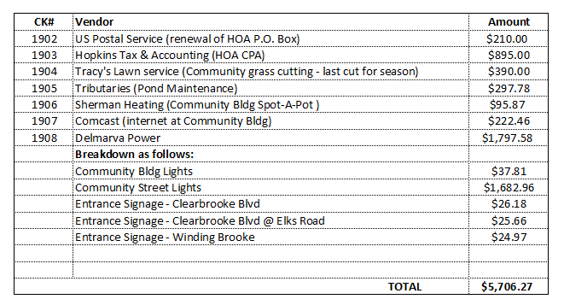

Meeting Adjourned at 7:30pm
Next Board Meeting will be: December 20, 2025 @ 6:30pm

