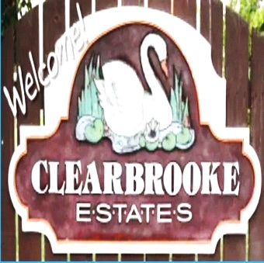 **Board Meeting Minutes from May 22, 2025**

The meeting was called to order by Mike McDermott @ 10:00am

Attendees: Mike McDermott, Dean Anderson, Paula Odom

**Motion to Pay Bills:**

1st Motion made by: Dean Anderson

2nd Motion made by: Paula Odom

Motion approved by all

**Motion to Approve Minutes from April:**

1st Motion made by: Dean Anderson

2nd Motion made by: Paula Odom

Motion approved by all

**Old Business:**

None

**New Business:**

**Paving:**

Mike McDermott reached out to Delmarva Paving and received One quote so far for the following areas to be paved:

* From Cannon Road – RT 18 enter onto Clearbrooke Blvd & Pave up to house 403 Clearbrooke Blvd.
* The Portion on Highland that runs between the ponds at the S. Winding Brooke intersection up to the intersection at Overbrooke

Mike is also working getting other quotes for comparison, so Treasurer Odom can check the funds available before anything is decided.

Continued . . . . .

 **Board Meeting Minutes from May 22, 2025**

**New Business Cont:**

**Collections:**

Treasurer Odom gave a report on the status of Collections by Bay Area.

Collections have slowed down.

Currently there are 16 what I call our “heavy hitters” that Bay Area is actively pursuing by various means

Late Fee/Interest Invoices that were sent out either by e-mail or mail in Feb, March, and April have resulted in:

8 partial payments – 10 haven’t paid anything yet.

**Checks Signed:**

|  |  |  |
| --- | --- | --- |
| **CK#** | **Vendor** | **Amount** |
| 1855 | Hopkins Tax & Accounting (HOA CPA) |  |
| 1856 | Tracy's Lawn service (Community grass cutting) | $960.00 |
| 1857 | Tributaries (Pond Maintenance) | $780.00 |
| 1858 | Sherman Heating (Community Bldg Spot-A-Pot ) | $95.87 |
| 1859 | Comcast (internet at Community Bldg) | $327.18 |
| 1860 | Delmarva Power | $1,767.58 |
|  | **Breakdown as follows:** |  |
|  | Community Bldg Lights | $41.07 |
|  | Community Street Lights | $1,654.33 |
|  | Entrance Signage - Clearbrooke Blvd | $25.33 |
|  | Entrance Signage - Clearbrooke Blvd @ Elks Road | $24.17 |
|  | Entrance Signage - Winding Brooke | $22.68 |

Motion to adjourn meeting was made by Mike McDermott @ 11:30am – Motion approved by all.

**Next Board Meeting**: will be June 19, 2025 @ 10:00am