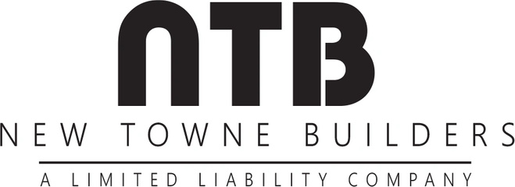
ELLIS Lots 146 & 149

- 3 CAR GARAGES
- SCREENED IN PORCH (Lot 149 Only)
- 30 YEAR ARCHITECTURAL ROOFING AND METAL ACCENTS
- STAIRS OFF DECKS TO REAR YARD
- BASEMENTS WILL HAVE MINIMUM 9’ WALLS, STUBBED WITH FUTURE BATH
- 10’ CEILING ON MAIN FLOOR/9’ CEILING ON 2ND FLOOR
- CUSTOM SHAKER STYLE CABINETS WITH SOFT CLOSING DOORS/DRAWERS & PULL OUT TRASH BIN
- CUSTOM FARMHOUSE STYLE TRIM PACKAGES (SHIPLAP & WOOD BEAM DETAIL)
- QUARTZ COUNTERTOPS ON ALL BATHS AND KITCHEN AREAS
- CUSTOM PLUMBING AND LIGHT FIXTURE PACKAGES
- SECURITY PRE-WIRING
- UNDER CABINET LIGHTING AT KITCHEN
- DIRECT VENT HOOD WITH WOOD SHROUD OVER COOKTOP IN KITCHEN
- FRIGIDAIRE GALLERY APPLIANCE PACKAGE
- FREE STAND TUB AT MASTER BATH
- FRAMELESS SHOWER DOOR AT MASTER BATH
- FRAMED MIRRORS AT ALL BATHS
- SITE FINISHED RED OAK HARDWOODS ON MAIN LEVEL LIVING AREAS & MASTER BEDROOM/CLOSET
- UPGRADED CARPET WITH 8LB PAD
- CARRIAGE STYLE GARAGE DOORS WITH GENIE QUIET OPENERS
- CUSTOM LANDSCAPING WITH IRRIGATION
- ONE YEAR BUILDER WARRANTY PROGRAM WITH GAHBA
- FULL 2-10 HOME BUYERS WARRANTY PROGRAM

